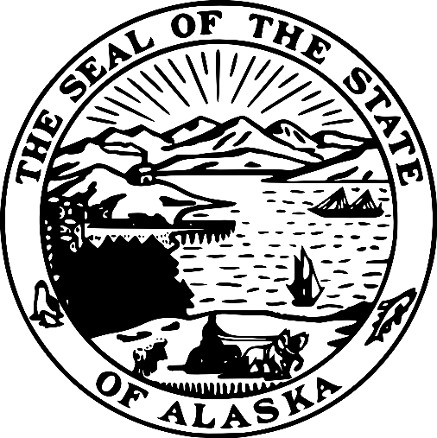
Alaska Bidder Preference Certification
AS 36.30.321(a) / AS 36.30.990(2)

BUSINESS NAME: Click or tap here to enter text.

Alaska Bidder Preference: Do you believe that your firm qualifies for the Alaska Bidder Preference? | □ Yes □ No
Alaska Veteran Preference: Do you believe that your firm qualifies for the Alaska Veteran Preference? | □ Yes □ No
Please list any additional Alaska Preferences below that you believe your firm qualifies for.
1. 2. 3. 4. 5. 6.

To qualify for and claim the Alaska Bidder Preference you must answer YES to all questions below in the Alaska Bidder Preference Questions section. To qualify for and claim the Alaska Veteran Preference, you must answer YES to these questions as well as answer YES to all the questions in the Alaska Veteran Preference section. A signed copy of this form must be included with your bid or proposal no later than the deadline set for receipt of bids or proposals.

If you are submitting a bid or proposal as a JOINT VENTURE, all members of the joint venture must complete and submit this form before the deadline set for receipt of bids or proposals. AS 36.30.990(2)(E)

If the procuring agency is unable to verify a response, the preference may not be applied. Knowingly or intentionally making false or misleading statements on this form, whether it succeeds in deceiving or misleading, constitutes misrepresentation per AS 36.30.687 and may result in criminal penalties.

Alaska Bidder Preference Questions:

- Does your business hold a current Alaska business license per AS 36.30.990(2)(A)?
☐ YES ☐ NO
If YES, enter your current Alaska business license number: Click or tap here to enter text.
2) Is your business submitting a bid or proposal under the name appearing on the Alaska business license noted in Question 1 per AS 36.30.990(2)(B)?
☐ YES ☐ NO
3) Has your business maintained a place of business within the state staffed by the bidder or offeror or an employee of the bidder or offeror for a period of six months immediately preceding the date of the bid or proposal per AS 36.30.990(2)(C)?
☐ YES ☐ NO
If YES, please complete the following information:

- Place of Business
Street Address: Click or tap here to enter text.
City: Click or tap here to enter text.
ZIP: Click or tap here to enter text.
“Place of business” is defined as a location at which normal business activities are conducted, services are rendered, or goods are made, stored, or processed; a post office box, mail drop, telephone, or answering service does not, by itself, constitute a place of business per 2 AAC 12.990(b)(3).
Do you certify that the Place of Business described in Question 3A meets this definition?
☐ YES ☐ NO

- The bidder or offeror, or at least one employee of the bidder or offeror, must be a resident of the state under AS 16.05.415(a) per 2 AAC 12.990(b)(7).

- Do you certify that the bidder or offeror OR at least one employee of the bidder or offeror is physically present in the state with the intent to remain in Alaska indefinitely and to make a home in the state per AS 16.05.415(a)(1)?
☐ YES ☐ NO
- Do you certify that that the resident(s) used to meet this requirement has maintained their domicile in Alaska for the 12 consecutive months immediately preceding the deadline set for receipt of bids or proposals per AS 16.05.415(a)(2)?
☐ YES ☐ NO
- Do you certify that the resident(s) used to meet this requirement is claiming residency ONLY in the state of Alaska per AS 16.05.415(a)(3)?
☐ YES ☐ NO
- Do you certify that the resident(s) used to meet this requirement is NOT obtaining benefits under a claim of residency in another state, territory, or country per AS 16.05.415(a)(4)?
☐ YES ☐ NO
4) Per AS 36.30.990(2)(D), is your business (CHOOSE ONE):
A. Incorporated or qualified to do business under the laws of the state?
☐ YES ☐ NO
If YES, enter your current Alaska corporate entity number: Click or tap here to enter text.
B. A sole proprietorship AND the proprietor is a resident of the state?
☐ YES ☐ NO
C. A limited liability company organized under AS 10.50 AND all members are residents of the state?
☐ YES ☐ NO
Please identify each member by name: Click or tap here to enter text.
D. A partnership under former AS 32.05, AS 32.06, or AS 32.11 AND all partners are residents of the state?
☐ YES ☐ NO
Please identify each partner by name: Click or tap here to enter text.

Alaska Veteran Preference Questions:

- Per AS 36.30.321(F), is your business (CHOOSE ONE):
- A sole proprietorship owned by an Alaska veteran?
☐ YES ☐ NO
B. A partnership under AS 32.06 or AS 32.11 AND a majority of the partners are Alaska veterans?
☐ YES ☐ NO
C. A limited liability company organized under AS 10.50 AND a majority of the members are Alaska veterans?
☐ YES ☐ NO
D. A corporation that is wholly owned by individuals, AND a majority of the individuals are Alaska veterans?
☐ YES ☐ NO
Per AS 36.30.321(F)(3) “Alaska veteran” is defined as an individual who:
- Served in the
- Armed forces of the United States, including a reserve unity of the United States armed forces; or
- Alaska Territorial Guard, the Alaska Army National Guard, the Alaska Air Nations Guard, or the Alaska Naval Militia; and
- Was separated from service under a condition that was not dishonorable.
Do you certify that the individual(s) indicated in Question 1A, 1B, 1C, or 1D meet this definition and can provide documentation of their service and discharge if necessary?
☐ YES ☐ NO
SIGNATURE
By signature below, I certify under penalty of law that I am an authorized representative of Click or tap here to enter text. and all information on this form is true and correct to the best of my knowledge.

Printed Name
Title
Date
Signature

