DEPT. OF ENVIRONMENTAL CONSERVATION
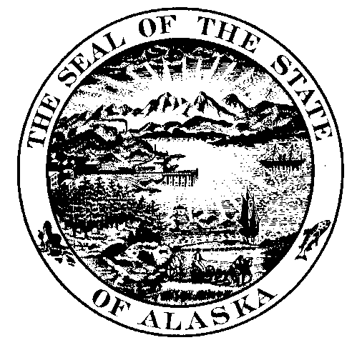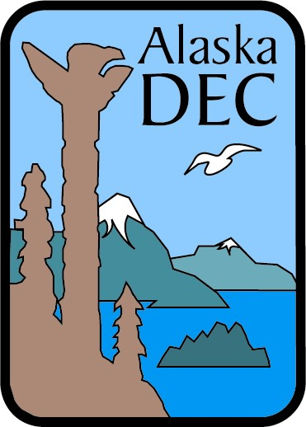

RFP SOLICITATION REGISTRATION FORM

To register with the State of Alaska, Department of Environmental Conservation for a solicitation, please fill out the following information and return to the Procurement Officer. To process your registration sooner, please send your request via email or fax.

Procurement Officer Information:
Sonja Love-Hestnes
555 Cordova Street
Anchorage, Alaska 99501
Phone: (907) 269-3090
Fax: (907) 269-3061
Email: Sonja.Love-Hestnes@alaska.gov
RFP Solicitation Number: |  | RFP 2013-1800-1740
RFP Solicitation Title: |  | Tsunami Marine Debris Surveying, Monitoring, Removal and Disposal
Business Name:
Contact Name:
Mailing Address
Phone: |  | Fax:
E-mail Address:

Important Notice: If you received this solicitation from the State of Alaska’s “Online Public Notice” web site, you must register with the procurement officer listed in this document to receive subsequent amendments. Failure to contact the procurement officer may result in the rejection of your offer.

