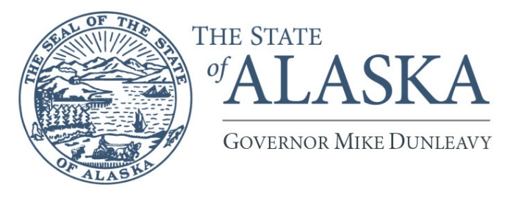
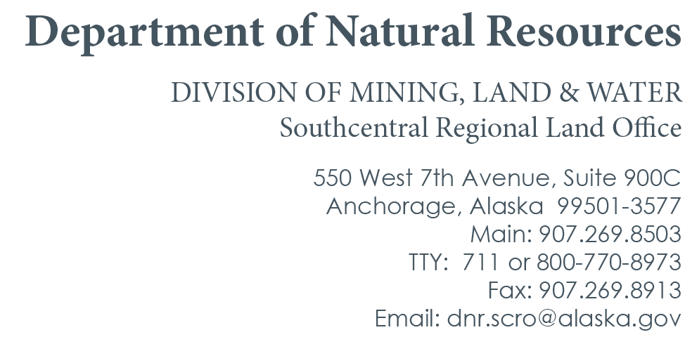

PUBLIC AND AGENCY NOTICE
ADL 234868
Old Harbor Airport
Interagency Land Management Assignment

August 12, 2026
Subject to AS 38.05.020(b)(2), the Department of Natural Resources (DNR), Division of Mining, Land, and Water (DMLW), Southcentral Regional Land Office (SCRO) has received an application for an Interagency Land Management Assignment (ILMA):
APPLICANT: Department of Transportation & Public Facilities (DOT&PF)
PROJECT NAME: ADL 234868
GEOGRAPHIC LOCATION: Old Harbor, Kodiak, Alaska
LEGAL DESCRIPTION: The SE ¼ of Section 16, Township 34 South, Range 25 West, Seward Meridian & the NE ¼ of Section 21, Township 34 South, Range 25 West, Seward Meridian.
REQUESTED ACTIVITY: The Department of Transportation and Public Facilities (DOT&PF) has requested the creation of an Interagency Land Management Assignment (ILMA) for the purpose of incorporating and expanding 3 pre-existing authorizations (ADL 223330, ADL 225230, and ADL 231842) that provide airport use at Old Harbor Airport. The pre-existing authorizations, are currently inconsistent with current department practices as they address airspace protection and fill placement separately. The proposed ILMA seeks to address airport use via a single authorization, allowing for integration and closure of the prior authorizations. The proposed ILMA will also allow DOT&PF to utilize the extended portion of the runway from 2013 by filing an update with the Federal Aviation Administration (FAA), citing the ILMA once issued. No further property development has been proposed. The ILMA is on state-owned DMLW-managed tide and submerged lands and is approximately 2,350 feet in length, 1,200 feet in width, totaling 41.4 acres, more or less. The authorization, if approved, may differ from that described herein.
REQUESTED TERM: Indefinite
DEADLINE FOR COMMENTS: September 14, 2026
The public is invited to comment on this activity. The purpose of this notice is to gather input before a decision is made on this activity. To ensure consideration, comments must be submitted in writing and received by the Division of Mining, Land and Water at the Southcentral Regional Land Office, 550 West, 7th Avenue, Suite 900C, Anchorage AK 99501 on or before the date noted above. Questions concerning this notice should be directed to the attention of Channing Buckmaster, Telephone: (907) 269-8503;or e-mail: channing.buckmaster@alaska.gov. After review and adjudication, we may issue an authorization with stipulations for the activity. The activity may be modified during the review and adjudication process.

DNR-DMLW complies with Title II of the Americans with Disabilities Act of 1990. Individuals with disabilities who may need auxiliary aids, services or special modifications to comment should contact Alaska Relay at 711 or 800-770-8973 for TTY services. DMLW reserves the right to waive technical defects in this notice.

