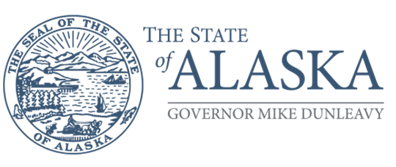
Department of Health
SENIOR AND DISABILITY SERVICES
Governor’s Council on Disabilities
and Special Education
550 W 7th Ave. Suite 1220
Anchorage, Alaska 99501
Main: 907.269.8990
Toll Free: 1.888.269.8990
Fax: 907.269.8995

Employment Committee Meeting Agenda
Tuesday, June 23, 2026
12:00 PM – 1:30 PM
TO JOIN THE MEETING:

Join Link:
https://us02web.zoom.us/j/87522598856?pwd=lP4fniBzMnKEslIzJIca47PLErORF3.1
Meeting ID: 875 2259 8856
Passcode: 311 685
Toll Free numbers: 888 475 4499, 833 548 0276, 833 548 0282, 877 853 5257
(if one phone number doesn’t work, it means it is full. Please try one of the other listed numbers).

Call to Order:
Anna Attla, Employment Committee Chair

Roll Call / Begin ZOOM Recording:
Committee Members: Anna Attla, Margret Evans, Lisa McDonald, Mariah Krueger, Scott Lindbloom, Corey Gilmore, Sabrina Richmond, Karen Heath
(Quorum is defined as a majority of Committee Members).

GCDSE Staff, Guests

Welcome from the Chair:
Introductions, announcements, and/or good news.

Conflict of Interest Declarations:
This is an opportunity for committee members to declare if they have a conflict with any item on the agenda, financial or otherwise.

Approval of the Previous Meeting Minutes and Agenda:
- Approval of Agenda
  - SAMPLE MOTION: I make a motion to approve the meeting agenda as presented.
- Approval of Past Meeting Minutes
  - SAMPLE MOTION: I make a motion to approve the meeting minutes as presented.

Reports (upcoming events, priorities, presentations, meetings, or updates to current activities).
- Chair-Anna Attla
- GCDSE Staff

Business:

- FY27 Activity/Objectives Review (see attached worksheet).

Time and Date of Next Meeting:=

Proposed: July 28, 2026 from 12-1:30 PM

Good of the Order and Adjournment:

- 1:30pm - Motion to Adjourn

