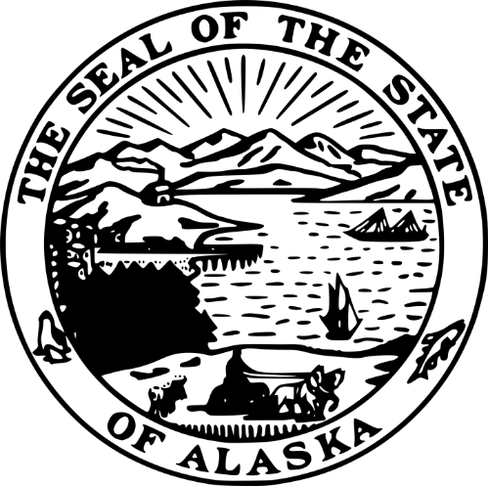
STATE OF ALASKA
DEPARTMENT OF COMMERCE, COMMUNITY, AND ECONOMIC DEVELOPMENT
DIVISION OF ADMINISTRATIVE SERVICES
RFP 260000023
Environmental Support Services for BEAD Projects
Amendment #01 (Mandatory)
Issued Wednesday, April 1, 2026
OFFERORS ARE REQUIRED TO ACKNOWLEDGE THIS FORM
Important Note to Offerors: You must acknowledge this amendment by either (1) signing and returning this page of the amendment document with your proposal, (2) returning this this page of the amendment document with an amendment(s) to a previously submitted proposal, OR (3) acknowledging this amendment on Submittal Form A of your proposal. Failure to do so may result in the rejection of your proposal. Only the RFP terms and conditions referenced in this amendment are being changed. All other terms and conditions of the RFP remain the same.

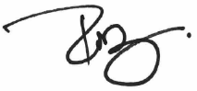

Rob Roys
Procurement Officer
Robert.roys@alaska.gov
^{COMPANY SUBMITTING PROPOSAL}
^{AUTHORIZED SIGNATURE}
^{DATE}

- The following changes/corrections have been made to the RFP:
  - Answers to questions received by close of business on Tuesday, March 31, 2026, have been added as Attachment 10 to the RFP.
  - Sections 4, 5, and 6 have had minor corrections made to match the names of submittal forms across the sections.
<end A03>

