
Employment Committee

Year 5- Work Plan for FFY26
Goal 3 - Employment

People with developmental disabilities will have access to supports, services, programs, and training necessary for successful transitions to adulthood, meaningful work experiences, integrated and competitive employment, as well as career development, across the lifespan.

Objective 1 – Employment First Implementation

People will have information, training, tools, and programs on telework, the state as a model employer, employment rights, and universally designed work environments to increase the percentage of people with developmental disabilities with meaningful, integrated, competitive employment in typical work settings.

Activity | Who | Target Date | Timeline
3.1.1: Work with partners to participate in at least 1 employment activity annually, such as: job fairs, transition fairs, conferences, and/or statewide stakeholder meetings or trainings. GCDSE and partner agencies will host at least 1 activity. Review sign-in sheets / participant lists for attendance count; surveys will measure self-reported increase in knowledge and location in Alaska to gauge reach.  Outcome: More Alaskans will have the opportunity to attend an activity, event, or training to learn more about employment services and agencies  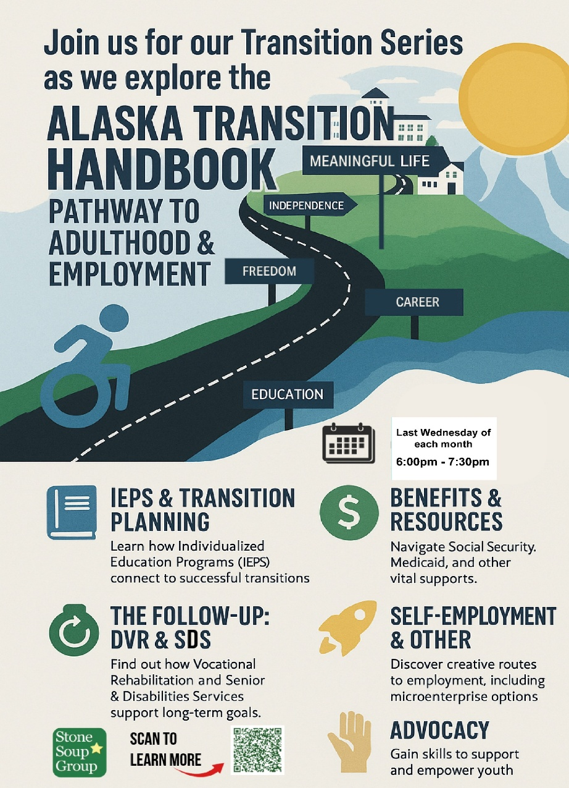  . | GCDSE Staff, Council Members

Progress Updates:
- ASSEC DIF Presentation Feb 3, 2025
- Accepted with SSG and SILC for ASSEC 2026 Presentation
- March 26, 2025 MatSu Employer Expo, over 800 in attendance
- LEND presentation on DIF Programs, March 28, 2025
- Assist Embracing AK Disabilities Expo in AK State Fair, August 2025

3.1.2: Collaborate and continue to support employment activities with key partner agencies (AMHTA, DVR, UAA CHD, DEED, SDS, GCDSE, and others) in at least 1 workgroup, meeting, conference or the like to support the Council’s 5-Year plan through the management and implementation of plan activities to ensure beneficiaries have greater access to employment, related support services, and accurate resources and information on how paid employment impacts Social Security and other benefits (health, housing, food, etc.).  Outcome: Alaskans with DD and their families, employers, and/or support professionals will have information and/or tools necessary to increase the number Alaskans with DD that will be able to secure and maintain integrated employment of their choice. | GCDSE Staff,

Progress Updates:

Continued Workgroup Participation
- Employment Champions (AADD)
- Work Matters Task Force
3.1.3: Microenterprise Grant Review Support employment for Alaska’s DD population by serving on the Microenterprise Grant Committee. Participating in the Microenterprise Grant reviews and discussions with Alaska WIPA Project Director through the UAA, Center for Human Development. Review Microenterprise grant applications, provide input and recommendations on applications no less than 2x per year.  Number of meetings and applications reviewed by GCDSE staff and approved by the committee.  Outcome: More Alaskans with DD will have opportunities for self-employment by receiving funds from the Alaska Mental Health Trust Authority in the form of Microenterprise grants.   | GCDSE Staff,  Council Members

Progress Updates:

17 original applications, 9 made it to review process.
- 4 MI
- 3 DD/MI
- 1 DD
- 1 SA

8 of 9 approved requests

$62,336.13 of $78,328.20 requested funds granted

Spring Application Deadline: Wednesday, March 11, 2026 at 12 p.m.

3.1.4: Serve as Statewide Coordinator for Project SEARCH sites and serve on site steering committees and visiting all sites at least once per year. Provide liaison with Project SEARCH national specialist, reviewing of fidelity requirements, attending at least 1 relevant conference or outreach event, and support current site growth and development. Organize agencies to create or restart at least 2 new sites by 2029.  Outcome: Increase of Project SEARCH program efforts in Alaska and support transition age youth growth in competitive, integrated employment.  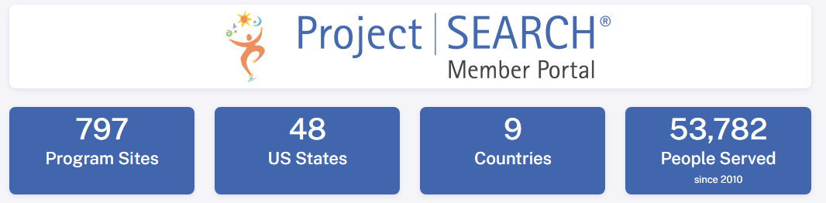 | GCDSE Staff,  Council Members

Progress Updates:

Reporting for 24-25 cohort (note final outcomes not completed til February 2026):
- 2/4 MatSu Employed
- 5/6 (83% Outcome) Fairbanks Employed
- 6/6 Anchorage (100% Outcome) Anchorage Employed

For 25-26 cohort: Currently 8 interns for Providence, 6 for MatSu, 4 for Fairbanks.
- Currently on 1st rotational areas, completing and moving toward 2nd

July 14-18, 2025 Project SEARCH Conference
- 3 attended, and presented ‘Measures of Success Beyond Employment Outcomes’
- Joy Burgess (Alaska PS National Liaison) visit 9/29 – 10/3 to all sites
- Meetings with Anchorage and Juneau areas to facilitate site development, interested host sites and partnerships but challenges in finding instructor for new sites is still in conversation.

3.1.5: Coordinate and promote with partners about employment benefits and incentives to beneficiaries. Increase awareness about available employment support programs and services. Such programs can include ABLE, WIPA, DVR, SDS Waiver Employment Services, Medicaid, etc.  Outcome: Increase knowledge of available supports and services to encourage growth in competitive, integrated employment for all Alaska people with disabilities desiring to work.  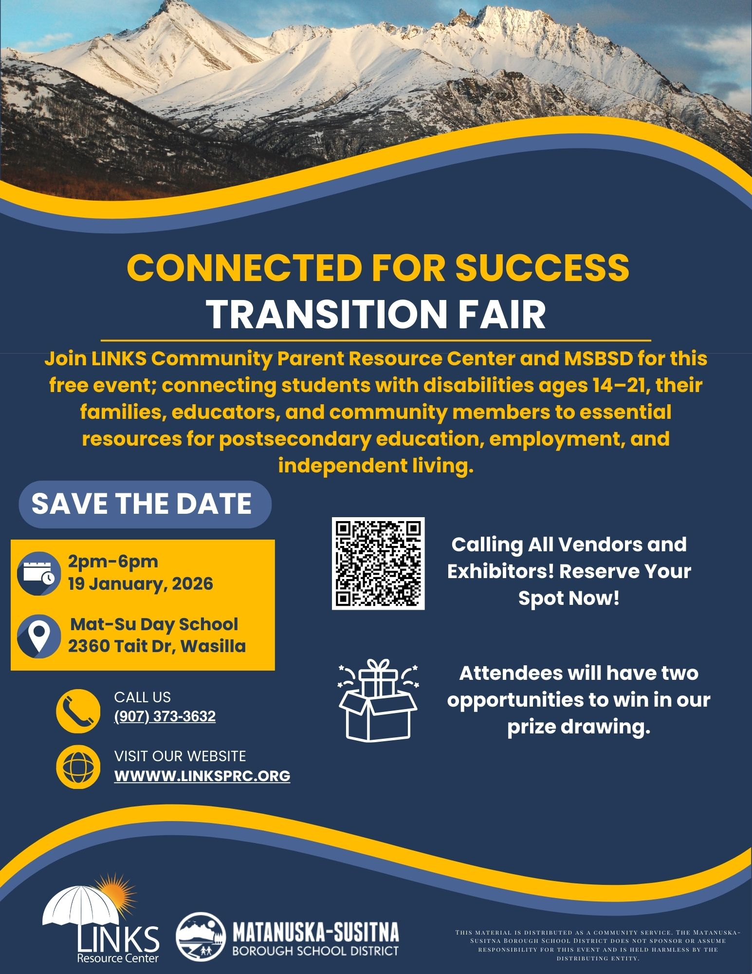 | GCDSE Staff,  Council Members

Progress Updates:
- Full Lives April 2025 Presentation with CHD on DB101/Employment Benefits
- Continued DIF School Outreach Contract work
- NDEAM promotion
  - Submitted with DVR coordination Gov Proclamation ‘Employ People with Disabilities Awareness Week’

Objective 2 – Traditional (Indigenous) Transition

Transition-aged youth (14-22) with developmental disabilities will have increased information, education services, training, and tools that are regionally, culturally, and linguistically relevant to them to increase the number of young adults in rural communities with skills for meaningful, place-based adulthood.

Targeted Disparity: “In collaboration with people with developmental disabilities, their families, and stakeholders, the unequal availability of educational resources for regionally, culturally, and linguistically appropriate transitions to adulthood in the Southwest region of rural Alaska will be decreased through capacity building by curriculum development, outreach, and training.”

[TD Outputs: new units of curriculum developed, outreach to families and professionals, and trainings for teachers and families. Outcomes: Greater availability of educational resources for regionally, culturally, and linguistically appropriate transitions to adulthood in the Southwest region of rural Alaska. Eval/Measurement: In SW AK, increased capacity by number of people trained, copies disseminated, views and downloads on online materials, professionals with knowledge needed to use curriculum, number using the curriculum.]

Activity | Who |  | Target Date |  | Timeline

3.2.1: Support growth of model and outreach efforts to benefiticaries of modified curriculum that is regionally, culturally, and linguistically relevant for rural transitions.

Examples: Support curriculm authors with outreach events and oppertunities, check in on efforts and implimentation on curriculm to schools, identify agencies that could provide efforts to bring curriculm to more areas.

Outcomes: More Alaskans will have access to a more culturally relevant Rural Transition curriculum.

Progress Updates:

Adding curriculum to Stone Soup Group Transitions Series Fall/Winter 2025/26 – CHD heads this as DIF grant activity so we do support outreach efforts.

3.2.2. Collaborate with partners on promotional materials and partner trainings on rural transitions, developing sustainability using the curriculum data and progress being measured with current grant funding outcome measurements.

Examples: Create promotional items for agencies to use when doing employment activities and create awareness of the curriculm. Have curriculm trainings and meetings with partners to increase knowledge of the cultural needs of Alaskas rural areas.

Outcome: More partners will have information for the rural transition curriculm and increased awareness of cultural needs for employment in rural Alaska communities.

Progress Updates:

Somewhat on hold until contract for CHD is in place.

Other work – Peer Power will begin school outreach to schools and creating statewide transitions program information.

3.2.3. Provide at least 1 training or webinar or social media outreach to parents and guardians and school special education staff on availability of curriculum by collaboration with partners  The Council will co-host 1 training or outreach event to parents / guardians on availability of curriculum.  Example: Providing in person event, or webinar, or podcast with curriculm author to parents and special education staff AND general public.  Outcomes: More Alaskan parents will have a greater understanding of the curriculum use. | GCDSE Staff, Council Members

Progress Updates:

Information shared via SSG Transitions Series

Other outreach coordination with CHD; presentation last at ASSEC 2025 from Rain
3.2.4. Promote curriculm and rural employment needs and efforts with appropriate State or National entities.  Example: Promotion of the culturally appropriate needs of rural Alaska in employment, support Tribal vocational Rehabilitation entities serving Native Alaska people with disabilities, using National outreach by presenting at confereces and summits when possible.  Outcomes: Increased advocacy for the needs of American Indian/Alaska Native people with disabilities to policy makers, program developers, and agencies. | GCDSE Staff, Council Members

Progress Updates:

Continued letters of support to federal representatives and comments to regulation (done through GCDSE Chair and EC Chair).

Primary letters of support include reintroduction of TCIEA and ABLE Act.

