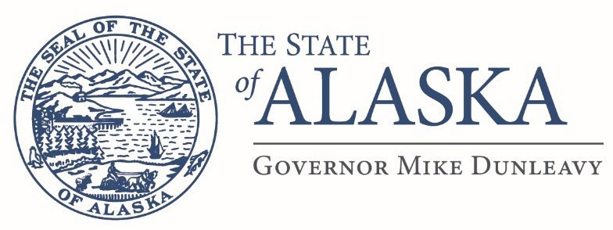

Department of Military and Veterans Affairs
FMO Design and Construction
57024 Roosevelt Rd
PO Box 5169
JBER, AK 99505

Email: scott.stewart@alaska.gov

Issue Date: September 9/16/25
ATTN: Vendors

RE: Project Name: JBER (BAAF) CONCRETE & ASPHALT REPAIR
Project Number: 02A7019051
Project Location: JBER, Alaska

Addendum #2

This addendum forms a part of the contract documents and modifies the original drawings and/or specifications for the subject work. In case of conflicts between this addendum and previously issued documents this addendum shall take precedence.

- Please take note of the areas that have been added to the SOW (see attached map)
- Please take note of the areas that have been removed from the SOW (see attached map)
- 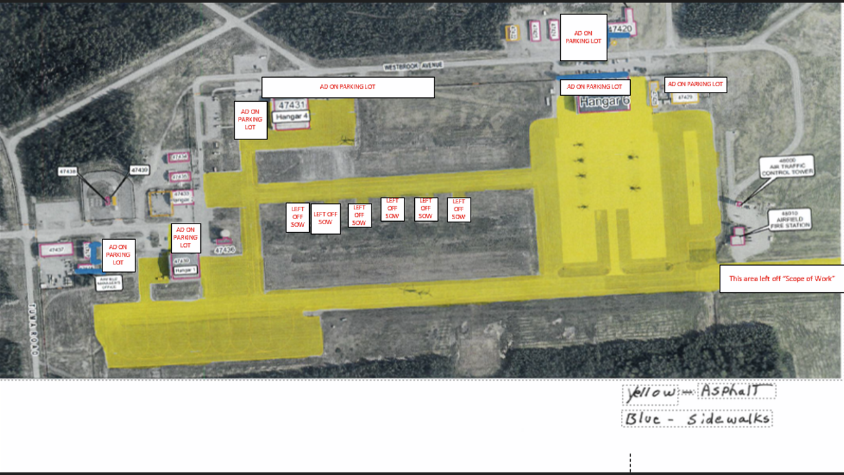

Scott Stewart
Building Management Specialist

