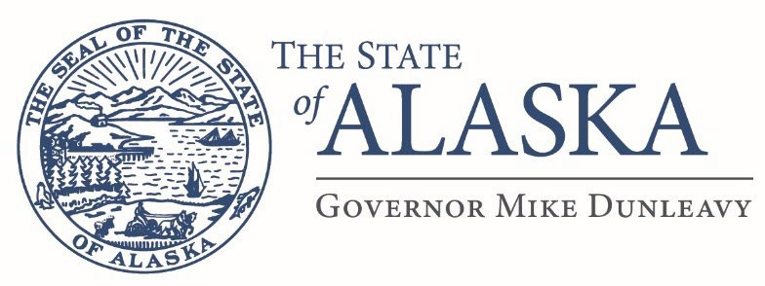

Department of Military and Veterans Affairs
FMO Design and Construction
57024 Roosevelt Rd
PO Box 5169
JBER, AK 99505

Email: scott.stewart@alaska.gov

Issue Date: September 9/11/25
ATTN: Vendors

RE: Project Name: JBER (BAAF) Concrete & Asphalt Repair
Project Number: 02A7019051
Project Location: JBER, Alaska

Addendum # 1

This addendum forms a part of the contract documents and modifies the original drawings and/or specifications for the subject work. In case of conflicts between this addendum and previously issued documents, this addendum shall take precedence.

The pre-bid walk through will be conducted on 9/16/25 @ 10:00am not 10:00pm. We will meet at Hangar #6.

Scott Stewart
Building Management Specialist
Scott.stewart@alaska.gov (907) 428-7198

