Attachment #9 SUBMITTAL FORM G – Cost Proposal
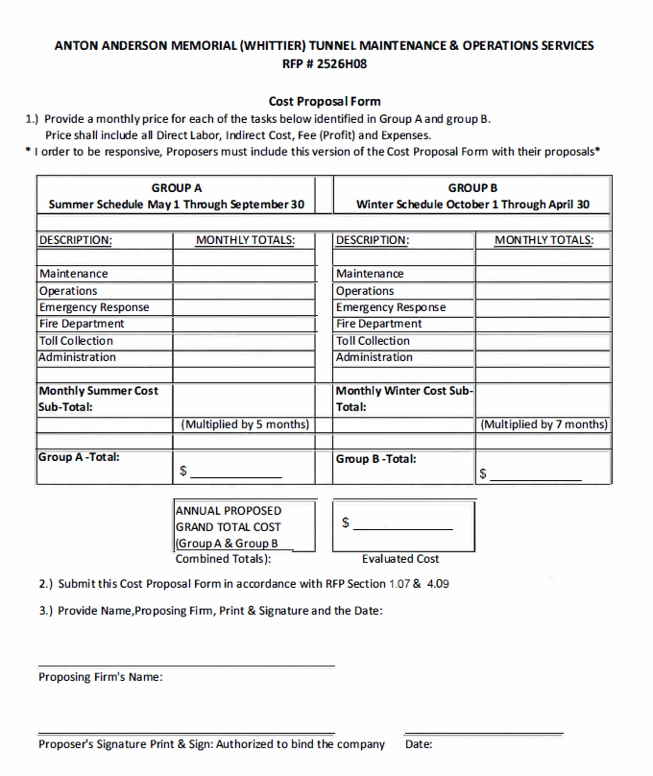
The following proposed rates and costs will not be evaluated for award; however, they will become the established contracted hourly rates for the personnel proposed, and equipment and installation costs.
Offerors must identify the employee, applicable job class, hourly rate and the fully loaded hourly billing rate for each proposed employee, essential for the completion of this project.

The State guarantees no minimum or maximum number of hours.
If additional page(s) are needed to identify each proposed employee, they shall be provided in the format below.
PERSONNEL LIST & FIXED RATES
(All staff proposed for the completion of this project)
Name |  | Job Class |  | Hourly Rate |  | Hourly Billing Rate
__________________ __________________ _____________ ________________
__________________ __________________ _____________ ________________
__________________ __________________ _____________ ________________
__________________ __________________ _____________ ________________
__________________ __________________ _____________ ________________
__________________ __________________ _____________ ________________
__________________ __________________ _____________ ________________
__________________ __________________ _____________ ________________
__________________ __________________ _____________ ________________
__________________ __________________ _____________ ________________
__________________ __________________ _____________ ________________

