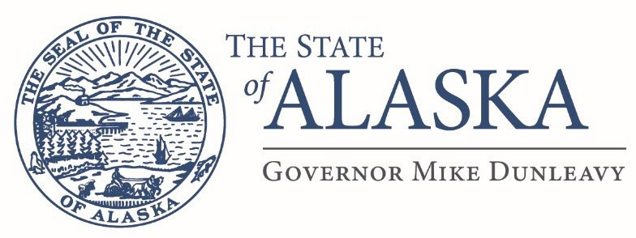

Department of Military and Veterans Affairs
FMO Design and Construction
57024 Roosevelt Rd
PO Box 5169
JBER, AK 99505

Email: scott.stewart@alaska.gov

Issue Date: September 8/20/25
ATTN: Vendors

RE: Project Name: Bethel Hangar Remodel
Project Number: 02A6525003
Project Location: Bethel, Alaska
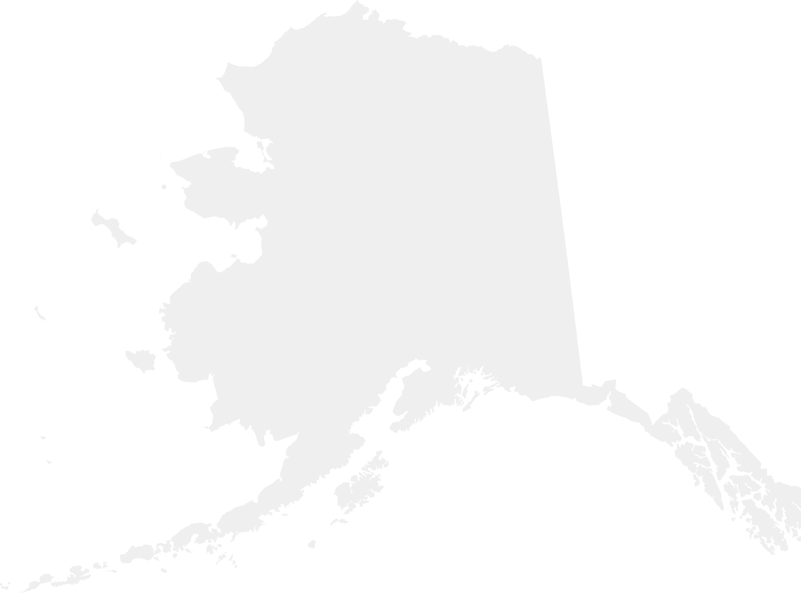
Addendum # 4
This addendum forms a part of the contract documents and modifies the original drawings and/or specifications for the subject work. In case of conflicts between this addendum and previously issued documents, this addendum shall take precedence.

The following questions were asked:

- Are there any specific door hardware requirements? Standard door hardware is required
- Cylindrical lock, mortise case lock, or panic hardware? mortise case lock.
- Are the doors all flush or are vision lite kites required? There are currently no doors installed. The contractor shall supply doors with windows.
- Please confirm that bids can be submitted via email? Yes.
- The ITB states that “when applicable, the contractor must perform a documented hazardous materials survey”. Is hazardous materials testing required on this project? No
- Please indicate on the floor plans which rooms the carpets are being replaced. Just the 3 upstairs offices.
- Please provide a specification on what type of new carpet is being installed. Miliken, color weave (rosetta gem)
- Please provide a finish schedule for the flooring. The contractor shall complete the carpet replacement in the 3 offices at the same time.
- Please provide a specification on the Alt#1 Stairway covering that needs to be replaced. The main entry staircase treadle covering.
- Please indicate on the floor plans which staircase is being replaced. The main entry staircase treadle.
- For the 4000-gal replacement tank, what insulation rating and type is required? Same as or greater than the existing tank.
- Is the foam required to be painted? If so what color? We will not paint the foam.
- What are the inlet and outlet requirements for the Openings? Can we get some kind of size call outs and how many that will help. I would like to know if there is any internal plumbing that needs to be installed during fabrication as well. All requirements for the opening shall be the same as the existing tank, internal plumbing shall be the same as the existing tank.
- For the tank metal are any specific paint or coatings requests? The new tank shall be arctic grade.
- What are the heat trace requirements for the sewage tank? Same as the existing tank.
- Does the Arctic pipe going to the tank need to be replaced as well? No
- Is a pad required for the new installation of the tank? If so, will it be gravel or concrete? Need size and thickness of pad. Yes, the contractor shall determine proper sizing for the new concrete pad.
- Is there is 2’x2’ ceiling grid, is there a specification for the replacement Ceiling tiles? Tiles must match color and texture as the existing tiles.
- It appears the hard lid in the locker room needs to be repainted after water damage, is this a part of the SOW? No
- Will the Owner be moving furnishings/stored material out of the rooms before contract work begins? The contractor shall move all furniture and equipment as well as move it back to it’s original place.
- For the concrete apron repairs – What products are specified for the expansion joint filler and cracks repairs? It is the contractors responsibility to determine proper material to be used.

