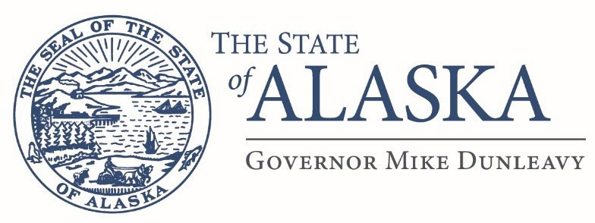

Department of Military and Veterans Affairs
FMO Design and Construction
57024 Roosevelt Rd
PO Box 5169
JBER, AK 99505

Email: scott.stewart@alaska.gov

Issue Date: September 8/20/25
ATTN: Vendors

RE: Project Name: Bethel Hangar Roof Replacement
Project Number: 02A6525004
Project Location: Bethel, Alaska

Addendum # 4
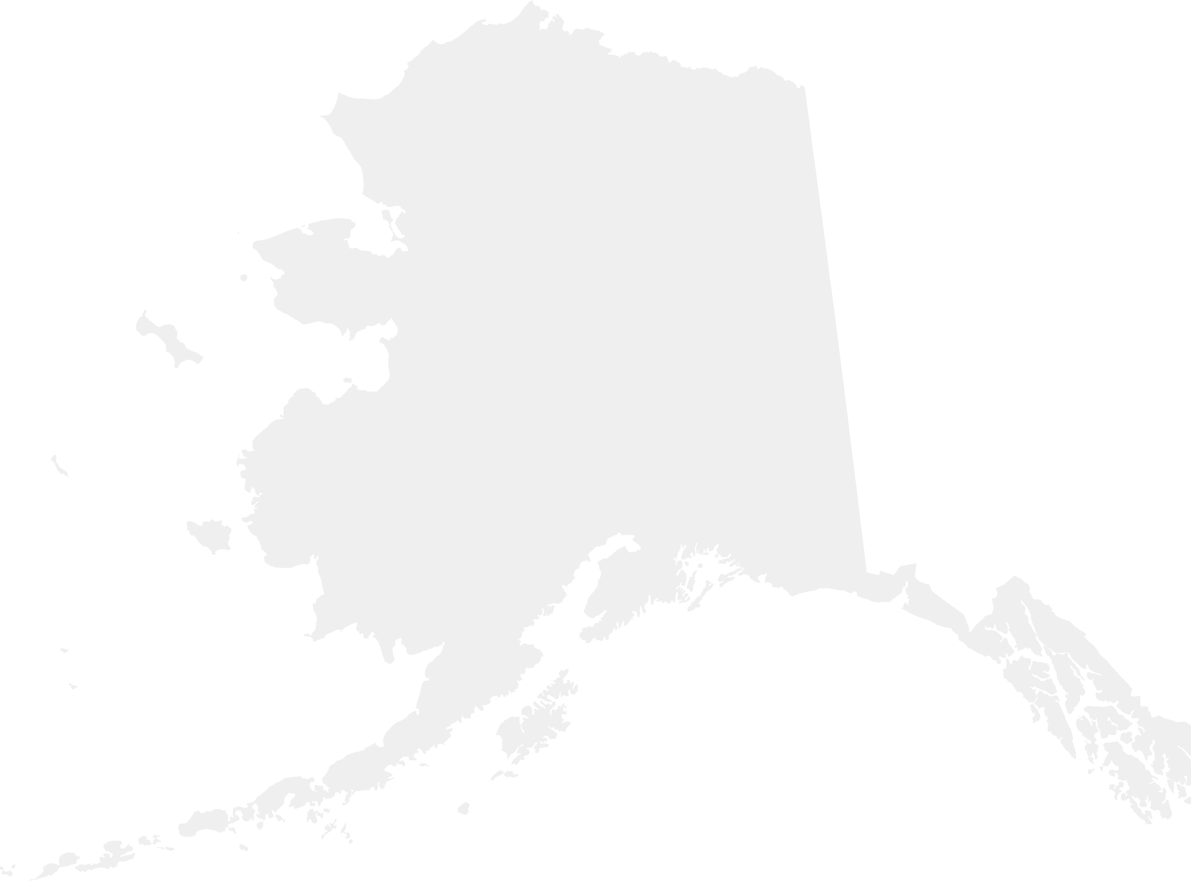
This addendum forms a part of the contract documents and modifies the original drawings and/or specifications for the subject work. In case of conflicts between this addendum and previously issued documents, this addendum shall take precedence.

The following questions were asked:

- Regarding submission of the Bid Bond/Bid Guarantee in relation to electronic bid submission via email. Will a scanned copy of the completed Bid Bond be acceptable when emailing the Bid submission, and then follow up with the original being transmitted if determined offeror is apparent low bidder? Yes, this is acceptable.

- Please reference General Requirements Part 4 – Environmental Requirements. The analysis notes the scope of work “includes removal of existing roofing membrane and installing a brand-new roof membrane….”, further states, “A complete AAOF roof overhaul is beyond the scope of this analysis and would require re-evaluation to satisfy NEPA.” However, General Requirements Part 1, para. 1.02.01: Roof covering replacement, sub paragraph B thru D, specifies that more than just the roofing membrane is to be replaced. Will a re-evaluation be required to satisfy NEPA? We are replacing the roof covering and not the entire roof structure.

- On page 2 of 2 I see information referencing JBER, a Dig Permit, a CGP and a SWPPP. Is this info. relevant to the Hangar Remodel in Bethel? The Bethel project does not require a dig permit.

- Does the contractor need to re-install the bird deflectors on the edge of the roof? Yes, the contractor is responsible for re-installing the bird deflectors and replace any that are damaged.

- Is there more than one (1) roofing system on this roof? No.
- What R-factor do you want installed on this roof? The equivalent or greater “R” factor is required.
- What thickness EPDM rubber membrane do you want? The same thickness as the existing roof covering.
- Do you want a mechanically fastened system on here? Same as existing? Same as existing.
- Will the Contractor have sole discretion in determining the reusability of the existing parapet coping flashings? After the site visit, does the Owner intend to issue a directive regarding their reuse?
10.It is likely that the code requirements for the New Roof will cause the super structure to fall out of code compliance, resulting in a cost increase for the building to be upgraded to meet current building/structural code requirements to support the new roof. Will this cost be covered under a future change order? In the case you describe, yes we would create a change order to cover the additional costs.

1 of 2

- General Requirements 1.02.01 D. Roof Covering Replacement: States "The Contractor shall install a new roof covering, substrate boards, insulation, flashing, trim, fasteners and all associated material needed that meets or exceeds the same standards of quality that the existing roof covering & associated material has." Can you provide us with the type of existing roof covering, substrate boards, insulation with R value, flashing, trim, fasteners and associated materials so that we can meet or exceed the same standards of quality that the existing roof covering & associated material has? The roof covering is EPDM and all the associated parts and pieces are common grade roofing material.
- Construction Documents Part 5 Attachments seem to show Three Roof plans; however, I only see two the roof framing plan, and the structural details. Is there a third roof plan? No
- The photos attached with the bid documents are 6 small thumbnails copied onto a part of a single sheet and of such poor quality that enlarging them just makes it blurry. Is it possible to have the photos formatted so that we can clearly see what is in the photos? Unfortunately, I can not improve the quality of the pictures.
- Will 65%, 95%, and 100% drawings be required? No

Scott Stewart
Building Management Specialist

2 of 2

