Attachment #3 SUBMITTAL FORM A – Offeror Information
Revised March 13, 2024
PROJECT INFORMATION
RFP NUMBER: | 2526H008
PROJECT NAME: | Whittier Tunnel Operations & Maintenance -Federally Funded

OFFEROR INFORMATION
Company Name:
Address:
Tax ID:
Alaska Business License #:

CONTACT INFORMATION
Provide contact information for the individual that can be contacted for clarification regarding this proposal:

Name
Title
Address
Email
Telephone

CRITICAL TEAM MEMBERS
Provide the names of all critical team members that will be assigned to this contract. Note: These individuals cannot be removed or replaced from this project, or their positions, unless approved in writing the project director or procurement officer.

Name of Position 1
Name of Position 2
Name of Position 3
Name of Position 4
Name of Position 5

ADDENDA ACKNOWLEDGEMENT

The offeror acknowledges receipt of the following amendments and has incorporated the requirements of such amendments into their proposal. Failure to identify and sign for all amendments may subject the offeror to disqualification. The offeror must list all amendments (by number), then initial and date to confirm that you have received and incorporated them into your proposal (add more rows as necessary).

Number | Initials & Date |  | Number | Initials & Date |  | Number | Initials & Date
CERTIFICATIONS
No | Criteria | Response*
1 | The offeror is presently engaged in the business of providing the services & work required in this RFP. | True | False
2 | The offeror confirms that it has the financial strength to perform and maintain the services required under this RFP. | True | False
3 | The offeror accepts the terms and conditions set out in the RFP and agrees not to restrict the rights of the state. | True | False
4 | The offeror confirms that they can obtain and maintain all necessary insurance as required on this project. | True | False
5 | The offeror certifies that all services provided under this contract by the contractor and all subcontractors shall be performed in the United States. | True | False
6 | The offeror is not established and headquartered or incorporated and headquartered, in a country recognized as Tier 3 in the most recent United States Department of State’s Trafficking in Persons Report. | True | False
7 | Offeror complies with the American with Disabilities Act of 1990 and the regulations issued thereunder by the federal government. | True | False
8 | Offeror complies with the Equal Employment Opportunity Act and the regulations issued thereunder by the federal government. | True | False
9 | Offeror complies with the applicable portion of the Federal Civil Rights Act of 1964. | True | False
10 | The offeror can provide (if requested) financial records for the organization for the past three years. | True | False
11 | The offeror has not had any contracts terminated by the State of Alaska (within the past five years). | True | False
12 | The offeror certifies that it is not currently debarred, suspended, proposed for debarment, or declared ineligible for award by any public or federal entity. | True | False
13 | The offeror certifies that they will not support or participate in a boycott of Israel. Failure to comply with this requirement may cause the state to reject the proposal as non-responsive or cancel the contract. | True | False
14 | The offeror certifies that they do not have any governmental or regulatory action against their organization that might have a bearing on their ability to provide services to the state. | True | False
15 | The offeror certifies, within the last five years, they have not been convicted or had judgment rendered against them for: fraud, embezzlement, theft, forgery, bribery, falsification or destruction of records, false statements, or tax evasion. | True | False
16 | The offeror does not have any judgments, claims, arbitrations or suits pending/outstanding against your company in which an adverse outcome would be material to the company. | True | False
17 | The offeror is not (now or in the past) been involved in bankruptcy or reorganized proceeding. | True | False
18 | Offeror certifies they comply with the laws of the State of Alaska. | True | False
19 | Offeror confirms their proposal will remain valid and open for at least 90 days. | True | False

* Failure to answer or answering “False” may be grounds for disqualification. For any “False” responses, provide clarification (up to 250 word maximum for each “False” clarification) below (add rows as necessary).
Section | Clarification

CONFLICT OF INTEREST STATEMENT
Indicate below whether or not the firm or any individuals that will work on the contract has a possible conflict of interest (e.g., currently employed by the State of Alaska or formerly employed by the State of Alaska within the past two years) and, if so, the nature of that conflict. The procurement officer reserves the right to consider a proposal non-responsive and reject it or cancel the award if any interest disclosed from any source could either give the appearance of a conflict or cause speculation as to the objectivity services to be provided by the offeror.

Does the offeror, or any individuals that will work on this contract, have a possible conflict of interest? | □ Yes □ No
* Failure to answer may be grounds for disqualification.

If “Yes”, please provide additional information regarding the nature of that conflict:

FEDERAL REQUIREMENTS
Indicate below all known federal requirements that apply to the proposal, proposal evaluation, or contract:

Attachment #4 SUBMITTAL FORM B – Experience and Qualifications
SPECIAL REQUIREMENTS: This Submittal Form must not identify the offeror’s proposed costs and must not exceed five pages (reference RFP section 4.02).

Attachment #5 SUBMITTAL FORM C – Understanding of the Project
SPECIAL REQUIREMENTS: This Submittal Form must not identify the offeror’s proposed costs and must not exceed five pages (reference RFP section 4.02).

Attachment #6 SUBMITTAL FORM D – Methodology Used for the Project
SPECIAL REQUIREMENTS: This Submittal Form must not identify the offeror’s proposed costs and must not exceed five pages (reference RFP section 4.02).

Attachment #7 SUBMITTAL FORM E – Management Plan for the Project
SPECIAL REQUIREMENTS: This Submittal Form must not identify the offeror’s proposed costs and must not exceed five pages (reference RFP section 4.02).

Attachment #8 SUBMITTAL FORM F – Subcontractors

Please complete the form below if using subcontractors. During contract negotiation, the state may require a signed written statement from each subcontractor that clearly verifies the subcontractor is committed to performing the services required by the contract. Prior to contract award, the state will also require evidence that a subcontractor possesses a valid Alaska business license if they will be performing work within Alaska.

Subcontractor Function | Subcontractor Name | Address | % of Work Performing

Attachment #9 SUBMITTAL FORM G – Cost Proposal
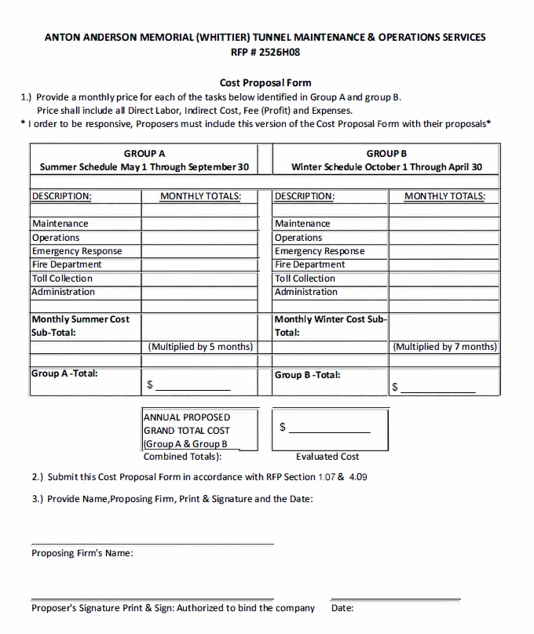
The following proposed rates will not be evaluated for award; however, they will become the established contracted hourly rates for the personnel proposed.
Offerors must identify the employee, applicable job class, hourly rate and the fully loaded hourly billing rate for each proposed employee, essential for the completion of this project.

The State guarantees no minimum or maximum number of hours.
If additional page(s) are needed to identify each proposed employee, they shall be provided in the format below.
PERSONNEL LIST & FIXED RATES
(All staff proposed for the completion of this project)
Name |  | Job Class |  | Hourly Rate |  | Hourly Billing Rate
__________________ __________________ _____________ ________________
__________________ __________________ _____________ ________________
__________________ __________________ _____________ ________________
__________________ __________________ _____________ ________________
__________________ __________________ _____________ ________________
__________________ __________________ _____________ ________________
__________________ __________________ _____________ ________________
__________________ __________________ _____________ ________________
__________________ __________________ _____________ ________________
__________________ __________________ _____________ ________________

