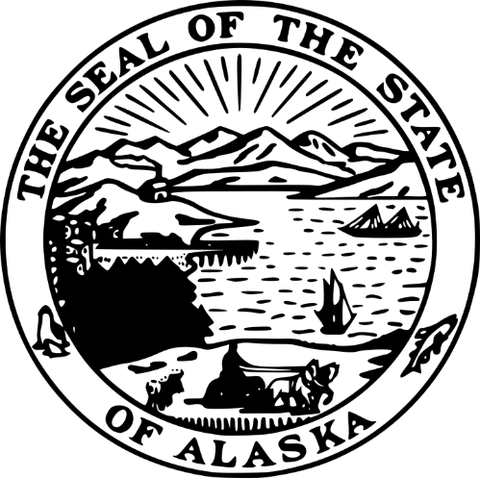
STATE OF ALASKA
DEPARTMENT OF COMMERCE, COMMUNITY, AND ECONOMIC DEVELOPMENT
DIVISION OF ADMINISTRATIVE SERVICES
ALASKA BROADBAND OFFICE
GRANT RECIPIENT NEPA REVIEWER

RFP 250000011
Amendment #05

Issued Tuesday, June 17, 2025
This amendment is being issued to recognize changes to the RFP.
Important Note to Offerors: You must acknowledge this amendment by signing and returning this page of the amendment document with your amended proposal. Failure to do so may result in the rejection of your proposal. Only the RFP terms and conditions referenced in this amendment are being changed. All other terms and conditions of the RFP remain the same.
Rob Roys
Procurement Officer
Robert.roys@alaska.gov
Rob Roys  Procurement Officer  Robert.roys@alaska.gov |  | ^{COMPANY SUBMITTING PROPOSAL}
Rob Roys  Procurement Officer  Robert.roys@alaska.gov |  | ^{AUTHORIZED SIGNATURE}
Rob Roys  Procurement Officer  Robert.roys@alaska.gov |  | ^{DATE}

(Note: numbering continues from Amendment 04 and begins here with F)
- Federal requirements have set the timeline for all reviews to be done between Monday, July 21, 2025, and Friday, August 1, 2025. Because of this, we are making changes to RFP 250000011.
  - The RFP is open again for new or amended proposals under §1.11.
  - To respond to this RFP, prior offerors must send the following to ced.procurement@alaska.gov by 5:00 PM Alaska Time on Wednesday, June 25, 2025:
    - A signed copy of this amendment.
    - Any forms that have been changed because of the new review period.
You don't need to resend forms that haven't changed. Any modified forms will replace the old ones.
Examples:
      - If you only made a change to Submittal Form C, that, and this signed amendment, is all that you need to send.
      - If every form is slightly changed, every form must be resubmitted along with this signed amendment.
      - If nothing is changed all that is required is this signed amendment.
      - If you change one or more forms but want to keep all your submittal forms in one email, you may submit them all again along with this signed amendment.
  - Any offeror may submit a new proposal, even if they didn't submit one before. A new offeror must submit a new proposal that complies with the RFP to ced.procurement@alaska.gov .
  - No previous proposals have been opened or reviewed.
- By submitting this signed amendment, offerors confirm their ability to perform the work required in the RFP between Monday, July 21, 2025, and Friday, August 1, 2025.
- The IRIS VSS posting is no longer the public notice for this RFP. All RFP forms and documents are now on the Alaska Online Public Notice Page at: http://notice.alaska.gov/218725 .
<end A05>

