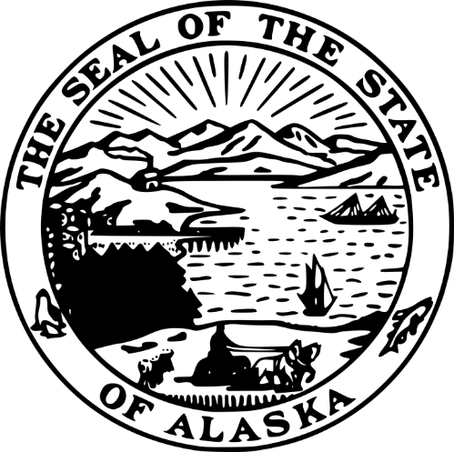
STATE OF ALASKA
DEPARTMENT OF COMMERCE, COMMUNITY, AND ECONOMIC DEVELOPMENT
DIVISION OF ADMINISTRATIVE SERVICES
ALASKA BROADBAND OFFICE
GRANT RECIPIENT NEPA REVIEWER

RFP 250000011

Amendment #03

Thursday, March 20, 2025
This amendment is being issued to recognize changes to the RFP.

OFFERORS ARE NOT REQUIRED TO RETURN THIS FORM

Rob Roys
Procurement Officer
Phone: (907) 465-2519
Email: robert.roys@alaska.gov

(Note: numbering below continues from Amendment 02 and thus starts with C)
- The proposal conference was held. The official Q&A is provided in attachment 09 to the RFP. A recording of the conference may be downloaded until approximately 16:00 on March 31, 2025, from AKZendTo at:
https://drop.state.ak.us/drop/pickup.php?claimID=aakEonstRRMooRvT&claimPasscode=pw2nHYZkyRBYweek Z
Claim ID: aakEonstRRMooRvT
Claim Passcode: pw2nHYZkyRBYweek
Offerors wishing to receive a copy of the conference after 16:00 on March 31, 2025, will need to contact the Procurement Officer.
<end A03>

