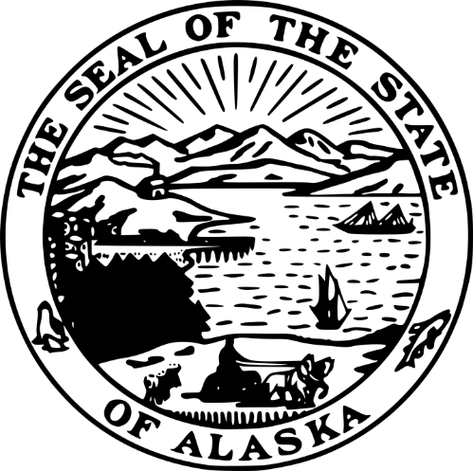
STATE OF ALASKA
DEPARTMENT OF COMMERCE, COMMUNITY, AND ECONOMIC DEVELOPMENT
DIVISION OF ADMINISTRATIVE SERVICES
ALASKA BROADBAND OFFICE
GRANT RECIPIENT NEPA REVIEWER

RFP 250000011
Amendment #02

Issued Wednesday, March 19, 2025
This amendment is being issued to recognize changes to the RFP.
Important Note to Offerors: You must acknowledge this amendment by signing and returning this page of the amendment document with your amended proposal. Failure to do so may result in the rejection of your proposal. Only the RFP terms and conditions referenced in this amendment are being changed. All other terms and conditions of the RFP remain the same.
Rob Roys
Procurement Officer
Robert.roys@alaska.gov
Rob Roys  Procurement Officer  Robert.roys@alaska.gov |  | ^{COMPANY SUBMITTING PROPOSAL}
Rob Roys  Procurement Officer  Robert.roys@alaska.gov |  | ^{AUTHORIZED SIGNATURE}
Rob Roys  Procurement Officer  Robert.roys@alaska.gov |  | ^{DATE}

(Note: numbering continues from Amendment 01 and begins here with B)
- The following revisions or corrections have been made to the RFP:
  - In §1.04 and §1.12 the deadline for receipt of proposals has been changed to 16:00 on Monday, March 31, 2025.
  - Item 10 has been added to §5.01 to allow for multiple awards in case of conflicts with the highest scoring offeror.
  - Submittal Form RFP 250000011 A07 FORM F replaced with RFP 250000011 A07 FORM F vA02.
  - Attachment 09 RFP 250000011 A09 QUESTIONS AND ANSWERS has been added and listed in §7.01.
<end A02>

