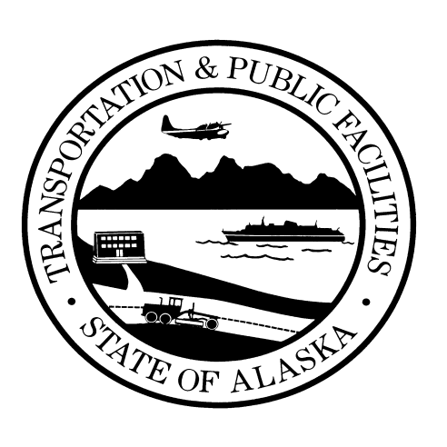
Notice of
Public Meeting

Alaska Department of

Transportation &

Public Facilities

Ted Stevens International Airport Part 150 Noise Compatibility Study

Project No. CFAPT01221 / AIP 3-02-0016-236-2024

The Ted Stevens Anchorage International Airport (ANC) is conducting a Part 150 Airport Noise Compatibility Study to identify and evaluate current and future noise effects associated with aircraft operations at ANC. The goal of the study is to reduce the number of people affected by aircraft noise.

ANC will hold a project open house on May 20, 2025 from 5:00 – 7:00 pm at the Spenard Recreation Center. Stop by to learn about the study purpose and process, share your thoughts, and ask questions of the study team. Anyone is welcome.

Project Kick Off Open House

Tuesday, May 20, 2025

5:00 – 7:00 pm
Spenard Recreation Center
2020 W. 48th Avenue, Anchorage, AK 99517

Comments or questions can be submitted during the meeting in person or online via the project website. Visit the website for additional study events, news, and information here: ANC150NoiseStudy.com

Persons with a hearing impairment can contact DOT&PF at our Telephone Device for the Deaf (TDD), 907-269-0473. We are also able to offer, upon request, Alaska Native language translation.

