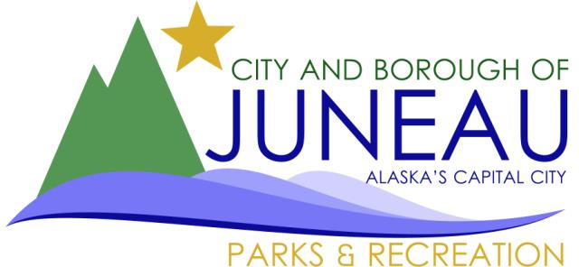

RECREATIONAL TRAILS GRANT APPLICATION
PUBLIC NOTICE

Project Title: 35-Mile ORV Riding Park (Phase II)
Organization Name: City & Borough of Juneau, Parks & Recreation Dept.
Date Notice Posted: September 30, 2024

Brief Description of Proposed Project:
The CBJ Parks & Recreation Dept. is continuing construction of an Off-Road Vehicle (ORV) riding park at Mile 35 Glacier Hwy. The parking lot, stormwater BMP structures, site furnishings, and initial clearing of Phase I trails was completed in 2024. This public notice is for a Recreational Trails Program grant to continue development of the facility's trail system, as described in the project's Conditional Use Permit (USE2022 015).

Proposed Timeline of the Project:
Project Start Date: April 1, 2025
Project End Date: November 1, 2025

Applicant Contact Information:
Contact Name: George Schaaf
Phone Number: 907-586-5226
Email Address: george.schaaf@juneau.gov
Mailing Address: CBJ Parks & Recreation Dept.
155 Heritage Way
Juneau, AK 99801

Public Comment or Opposition can be submitted via methods listed below:
Phone Number: 907-586-5226
Email Address: Parks.Rec@juneau.gov
Mailing Address: CBJ Parks & Recreation Dept.
155 Heritage Way
Juneau, AK 99801

Deadline for Public Comment: October 30, 2024

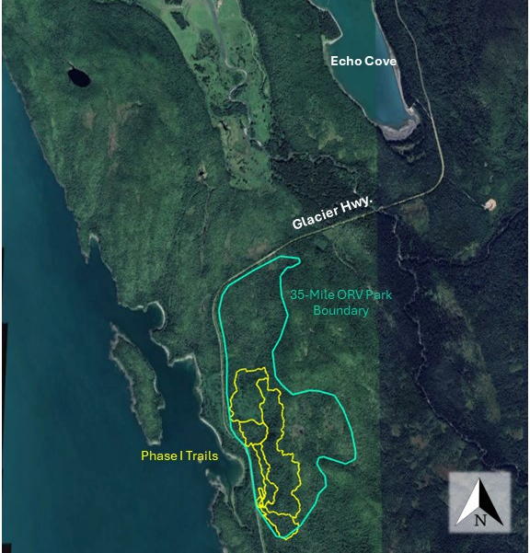

The Alaska Recreational Trails Program is the possible funding agency for this proposed project. For information regarding the Alaska Recreational Trails Program, please visit the State website at http://dnr.alaska.gov/parks/grants/trails.htm.

