Alaska Department of Public Safety (DPS) JAG 2024 Grant Application Proposal Narrative

Description of the Issue:

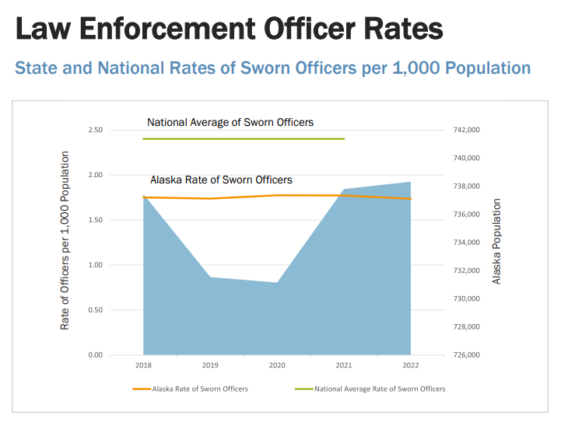
Alaska experiences one violent crime every hour, one assault every two hours, one property crime every 39 minutes, one burglary every four hours, one murder every five days, one larceny every 55 minutes, one rape every eight hours, one vehicle theft every four hours, one robbery every 15 hours, and one arson every one day. In 2022, there were a total of 5,650 violent crimes: murder (70), rape (1,049), robbery (555), and aggravated assault (3,976). Aggravated assault accounted for 20.8% of all crimes. In 2022, there were a total of 13,423 property crimes: arson (211), motor vehicle theft (1,802), burglary (2,001), and larceny-theft (9,409). Larceny-theft accounted for 70.1% of all property crimes. In 2022, Alaska's overall reported crime rate decreased by 1.4%, the violent crime rate increased by 1.8%, and the property crime rate decreased by 2.7%. The murder rate increased 67.0% from 2021 to 2022¹.
¹ https://dps.alaska.gov/getmedia/143c5db6-6206-4fd8-b45e-7a0cbb7f611e/Crime-in-Alaska-2022

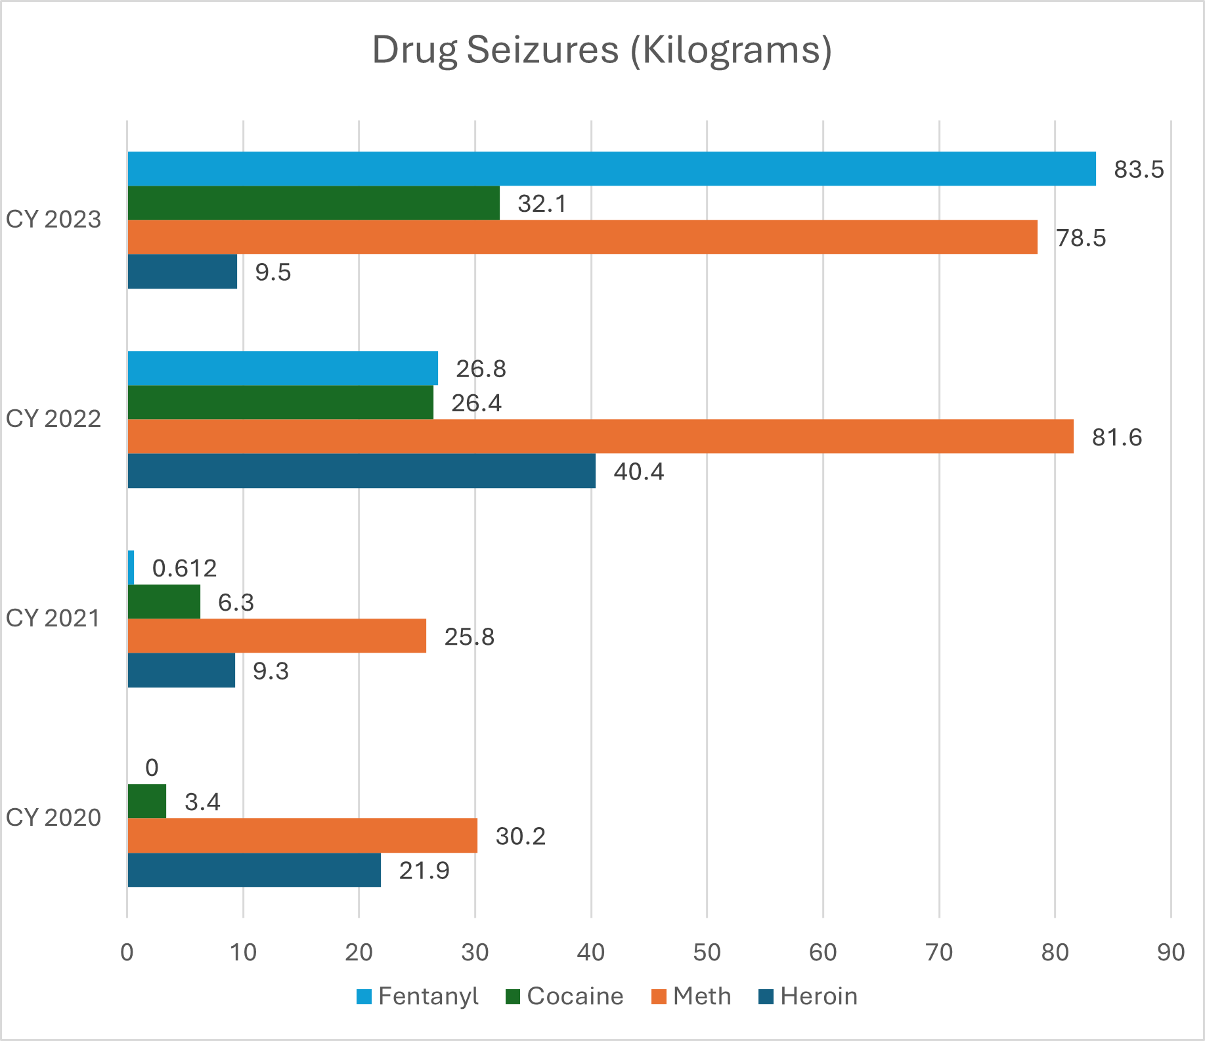
Alaska remains an attractive marketplace for drug trafficking organizations (DTOs) due to its remote location, high demand for illicit substances, and limited law enforcement resources. DTOs utilize several similar methods of transportation to import and distribute cocaine, methamphetamine, and opioids into and throughout Alaska. The most common transportation methods are by air and parcel, followed by road, ferry, and boat. Due to Alaska's geography, there does not appear to be a difference in transportation methods by drug type. The high rate of return for drug and alcohol traffickers greatly incentivizes supply into and throughout Alaska. Illegal drugs are predominantly
imported and then distributed throughout the state. Alaska is not known to produce illicit drugs. Illegal alcohol, however, is purchased in the hub cities or other legal locations and then distributed to local option communities. ²
Unorganized individuals continue to import illegal alcoholic beverages into one of the 108 local-option communities in Alaska that either: ban the sale of alcohol, sale by specific type of license only, sale by municipality operated license only, ban sale and importation, or ban the sale, importation, and possession of alcohol³.

² Seizure data provided by the Alaska State Trooper Statewide Drug Enforcement Unit monthly reports
³ Department of Commerce, Community, and Economic Development. Alcohol & Marijuana Control Office.
Current list of local option communities – 10/15/2020. Accessed January 15, 2021.

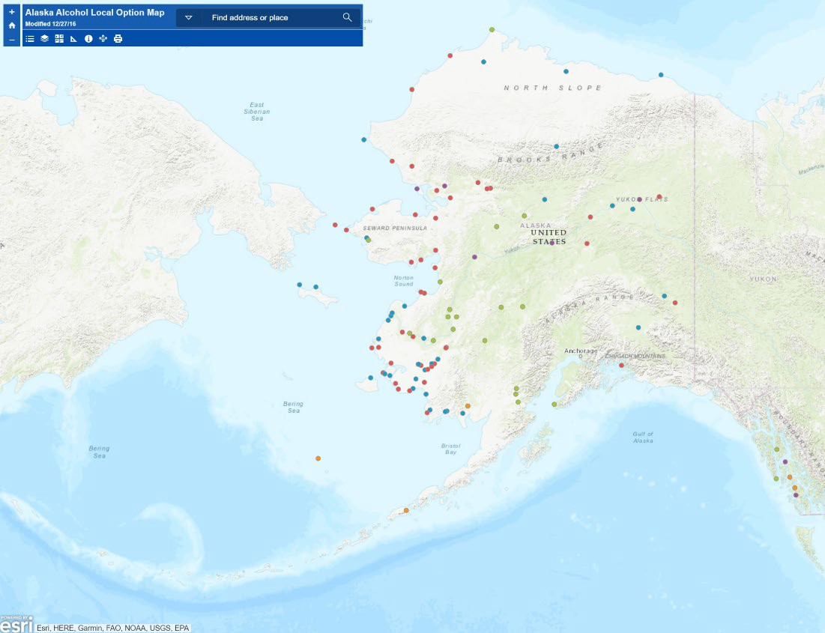
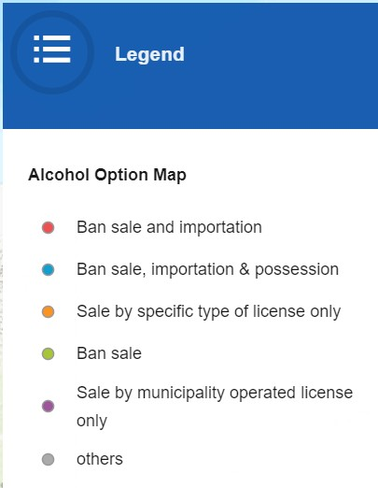
Alaska Alcohol Local Option Map⁴

DPS recognizes that the state is a desirable drug market due to the exponentially higher retail prices for drugs in the state, especially in remote areas. DPS also acknowledges the strong correlation between drug and alcohol use and sexual assault, and domestic violence in Alaska. "In 2018, combined estimated direct costs of substance-use disorders – borne by state and local governments, employers, and residents of Alaska – totaled $3.4 billion. Approximately $2.39 billion (69% of total costs) were due to alcohol misuse; the remaining $1.06 billion (31%) were associated with drug misuse. The majority of these costs (a total of 71%) are linked to health care ($1.3 billion) and productivity losses ($1.1 billion)".

⁴ Department of Commerce, Community, and Economic Development. Alcohol & Marijuana Control Office.
Current Map of local option communities. https://dcced.maps.arcgis.com/apps/View/index.html?appid=938423a38ebb48dbbd393ca8fc402251Access ed January 15, 2021.

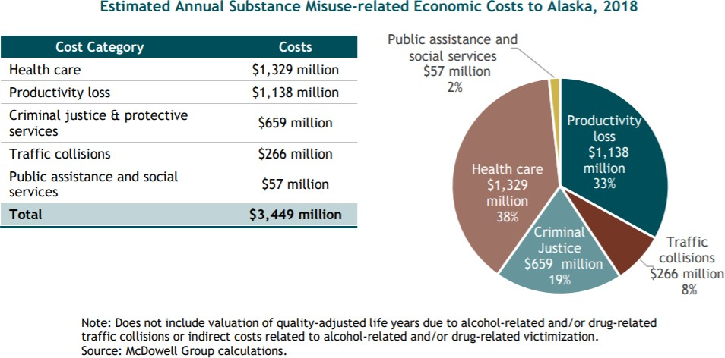
5

Alaska is unusual because it does not share a border with any other state in the U.S. Seattle is the closest major city to Anchorage – Alaska's largest city – and it is roughly 1,500 miles away. Alaska is geographically the largest and the most sparsely populated state in the nation. Alaska encompasses 663,300 square miles, with 33,904 miles of shoreline; the total population is 733,406. There are 343 population centers on record in Alaska: 260 (78.5%) have 1,000 people or less; seven have populations over 10,000; only Anchorage (with 286,075 people) has a population over 35,000. There are also 204 officially recognized native villages in Alaska.
Alaska's ports of entry (POE) are Alcan, Anchorage, Dalton Cache, Fairbanks, Juneau, Ketchikan, Kodiak, Nome, Sitka, Skagway, Valdez, and Wrangell – not all are currently staffed⁶. The U.S.-Canadian border is 3,987 miles long excluding Alaska and the US-Mexican border is 1,933 miles long; the Alaska-Canada border is 1,538 miles long. Alaska has 6,640 miles of general coastline and, including islands, has 33,904 miles of shoreline⁷. "There are five main border

⁵ McDowell Group (January 2020). Summary of the Economic Costs of Substance Use Disorders in Alaska 2019 Update. [PDF].
⁶ U.S. Customs and Border Protection. Locate a Port of Entry in Alaska. Accessed June 9, 2020 https://www.cbp.gov/contact/ports/AK.
⁷ https://www.alaska-demographics.com/cities_by_population Accessed September 10, 2024.

crossings between Alaska and Canada: on the Alaska Highway south of Tok; the Top of the World Highway, east of Chicken; and three in the Southeast, at Pleasant Camp, British Columbia, east of Haines; at Fraser, B.C. between Skagway and Whitehorse; and between Hyder and Stewart, B.C.⁸"
Air cargo/passenger services are the most important mode of transportation in Alaska due to a lack of road systems and year-round marine access to over 80 percent of all communities in Alaska. Additionally, 82 percent of Alaska communities are not accessible by road, and 251 are accessed exclusively by air, which leads to Alaska having six times as many pilots per capita and 16 times as many aircraft per capita compared to the rest of the United States. For aircraft with 40 passengers or less, the passengers and cargo are not subject to the Department of Homeland Security (DHS) Transportation Security Administration screening. Since a significant amount of travel to and from Alaskan communities occurs on small airplanes, there is a considerable need for interdiction efforts. According to the Federal Highway Administration, Alaska has only 31,618 lane miles of road. This places Alaska nearly last out of the 50 states and Washington, D.C. in terms of the number of roadways.
Geography plays an important role in preventing and reducing crime and recidivism. Alaska's geography is a significant factor in the state's violent crime rates and is the most significant barrier to collecting data and developing evidence-based approaches. DPS is not present in every village across the state. Weather, resource allocation, and time to fly, snowmachine, boat, or drive to a crime scene greatly affect the department's ability to preserve scenes and gather evidence.

⁸ Resneck, Jacob (March 19, 2020). As Canada closes the border, unanswered questions from Alaskans pile up.
Accessed June 9, 2020, https://www.alaskapublic.org/2020/03/19/alaskans-seek-answers-as-canada-closes- border-to-non-essential-travel/.

Identify the state's strategy/funding priorities for the F.Y. 2024 JAG funds

DPS is applying for this grant to support local law enforcement agencies throughout Alaska to participate in multi-jurisdictional drug task forces. These positions will be part of the Alaska State Troopers' Statewide Drug Enforcement Unit (SDEU) which is also attached to the Alaska HIDTA program. As part of the Alaska HIDTA, these agencies will play a significant role in the interdiction of illegal substances being transported to smaller Alaskan communities.
DPS will inform all local law enforcement agencies of the award and will solicit funding applications for allowable expenditures. With more robust outreach, DPS feels the local agency participation will increase this year.
DPS will use funding to support three (3) DPS long term non-permanent investigators to work with drug interdiction teams to interdict illegal drugs that are being trafficked in Alaska.
DPS will use funding to build/place premanufactured storage containers to be used as secure storage for seized drug evidence at DPS facilities.
Subgrant award process and timeline

Subawards are made competitively using a Request for Proposal process. The Notice of request for proposals is posted publicly and sent to local police departments via email. Subaward applications are reviewed for minimum responsiveness, then scored using a ranked rubric. Subawardees who received prior fiscal year awards and are in good standing receive priority scoring. Subawards are usually made to local government above and beyond the required pass through amount. In recent years, subawards have also been made available to other state agencies housing Airport Police using funds that would otherwise be used by the department directly. Subaward proposal requests are typically posted in the second year of the prime award. Subawards must align with the state goals and objectives, as set by the 5 Year Strategic Plan.

Progress or Challenges

SDEU remains steadfast in its commitment to the Alaska HIDTA program and focuses on better coordination, cooperation, efficiency, and effectiveness. Following the state's judicial district boundaries, the SDEU teams align with the Alaska HIDTA enforcement initiatives. The Alaska HIDTA program was designated on May 1, 2018, and the Alaska HIDTA executive board authorized funding and the creation of initiatives on October 1, 2018.
As part of the Alaska HIDTA program, the local law enforcement agencies have better access, partnerships, communication, efficiency, and effectiveness. These agencies are an integral part of the success of the Alaska HIDTA enforcement initiatives within Alaska for drug enforcement and impact.

Description of the programs to be funded over the 4-year grant period

The pass-through funds provide local law enforcement agencies the ability to participate in SDEU task forces to investigate drug trafficking. By design, SDEU task forces are also HIDTA initiatives and thus allow local agencies to receive HIDTA funding. These funds would allow the law enforcement agencies to continue disrupting and dismantling drug trafficking organizations intending to import and/or distribute drugs in Alaska.
DPS will use funding to support three (3) DPS long term non-permanent investigators to work with drug interdiction teams to interdict illegal drugs that are being trafficked in Alaska.
DPS will use funding to build/place premanufactured storage containers to be used as secure storage for seized drug evidence at DPS facilities.
Project Design and Implementation

DPS engages stakeholders across the justice continuum and uses their input to inform priorities. Local law enforcement agencies participating in an Alaska HIDTA initiative are surveyed yearly to help determine the drug threat. State and local planning efforts are coordinated through SDEU, which are Alaska HIDTA initiatives and teams.
DPS's drug task forces and three of the Alaska HIDTA enforcement initiatives are one in the same. Thus, to address drug trafficking and money laundering in the state, most local law enforcement agencies, the state law enforcement agency, and all federal agencies are commingled and collocated. The Alaska HIDTA program consists of 12 local law enforcement agencies, four state agencies, and eight federal agencies. The program also consists of four enforcement initiatives, three of which build upon DPS's SDEU task forces. This assembly allows for stakeholder input at an unprecedented level to address resource allocation, improvements to the administration of the criminal justice system, and the coordination of JAG funds.
One of the two goals of the HIDTA program is to improve the efficiency and effectiveness of the program, which is attained through information sharing, deconfliction, and active participation. Coordination challenges are active participation and recognizing all involved participants.

The only stakeholders for this grant application are the local agencies that apply for these funds through DPS. DPS is the main participant in the strategic planning process, identifying the gaps in the state's needed resources for criminal justice purposes, plans to improve the administration of the criminal justice system, and how JAG funds will be coordinated with state and related justice funds. A survey of stakeholders was completed in early 2021. The foundation of utilizing JAG funding for drug interdiction remains the priority to have the most significant impact on our communities as Alaska sees an increase in fentanyl, fentanyl seizures, and fentanyl and other opioid overdoses.

FFY2023 through September 9
Fentanyl | 92387.62 | grams | 92.39 | kilograms
Heroin | 14256.53 | grams | 14.26 | kilograms
Methamphetamine | 87633.58 | grams | 87.63 | kilograms
Cocaine | 35896.33 | grams | 35.90 | kilograms
FFY2022
Fentanyl | 45541.74 | grams | 45.54 | kilograms
Heroin | 10891.35 | grams | 10.89 | kilograms
Methamphetamine | 51702.15 | grams | 51.70 | kilograms
Cocaine | 20066.23 | grams | 20.07 | kilograms

Capabilities and Competencies

DPS develops and maintains the Alaska Public Safety Information Network (APSIN), which tracks arrests, criminal histories, warrants, missing persons, stolen property, and other

information for law enforcement purposes. APSIN also provides access to Alaska motor vehicle and driver license data, connects to the FBI's National Crime Information Center, and to other states through the National Law Enforcement Telecommunications System. DPS will utilize APSIN and the Alaska Records Management System (ARMS) for gathering data and developing and using evidence-based and evidence-gathering approaches in support of JAG funding. Additionally, DPS' records management system (RMS) data is fed into LexisNexis Accurint Virtual Crime Center, a database available to law enforcement throughout the country. DPS signed a five-year agreement with LexisNexis to solicit local law enforcement agencies throughout the state to join and pay for their AVCC subscription through 2023⁹. This agreement will be renewed next year and will help address the barrier of incompatible RMS's used throughout the state by various law enforcement agencies.

Plan for Collecting the Data Required for this Solicitation's Performance Measures

DPS understands that F.Y. 2024 JAG Program funding is designed to provide states with additional personnel, equipment, supplies, contractual support, training, technical assistance, and information systems for criminal justice. DPS also recognizes that this funding is designed to assist units of local government with respect to their criminal justice needs.
Following JAG funding guidelines, DPS will submit the required performance data demonstrating the results of the work carried out under the award.

⁹ Accurint Virtual Crime Center (AVCC) is a linking technology that will automatically link people found in RMS data, calls for service data, license plate reader data, offender databases, and many other databases found in law enforcement agencies. AVCC's policing platform for COMPSTAT, analytics, crime analysis, and investigations helps law enforcement agencies obtain actionable insights from big data. AVCC links billions of public records to agency-provided data in a cross-jurisdictional information exchange to provide law enforcement with unprecedented visibility into crime in their own jurisdiction and around the country.

