ADDITIONAL REGULATIONS NOTICE INFORMATION
(AS 44.62.190(d))

1. Adopting agency: Department of Environmental Conservation
2. General subject of regulation: DEC is proposing to reclassify protected uses for several waters on LaTouche Island, Prince William Sound that have been impacted by historic mining activities. Rio Tinto (property owner) has demonstrated these waters are incapable of meeting protected uses due to poor water quality and should be reclassified under 18 AAC 230.
3. Citation of regulation (may be grouped): 18 AAC 230(e)
4. Department of Law file number, if any:202400175
5. Reason for the proposed action:
( X ) compliance with federal law
( ) compliance with new or changed state statute
( ) compliance with court order
( ) development of program standards
( X ) other: (please list) Formal rulemaking is required to reclassify waters in accordance with 18 AAC 70.230
6. Appropriation/Allocation: Water Division, Water Quality Standards Program

7. Cost of implementation to the state agency and available funding (in thousands of dollars): N/A

Initial Year Subsequent
FY 25 Years
Operating Cost $__0___ $___0____
Capital Cost $_0_____ $___0____

1002 Federal receipts $__0_____ $__0____
1003 General fund match $__0_____ $__0____
1004 General fund $__0_____ $___0____
1005 General fund/
program $__0____ $___0____
1037 General fund/
mental health $__0_____ $___0____
Other $__0_____ $__0_____

8. The name of the contact person for the regulations:
Name Brock Tabor
Title EPS IV____________
Address ADEC. State Office Building. Juneau, Alaska
Telephone 907.957.3586
E-mail address: Brock.Tabor@alaska.gov

9. The origin of the proposed action:

_____ staff of state agency
_____ federal government
_____ general public
____x_ petition for regulation change
_____ other (please list)______________________________________________________

10. Date: 10/03/24_____ Prepared by: 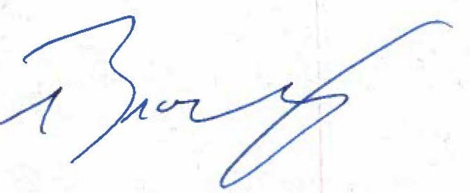 _
[signature]
Name (printed) _Brock Tabor_____
Title (printed) _EPS IV________________
Telephone: _907.465.5185__

