RETURN THIS AMENDMENT TO THE ISSUING OFFICE AT:

Department of Family and Community Services
Procurement Officer patricia.hull@alaska.gov

1

THIS IS NOT AN ORDER DATE AMENDMENT ISSUED: 02/14/2024

ITB OPENING DATE AND TIME: 02/23/2024 at 2pm Alaska Time
ITB TITLE: ITB Patient Clothing & Linens for Alaska Psychiatric Institute

The following changes are required:

- The solicitation was misnamed in the initial posting to reference 2024-2600-0285 rather than 2024-2600-0235 the correct ITB Number. This amendment corrects the naming error on the posting and any affected attachments to the ITB.

- This amendment also posts Attachment B, a draft of the contract that will result from this procurement which was omitted from the original posting.

NOTE TO BIDDERS: Bidders are required to sign and return this page with their bid or prior to the bid deadline date.

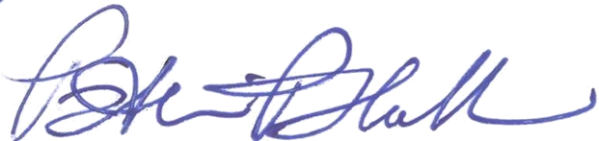
Patricia Hull, Procurement Officer
Patricia.Hull@alaska.gov
PHONE: (907) 465-3610
TDD: (800) 478-7778

NAME OF COMPANY

SIGNATURE DATE

FOR STATE USE ONLY - THIS AMENDMENT COVERS PR# 2326081

