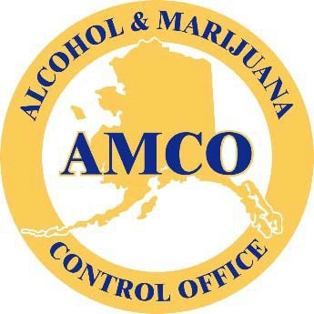

Alcohol and Marijuana Control Office

CURRENT MARIJUANA LICENSING PROCESS

Marijuana Control

Overview:

The following is a detailed list and examples of the current state of the many processes involved in obtaining a new Marijuana license and the process of renewal of a marijuana license. These are provided to help potential database design or for proposal candidates see how the current systems work and to use the information to provide solutions which eliminate inefficiencies and automate many processes which as currently produced by hand.

Marijuana Licensing Specific Forms/Processes:

The following are the specific forms and processes used by AMCO to facilitate the Marijuana Licensing, including, but not limited to, New license Applications, Renewal Forms, and License Transfers. Each of these forms and associated processes will need to be incorporated and automated in any online database portal solution.

Marijuana License Application Process (New license applications)

Overview:

The following types of new Marijuana license applications, include, but not limited to:

- Standard Marijuana Cultivation Facilities
- Limited Marijuana Cultivation Facilities
- Marijuana Product Manufacturing Facilities
- Marijuana Concentrate Manufacturing Facilities
- Marijuana Testing Facilities
- Marijuana Retails Stores
- Onsite Consumption Endorsements

NOTE: A new marijuana license and handler permit application is initiated online using the State of Alaska online system. This is a flat database and is used to gather the initial application information, including, but not limited to State of Alaska Division of Corporations, Business and Professional Licensing business license verifications.

Marijuana License Application Diagram Flowchart

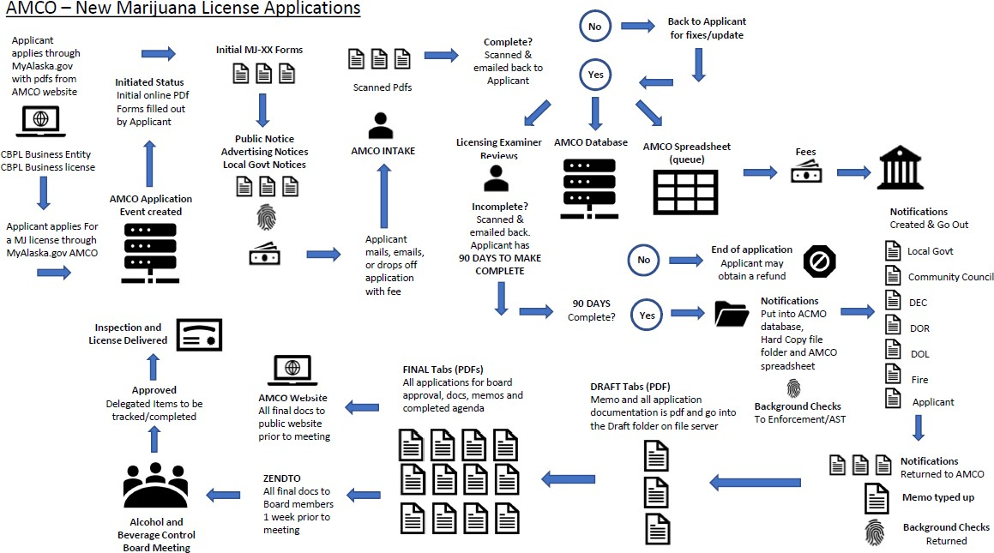

Supplemental Application Documents

Standard Marijuana Cultivation Facilities Application Forms
Applications for a Standard Marijuana Cultivation Facility (more than 500 plants) requires the following additional forms for submittal and review:

Form MJ-00 Application Certifications
Form MJ-01 Operating Plan
Form MJ-02 Premises Diagram
Form MJ-04 Marijuana Cultivation Facility
Form MJ-07 Public Notice Posting Affidavit
Form MJ-08 Local Government Notice Affidavit
Publishers Affidavit
Form MJ-09 Statement of Financial Interest
Proof of Possession for Proposed Premises
Entity Documents

Fingerprint Cards

Limited Marijuana Cultivation Facilities Application Forms
Applications for a Limited Marijuana Cultivation Facility (less than 500 plants) requires the following forms for submittal and review:

Form MJ-00 Application Certifications
Form MJ-01 Operating Plan
Form MJ-02 Premises Diagram
Form MJ-04 Marijuana Cultivation Facility
Form MJ-07 Public Notice Posting Affidavit
Form MJ-08 Local Government Notice Affidavit
Publishers Affidavit
Form MJ-09 Statement of Financial Interest
Proof of Possession for Proposed Premises
Entity Documents
Fingerprint Cards

Marijuana Product Manufacturing Facilities
Applications for a Marijuana Product Manufacturing Facility requires the following forms for submittal and review:

Form MJ-00 Application Certifications
Form MJ-01 Operating Plan
Form MJ-02 Premises Diagram
Form MJ-05 Marijuana Product Manufacturing Facility
Form MJ-07 Public Notice Posting Affidavit
Form MJ-08 Local Government Notice Affidavit

Publishers Affidavit
Form MJ-09 Statement of Financial Interest
Proof of Possession for Proposed Premises
Food Safety Permit
Fingerprint Cards

Marijuana Concentrate Manufacturing Facilities
Applications for a Marijuana Concentrate Manufacturing Facility requires the following forms for submittal and review:

Form MJ-00 Application Certifications
Form MJ-01 Operating Plan
Form MJ-02 Premises Diagram
Form MJ-05 Marijuana Product Manufacturing Facility
Form MJ-07 Public Notice Posting Affidavit
Form MJ-08 Local Government Notice Affidavit
Publishers Affidavit
Form MJ-09 Statement of Financial Interest
Proof of Possession for Proposed Premises
Food Safety Permit
Fingerprint Cards

Marijuana Testing Facilities
Applications for a Marijuana Testing Facility requires the following forms for submittal and review:

Form MJ-00 Application Certifications
Form MJ-01 Operating Plan

Form MJ-02 Premises Diagram
Form MJ-06 Marijuana Testing Facility
Form MJ-07 Public Notice Posting Affidavit
Form MJ-08 Local Government Notice Affidavit
Publishers Affidavit
Form MJ-09 Statement of Financial Interest
Proof of Possession for Proposed Premises
Fingerprint Cards

Marijuana Retail Facilities

Applications for a Marijuana Retail Facility requires the following forms for submittal and review:

Form MJ-00 Application Certifications
Form MJ-01 Operating Plan
Form MJ-02 Premises Diagram
Form MJ-03 Retail Marijuana Store
Form MJ-07 Public Notice Posting Affidavit
Form MJ-08 Local Government Notice Affidavit
Publishers Affidavit
Form MJ-09 Statement of Financial Interest
Proof of Possession for Proposed Premises
Food Safety Permit
Fingerprint Cards

Onsite Consumption Endorsement

Applications for an Onsite Consumption Endorsement requires the following forms for submittal and review:
Form MJ-28a Onsite Consumption Endorsement Application Checklist

Form MJ-28b Onsite Consumption Endorsement Operating Plan Supplemental
Diagram
Form MJ-02 Premises Diagram (as applicable)
Form MJ-14 Licensed Premises Diagram Change (as applicable)
Form MJ-07a Onsite Consumption Endorsement Public Notice Posting Affidavit
Form MJ-08a Onsite Consumption Endorsement Local Government Notice Affidavit
Publishers Affidavit

Additionally, the following forms and documents should be submitted as applicable.

Item
Form MJ-07b Onsite Consumption Endorsement Mailed Notice Affidavit
Proof of Possession for Consumption Area

Marijuana License Renewal Forms

When notified of a pending license renewal, marijuana renewal license applications normally occur online through the State of Alaska MyAlaska portal. Paper applications can be filled out and presented using the MJ-20 Renewal Application and, if applicable, the MJ-20a residence exception affidavit. These forms are generally available online during the renewal period and will be made available upon request.

Miscellaneous Forms

The following as additional miscellaneous forms needed for various marijuana related licenses.

- Form MJ-10 Marijuana Handler's Course Provider Application
- Form MJ-12 Petition
- Form MJ-13 Marijuana Business Name Change
- Form MJ-14 Licensed Premises Diagram Change
- Form MJ-15 Operating Plan Change
- Form MJ-15c Operating Plan Change - Emergency Regulations
- Form MJ-15d Previously Approved Edible Product THC Limit Change
- Form MJ-16 Proposed New Marijuana Product

- Form MJ-17 Ownership Change
- Form MJ-26 Quality Control Report
- Form MJ-22a Request to Retest
- Form MJ-22b Request to Transfer Failed Material
- Form MJ-25 Marijuana Waste Disposal
- Form MJ-27 Marijuana from Unlicensed Source

Conversion Forms

The following as additional miscellaneous forms needed for various Conversion Applications. All items on Conversion Application Checklist (MJ-29a) must be completed and submitted to the Alcohol & Marijuana Control Office.

Form MJ-07c Public Notice Posting Affidavit
Form MJ-08b Local Government Notice Affidavit
Form MJ-24b Newspaper or Radio Notice
Form MJ-29a Application Checklist
Form MJ-29b Conversion Application
Form MJ-29c Operating Plan Change

Transfer Forms

The following as additional miscellaneous forms needed for license transfer applications.

Form MJ-17b Transfer Application Checklist
Form MJ-17c License Transfer Application
Form MJ-17d Unaltered Operating Plan and Premises Diagram Affidavit
Form MJ-19 Creditors Affidavit
Form MJ-24 Newspaper or Radio Notice Template
Fingerprint Cards

Marijuana Fees/Payments

Purpose:

Marijuana Licensing fees are predetermined and are posted on the AMCO website.

Application and Admin Fees | Fee Amount
New Application Fee | $1000
Transfer Application Fee | $1000
Renewal Application Fee | $600
Fingerprint Fee | $48.25 (per person)
Business Name Change Fee (MJ-13) | $250
Licensed Premises Diagram Change Fee (MJ-14) | $250
Operating Plan Change Fee (MJ-15) | $250
Proposed New Marijuana Product Fee (MJ-16) | $250 (per product)
Ownership Change Fee (MJ-17) | $250
Conversion Application Fee | $1000
Onsite Consumption Endorsement Application Fee | $1000
Onsite Consumption Endorsement Fee | $2000
License Type |  | Fee Amount
Standard Marijuana Cultivation Facilities |  | $5,000

License Type | Fee Amount
Limited Marijuana Cultivation Facilities | $1,000
Marijuana Product Manufacturing Facilities | $5,000
Marijuana Concentrate Manufacturing Facilities | $1,000
Marijuana Testing Facilities | $1,000
Retail Marijuana Store | $5,000
Renewal Fees | Fee Amount
Limited Marijuana Cultivation Facilities | $1,400
Marijuana Concentrate Manufacturing Facilities | $2,000
Marijuana Testing Facilities | $5,000
Standard Marijuana Cultivation Facilities | $7,000
Marijuana Product Manufacturing Facilities | $7,000
Retail Marijuana Store | $7,000

