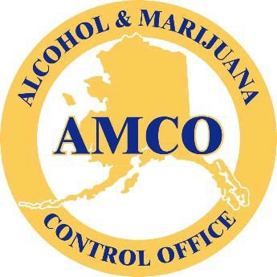

Alcohol and Marijuana Control Office

CURRENT ALCOHOLIC BEVERAGE LICENSING PROCESS

Alcohol Beverage Control

Overview:

The following is a detailed list and examples of the current state of the many processes involved in obtaining a new alcohol license and the process of renewal of an alcohol license. These are provided to help potential database design or for proposal candidates see how the current systems work and to use the information to provide solutions which eliminate inefficiencies and automate many processes which as currently produced by hand.

Alcohol Licensing Specific Forms/Processes:

The following are the specific forms and processes used by AMCO to facilitate the Alcohol Licensing, including, but not limited to, New license Applications, Renewal Forms, License Transfers, and Permits. Each of these forms and associated processes will need to be incorporated and automated in any online database portal solution.

Alcohol License Application Process (New license applications)

Overview:

The following forms are utilized for new alcohol license applications

Form AB-00 New License Application
Form AB-02 Premises Diagram
Form AB-03 Restaurant Designation Permit Application
Form AB-07 Public Notice Posting Affidavit
Form AB-08a Authorization of Records Rel
Form AB-09 Statement of Financial Interest
Advertising Format

Attached below and via link is a copy of the processes currently use to accept, examine, and approve new Alcohol License applications.

Alcohol License Application Diagram Flowchart

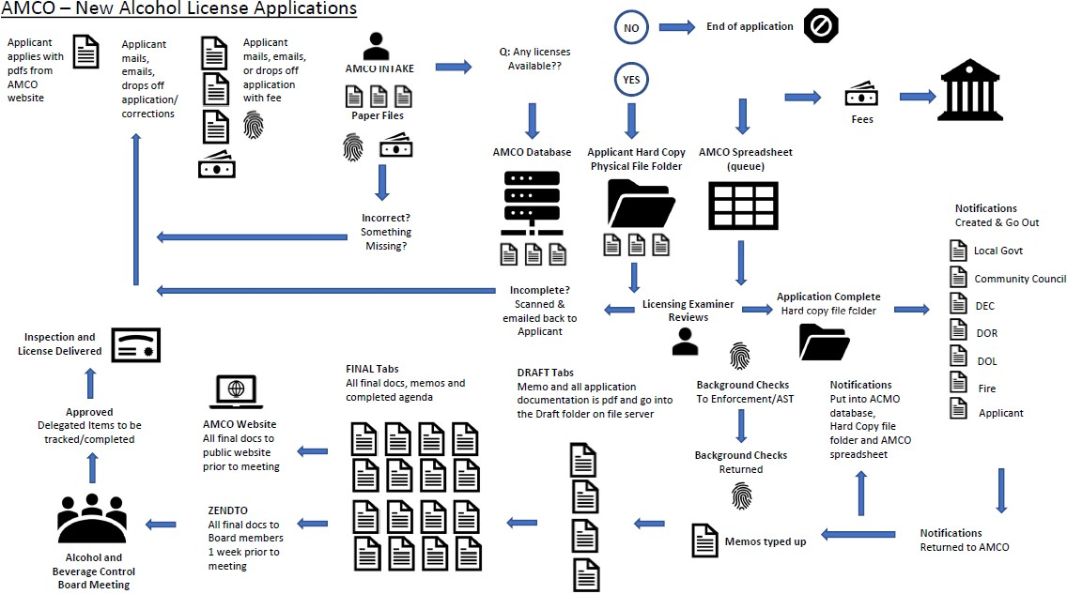

Alcohol License Renewal Process

Overview:

Existing Alcohol licensees must renew their licenses every two years. The license pool is split, and each half of licensees renews on alternating years.

The following forms are utilized for Alcohol license renewals.

Form AB-17 General Renewal Application
Form AB-17 Package Store Renewal Application
Form AB-25 Supplier Certification for Wholesalers
Wholesale Supplier Fee Schedule
Tourism Statement Form for BDL-Tourism
Recreational Site Statement
Form AB-33 Restaurant Receipts Affidavit for REPL
Form AB-31 Credit Card Payment Form

The following is a copy of the processes currently use to accept, examine, and approve Alcohol License renewals.

Alcohol License Renewal Diagram Flowchart
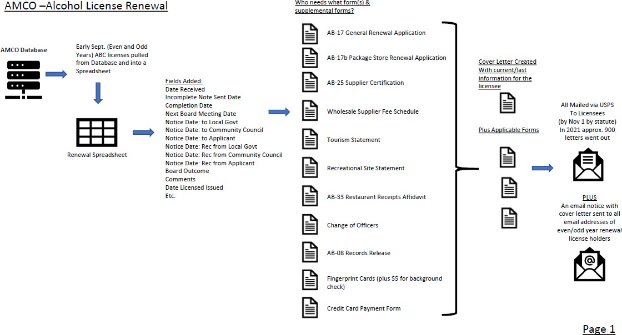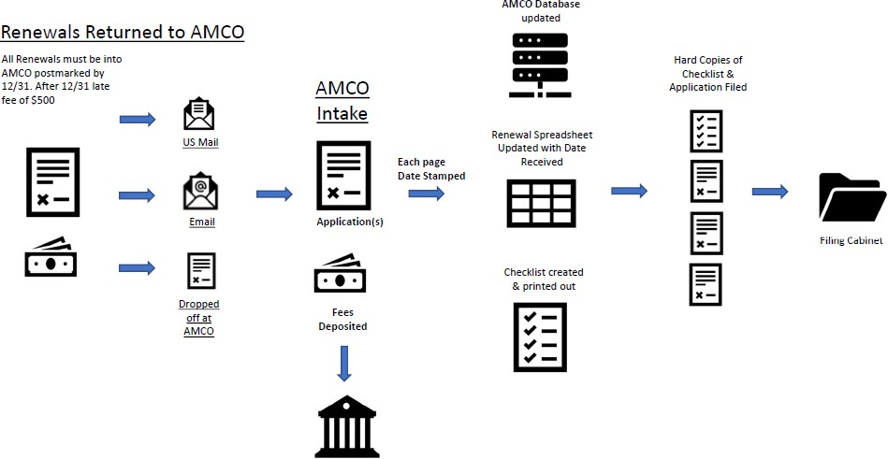

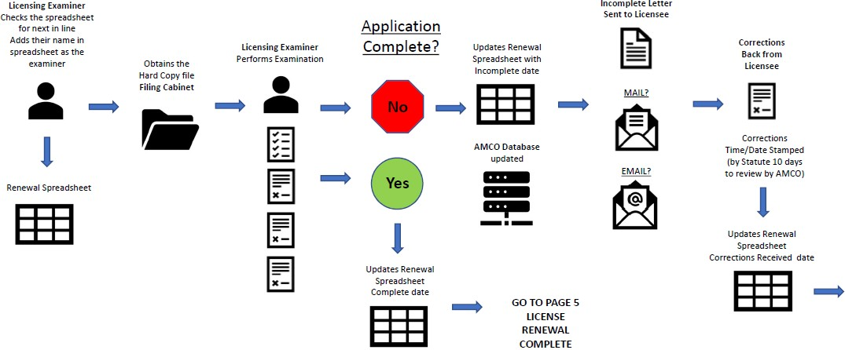
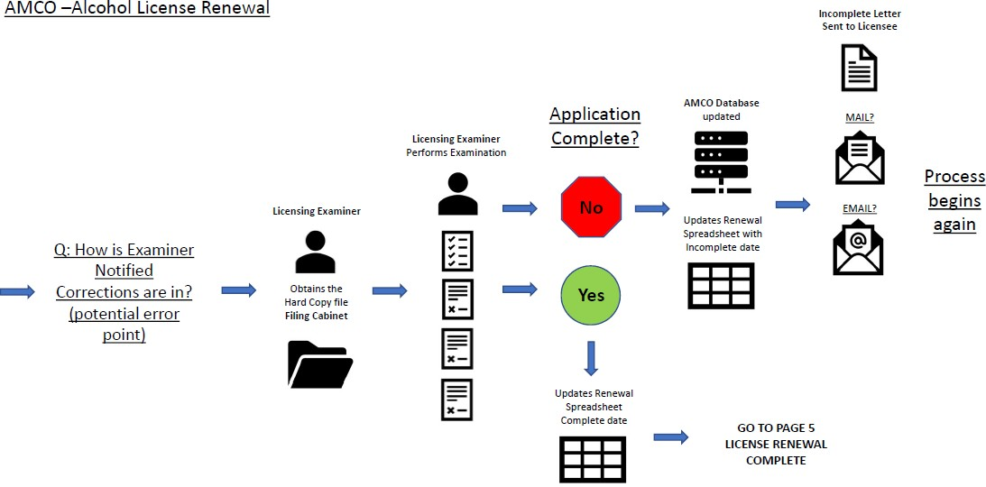

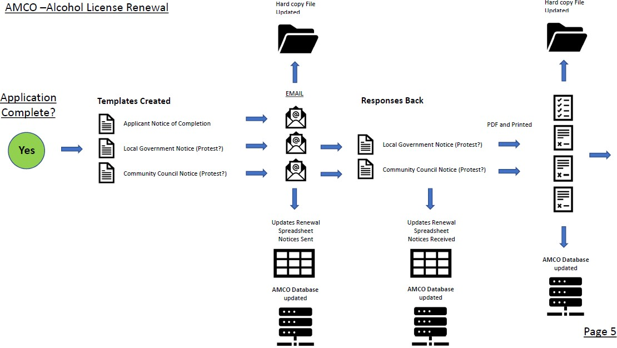
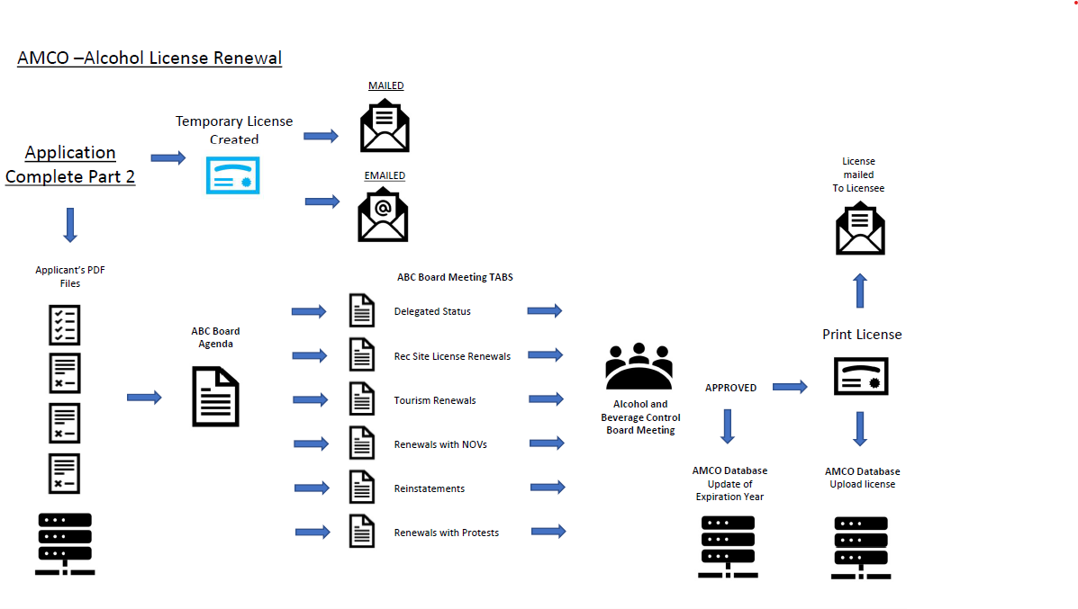

Alcohol License Transfer Application Process

Overview:

The following forms are utilized for Alcohol license transfer requests.

Form AB-01 Transfer License Application
Form AB-02 Premises Diagram
Form AB-03 Restaurant Designation Permit
Form AB-07 Public Notice Posting Affidavit
Form AB-08a Authorization of Records Release
Form AB-09 Statement of Financial Interest
Form AB-11 Creditors Affidavit
Advertising Format

Alcohol Permit Application Process

Permits for Liquor License Holders:

Permits allow for several different type of special events, all of which are designed as having a specific occasion and with a short, and defined lifespan.

Caterer’s Permit Application

Eligible License Type: Beverage Dispensary
Event Requirements: Must be a specific event.

Application
Form AB-04 Caterer's Permit Application

Restaurant Caterer’s Dinner Permit Application

Eligible License Type: Restaurant/Eating Place
Event Requirements: Must be a banquet or dinner event.

Application
Form AB-06 Restaurant Caterer's Dinner Permit Application

Club License Permit Application

Eligible License Type: Club
Event Requirements: Must be a specific event held off of the licensed premise.

Application
Form AB-20 Club License Caterer's Permit Application

Art Exhibit Permits

Eligible License Types: Restaurant/Eating Place or Beverage Dispensary
Event Requirements: Must be an art exhibit event at an art gallery, art studio, art store, art dealer, or museum.

Applications
Form AB-21 Art Exhibit Permit Application
Form AB-22 Multiple Event or Location Art Exhibit Permit Application

Entertainment Time Extension

Eligible License Types: Restaurant/Eating Place

Application
Form AB-18 Entertainment Time Extension Application

Special Events Permit

Eligible Entities: A nonprofit fraternal, civic, or patriotic organization, active for a period of at least two years before application and incorporated under AS 10.20.
Event Requirements: Must be a specific occasion.

Application
Form AB-05 Special Events Permit Application

For-Profit Permit Applications:

Wine Auction Permit

Eligible Entities: A nonprofit fraternal, civic, or patriotic organization, active for a period of at least two years before application and incorporated under AS 10.20.
Event Requirements: Must be a specific occasion.

Application
Form AB-23 Wine Auction Permit Application

Miscellaneous Alcohol Forms

Purpose:

The following miscellaneous forms are designed to illicit specific information depending on the type of license and what process they must follow for completion of their application.

Form AB-12 Petition
Form AB-13 Business Name Change
Form AB-14 License Premises Diagram Change and Instructions
Form AB-25 Supplier Certification
Form AB-29 Waiver Application
Form AB-30 Proof of Minimum Operation Checklist
Form AB-31 Credit Card Payment Form
Form AB-32 Request for Removal from Restricted Purchaser List
Form AB-34 Alternating Premises Request

Form AB-35 Seasonal Alternating Premises Request
Wholesaler Fees Affidavit
Tourism Statement Guidelines
Recreational Site Statement Guidelines
Entertainment Time Extension Request

Mandatory Alcohol Server Courses and Providers

Purpose:

The Alcohol and Beverage Control Board oversees the training materials used by approved and licensed course providers.

Mandatory Alcohol Server Course Providers

Persons and entities seeking to have an alcohol server education course must be approved by the Alcoholic Beverage Control Board under AS 04.21.025 and 3 AAC 304.465 and make application for a license to provide such education.

Form AB-10 Alcohol Server Education Course Provider Application

Mandatory Alcohol Server Training

All servers of alcoholic beverages, their supervisors and persons providing security in licensed businesses must receive approved alcohol server training within thirty days of employment. Each server, supervisor or security person must renew their server training certification every three years. Persons may enroll in any one of the following approved courses by contacting the approved vendors on the AMCO website.

Alcohol Fees Payments

Purpose:

Alcohol Licensing fees are predetermined and are posted on the AMCO website.

Application and Admin Fees | Fee Amount
New Application Fee | $500
Transfer Application Fee | $500
Renewal Application Fee | $300
Fingerprint Fee | $48.25 (per person)
Restaurant Designation Fee | $50
Business Name Change Fee (AB-13) | $250
Licensed Premises Diagram Change Fee (AB-14) | $250
Seasonal Alternating Premises Request (AB-35) | $250
Late Application Fee | $1000
Reinstatement Fee | $1000

License Type | Year-Round Fee | Seasonal Fee
Beverage Dispensary | $2,500 | $1,250
Brewery | $1,000 | $500
Brewpub | $500 | $250
Bottling Works | $500 | $250
Club | $1,200 | $600

Common Carrier- Vessel | $1,000 | $500
Common Carrier- Community | $2,000 | $1,000
Destination Resort | $1,250 | $625
Distillery | $1,000 | $500
Golf Course | $400 | $200
Outdoor Recreation Lodge | $1,250 | $625
Package Store | $1,500 | $750
Pub | $800 | $400
Recreational Site | $800 | $400
Restaurant Eating Place | $600 | $300
Theatre | $600 | $300
Wholesale- General | $2,000 | $1,000
Wholesale- Malt Beverage and Wine | $400 | $200
Winery | $500 | $250
New Server Education Course | $800
Updates to Existing Server Education Courses | $250

Fees Are Updated under the Title 4 Rewrite as follows:

Application and Admin Fees | Fee Amounts Set by Regulation and Subject to Review
New Application Fee | $500
Transfer Application Fee | $500
Renewal Application Fee | $300
Fingerprint Fee | $48.25 (per person)
Business Name Change Fee (AB-13) | $250
Licensed Premises Diagram Change Fee (AB-14) | $250
Seasonal Alternating Premises Request (AB-35) | $250
Late Application Fee | $1000
Reinstatement Fee | $1000

License Type | Biennial Fee | Applicable Endorsement Biennial Fees | Applicable Permit Fees to be set by regulation
Brewery Manufacturer | $1,250 | Sampling -- $200  Repackaging (if other license types held) -- $200 | Inventory Resale
Winery Manufacturer | $1,000 |  | Inventory Resale
Distillery Manufacturer | $1,250 |  | Inventory Resale
General Wholesale | $2,000 plus annual fee based on volume of sales |  | Inventory Resale
Limited Wholesale Brewed Beverage and Wine | $400 plus annual fee based on volume of sales |  | Inventory Resale
Beverage Dispensary | $2,500 | Multiple Fixed --$200  Hotel/Motel -- $200  Large Resort -- $200  Restaurant -- $200  Bowling -- $200 | Caterer  Art Exhibit  Inventory Resale
Beverage Dispensary Tourism | $2,500 | Multiple Fixed --$200  Hotel/Motel -- $200  Large Resort -- $200  Restaurant -- $200  Bowling -- $200  Golf Course –$200 | Caterer  Art Exhibit  Inventory Resale
Restaurant or Eating Place | $1,250 |  | Caterer  Art Exhibit  Music Festival  Inventory Resale
Seasonal Restaurant or Eating Place Tourism | $1,250 |  | Caterer  Art Exhibit  Inventory Resale

License Type | Biennial Fee
Manufacturer Direct Shipment | $200
Package Store | $1,500 | Shipping -- $200  Delivery -- $200  Repackaging -- $200  Sampling -- $200 | Tasting Event  Inventory Resale
Pub (college or university) | $1,250 |  | Inventory Resale
Theater | $1,250 |  | Inventory Resale
Common Carrier Dispensary | $1000 for each of the first 10 licenses, $100 for each additional – For airlines each aircraft as above or $2,000 for each community served |  | Inventory Resale
Sporting Activity or Event | $1,250 | Restaurant -- $200 | Inventory Resale
Club | $1,500 | Restaurant -- $200 | Caterer  Inventory Resale
Outdoor Recreation Lodge | $2,500 | Restaurant -- $200 | Inventory Resale
Fair | $1,250 | Restaurant -- $200 | Inventory Resale
Golf Course | $1,250 | Restaurant -- $200 | Inventory Resale
Destination Resort | $2,500 | Restaurant -- $200 | Inventory Resale
Brewery Retail | $1,250 |  | Inventory Resale  Live Music or Entertainment
Winery Retail | $1,000 |  | Inventory Resale  Live Music or Entertainment
Distillery Retail | $1,250 |  | Inventory Resale  Live Music or Entertainment
Common Carrier Approval | No statutorily listed fees
Nonprofit Permits |  |  | Nonprofit Organization Permit
Nonprofit Permits |  |  | Alcoholic Beverage Auction Permit
Conditional Contractor |  |  | Conditional Contractor
New Server Education Course | $800 (subject to review)
Updates to Existing Server Education Courses | $250 (subject to review)

