STATE OF ALASKA
DEPARTMENT OF MILITARY AND VETERANS AFFAIRS

SMALL PROCUREMENT
(CONSTRUCTION RELATED)

OFFEROR’S QUESTIONNAIRE
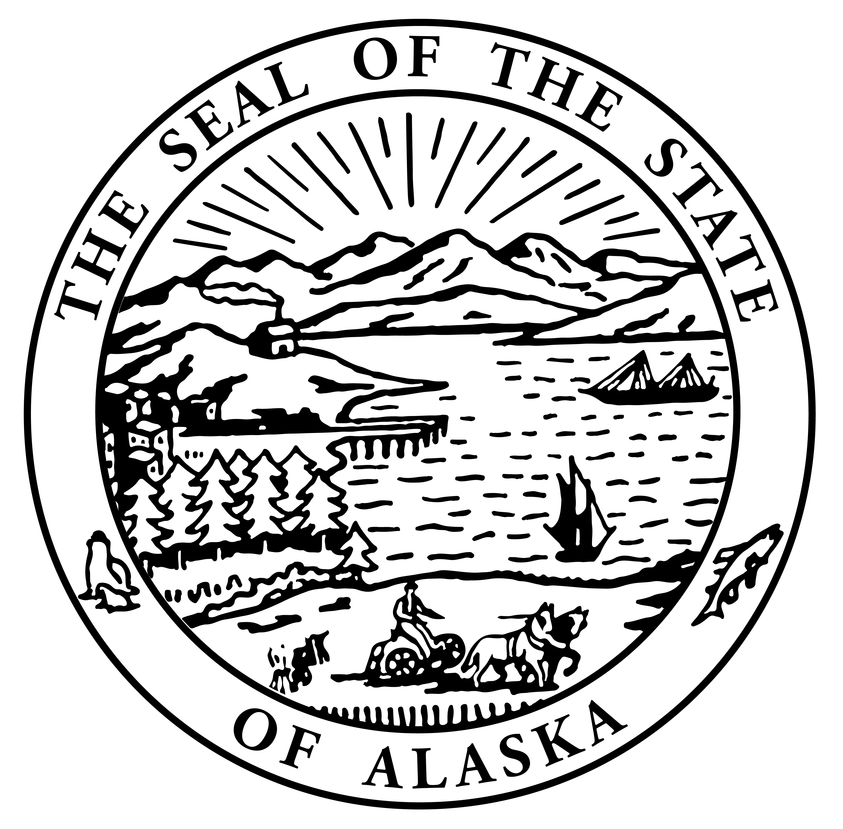
Project Name & Number:
Project Name:

Project Location:

A. FINANCIAL
- Have you ever failed to complete a contract due to insufficient resources?
Yes No If yes, explain:

2. Describe any arrangements you would make to finance this work:

B. EQUIPMENT
1. Describe the equipment you have available and would use for this project.
ITEM | QUAN. | MAKE | MODEL | SIZE/  CAPACITY | PRESENT  MARKET VALUE
- What percent of the total value of this contract would you subcontract?
- Would you purchase any equipment for use on this project: Yes No
If yes, describe type, quantity, and approximate cost:

- Would you rent any equipment for this work? Yes No
If yes, describe type, quantity, and approximate cost:

- Is your proposal based on firm offers for all materials for this project? Yes No
If no, please explain:

C. EXPERIENCE
- Have you had previous construction contracts or subcontracts with the State of Alaska?
Yes No
Describe the most recent or current contract, its completion date, and scope of work:

- List, as an attachment to this questionnaire, other construction projects you have completed; the dates of completion, scope of work, and total contract amount for each project completed in the past 12 months.
I hereby certify that the above statements are true and complete.

Contractor Name

Signature Date

Name and Title of Person Signing

