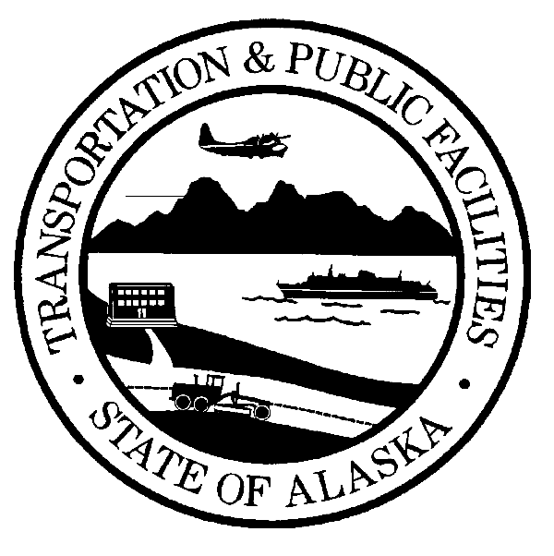 | STATE OF ALASKA  DEPARTMENT OF TRANSPORTATION AND PUBLIC FACILITIES  SMALL PROCUREMENT QUOTE SUBMITTAL  (CONSTRUCTION RELATED)  [per AS 36.30.320(a)]
Project Name & No.: AVTEC Welding Ventilation  721AVC1160  Location: Alaska Vocational Technical Center (AVTEC)  1916 Leirer Road  Seward, AK 99664 |  | Procurement Agency and Address:  Department of Labor and Workforce Development  Procurement Section  P.O. Box 111149  Juneau, AK 99811-1149
Procurement Officer: Brad Waldron  Brad.waldron@alaska.gov |  |  |  | Date of Issuance: 1/5/21  Bid is Due: 1/27/21 2:00 pm
QUOTE: Offerors must read all attachments to this schedule.

I have reviewed the bid documents, with addenda , and understand the scope of services and conditions required for Project number . I agree to furnish all necessary labor, materials, and equipment for the above amount(s). The Work shall be accomplished in a professional manner acceptable to the Procurement Officer.

Contractor Contractor Reg. No.

Authorized Signature Title

Address _________________________________________________________________________

Business License # EIN or SSN Phone #

Offeror is Claiming:  Alaska Bidder's Preference  Alaska Products Pref. (worksheet)
❐ Alaska Veteran Preference (SPC-007)
• • • • • • • • • • • • • • • • • • • • • • • • • • • • • • • • • • • • • • • • • • • • • • • • • • • • • • • • • • • • • • • • • • • • • • • • • • • • • • • •
Procurement Officer:
Date of Receipt of Bid:

Form SPC-002 Page 1 of 1 03/14

