ADDITIONAL REGULATIONS NOTICE INFORMATION
(AS 44.62.190(d))

1. Adopting agency: Alaska Department of Fish & Game

2. General subject of regulation: Annual regulation project to update the year in the Saltwater Charter Logbook and Vessel Registration forms and the Freshwater Sport Fish Guide Vessel Registration forms, adopted by reference from 2019 to 2020.

3. Citation of regulation: 5 AAC 75.076

4. Department of Law file number, if any: 2019200769

5. Reason for the proposed action: Select one and type just that one here

( ) Compliance with federal law or action (identify):
( ) Compliance with new or changed state statute
( ) Compliance with federal or state court decision (identify):
(X) Development of program standards
( ) Other (identify):

6. Appropriation/Allocation: Fish and Game Funds

7. Estimated annual cost to comply with the proposed action to:

A private person: $0
Another state agency: $0
A municipality: $0

8. Cost of implementation to the state agency and available funding (in thousands of dollars):

Initial Year Subsequent
FY 2020 Years
Operating Cost $600.00 $600.00
Capital Cost $0 $0

1002 Federal receipts $0 $0
1003 General fund match $0 $0
1004 General fund $0 $0
1005 General fund/
program $0 $0
Other (identify) $600.00 $600.00

9. The name of the contact person for the regulations:
Name: Shellene L. Hutter
Title: Regulations Program Coordinator
Address: P.O. Box 115526
Juneau, AK 99811-5526
Telephone: (907) 465-6124
E-mail address: shellene.hutter@alaska.gov

10. The origin of the proposed action: Select One and type here

__X__ Staff of state agency
_____ Federal government
_____ General public
_____ Petition for regulation change
_____ Other (identify):

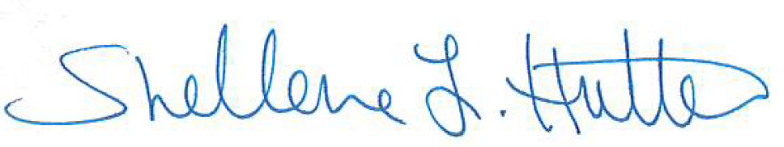
11. Date: 12/2/2019 Prepared by: _____________________________

Name: Shellene L. Hutter
Title: Regulations Program Coordinator
Telephone: (907) 465-6124

