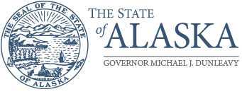

Department of Labor and
Workforce Development
ADMINISTRATIVE SERVICES
Management Services

PO Box 111149
Juneau, Alaska 99811
Main: 907.465.5980
Fax: 907.465.2107

REQUEST FOR INTEREST (RFI)
Ex-Offender Fidelity Bonding

The State of Alaska Department of Labor and Workforce Development (DOLWD) is seeking interest from qualified vendors who can provide Fidelity Bonds for Ex-Offenders, including individuals who are in recovery from opioid and other substance addiction. The bonds would be for $5,000 per bond with up to five (5) bonds being available for each employee, and be valid for 6 months.

Bonds purchased for this program are covered by Training and Employment Guidance Letter #15-18 as published by the United States Department of Labor. This document is available at https://wdr.doleta.gov/directives/corr_doc.cfm?docn=4320

DOLWD is proposing to establish a contract with a maximum length of four (4) years through this procurement process. It is estimated that the total contract value for all years would not exceed $85,000.00. This contract amount would cover all expenses related to providing the bonds described above.

Vendors interested in a future procurement for this must respond by email to brad.waldron@alaska.gov or fax to (907) 465-2107 no later than 5:00 pm Alaska Time, on Friday, August 2, 2019. In your response, please provide your organizations name, contact name, telephone numbers, mailing address, and email address.

Brad Waldron, Procurement Officer
Department of Labor and Workforce Development
(907) 465-4024

