ADDITIONAL REGULATIONS NOTICE INFORMATION
(AS 44.62.190(d))

1. Adopting agency: Alaska Department of Fish & Game

2. General subject of regulation: Sport Fish Guiding Services and Guides; Sport Fish Logbooks

3. Citation of regulation (may be grouped): 5 AAC 75.075 and 5 AAC 75.076

4. Department of Law file number, if any: Currently not available

5. Reason for the proposed action: Development of program standards

6. Appropriation/Allocation: Fish and Game Funds

7. Estimated annual cost to comply with the proposed action to:

A private person: $0
Another state agency: $0
A municipality: $0

8. Cost of implementation to the state agency and available funding (in thousands of dollars):

Initial Year Subsequent
FY 2019 Years
Operating Cost $0 $0
Capital Cost $0 $0

1002 Federal receipts $0 $0
1003 General fund match $0 $0
1004 General fund $0 $0
1005 General fund/
program $0 $0
Other (identify) $0 $0

9. The name of the contact person for the regulations:
Name: Shellene L. Hutter
Title: Regulations Program Coordinator
Address: P.O. Box 115526
Juneau, AK 99811-5526
Telephone: (907) 465-6124
E-mail address: shellene.hutter@alaska.gov

10. The origin of the proposed action: Staff of state agency

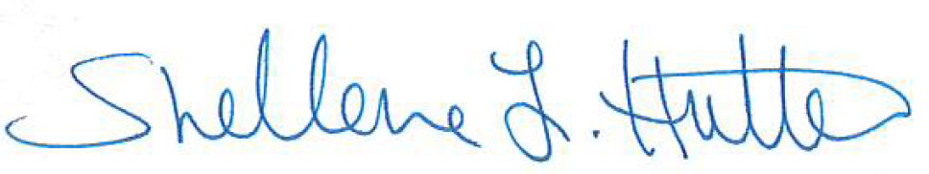
11. Date: 3/6/2019 Prepared by: _____________________________

Name: Shellene L. Hutter
Title: Regulations Program Coordinator
Telephone: (907) 465-6124

