

State Of Alaska
Department of Transportation & Public Facilities
State Equipment Fleet
2200 E 42nd Avenue
Anchorage, AK 99508

Invitation to Bid:
SEF- 2026 Bucket Truck for Fairbanks International Airport

Date of Issue: May 23, 2016
Bid Opening Date: June 15 July 6, 2016 @ 2:30 PM

Contracting Officer: Kristi Futrel
Phone: (907) 269-0793
E-Mail: Kristi.futrel@alaska.gov

CLICK HERE TO REGISTER WITH PROCUREMENT OFFICER

Offerors Are Not Required To Return This Form.

Important Notice: If you received this solicitation from the State of Alaska’s “Online Public Notice” web site, you must register with the procurement officer listed in this document to receive subsequent amendments. Failure to contact the procurement officer may result in the rejection of your offer.

NOTE: This section will be used for Terms and Conditions that are "special" and/or unique to a particular ITB. The paragraphs in this section may change from bid to bid. Accordingly, bidders must review this section to insure compliance.
- INTENT: This invitation to bid (ITB) is intended to result in the purchase of:
  - Contract Period: One Time Purchase
  - Quantities: 1
  - Location of Use: Fairbanks International Airport
  - Warranty locations: Fairbanks
  - In addition to the State of Alaska requirements, the Municipality of Anchorage and other Alaska political subdivisions may cooperatively purchase from the resulting contract.
    - At no time may the contractor change the terms and conditions, alter the price to another entity, which differs from the contractual price, nor charge undisclosed administrative fees to allow cooperative purchasing.
- DELIVERY:
  - Pre-delivery service: Prior to delivery, each vehicle, piece of equipment or attachment shall be serviced and inspected by the dealer or his agent. Inspection must include the following (as applicable to the type of equipment):
    - Dealer and vehicle identification.
    - Check-off of service and inspection performed including a list of all fluids including type weight and specification that are in the equipment as delivered for all fluid compartments.
    - The vehicle's crankcase, differential and transmission, and other fluid compartments shall be filled to the manufacturer's recommended capacity.
    - Fuel tank shall be filled to at least register a minimum ¼ full on the fuel gauge, unless restricted by the commercial carrier, when the vehicle arrives at the delivery location.
    - The vehicle shall be clean and free from defects when delivered and should be ready for immediate and continued use upon delivery.
    - Units delivered in an incomplete state, or which have deficiencies per the specification, are subject to the damage charges as noted in paragraph 4.0 below.
  - Inspections:
    - The State's inspection of all materials and equipment upon delivery is for the sole purpose of identification. Such inspection shall not be construed as final or as acceptance of the materials or equipment if materials or equipment do not conform to Contract requirements. If there are any apparent defects in the materials or equipment at the time of delivery, the State will promptly notify the Contractor thereof. Without limiting any other rights of the State, The State at its option, may require the Contractor to:
      - repair or replace at contractor's expense, any or all of the damaged goods,
      - refund the price of any or all of the damaged goods, or
      - accept the return of any or all of the damaged goods.
    - Costs of remedying all defects, indirect and consequential costs of correcting same, and/or removing or replacing any or all of the defective materials or equipment will be charged against the bidder.
  - Acceptance:
    - Units will not be considered “Accepted” until all deficiencies have been corrected. This includes item 2.5 Line Sheets/Bill of Materials and 8.0 Publications.

  - Delivery Receipt:
    - A delivery receipt will be required. The receipt must be filled out by the vendor, and acknowledged by state receiving personnel by signature and date of actual receipt of equipment. One copy of this delivery receipt is to be given to the state-receiving agency.
    - Vendors are cautioned and advised that such delivery forms or other receiving type documents will not in any way be construed to mean the state has formally and fully accepted unit(s) referenced thereon as complete and meeting every specification set forth. Only the Contracting Officer or designee may sign warranty documentation.
  - Line Sheets/Bill of Materials::
    - It is required at the time of delivery that the successful bidder provides a comprehensive listing of all components used to assemble the unit.
    - This includes any components installed by the manufacturer or any subcontractor or the successful bidder.
    - Information will include at a minimum, when available, make, model serial number on items such as engines, transmissions, axles, tires, bodies, etc. The listings will be specific to each piece of equipment and will be provided on an individual CD for each unit delivered.
    - A minimum of one (1) CD per unit are to be provided and marked with the make, model, and last main numbers of the units serial number or State PO number.
- F.O.B. POINT:
  - The F.O.B. point is as listed in Section IV, Bid Schedule. Ownership of and title will remain with the contractor until delivery is complete to final destination and accepted by the State. Equipment is not to be driven on the Alcan Highway without prior written approval from the contracting officer.
  - The cost of shipping and delivery for orders beyond the limits of Seattle/Tacoma dock will be handled as follows. The contractor will prepay the shipping and delivery charges to any destination named by the State in its order. The contractor will charge-back those shipping and delivery charges to the State as a separate line item on the State’s invoice.
  - All shipping charges over $100 must be documented by a copy of the actual shipping invoice and received with the invoice charge to the State.
  - Shipping must be consolidated for the best possible price. Shipping items separately must be pre-approved by the Contracting Officer PRIOR to shipment. For example, GP Bucket or Spare Tire not being shipped with host unit must be pre-approved.
- DAMAGES FOR LATE DELIVERY AND NON-CONFORMING GOODS:
  - Time is of the essence in this contract. The Bidder is expected to deliver goods that conform in all material respects to the contract specifications on or before the date provided therein, as may be amended by written agreement of the parties.
  - In the event that the equipment is delivered late or does not conform to the contract specifications, the State shall be entitled to offset against the Contract Price, as liquidated damages and not as a penalty, an amount equal to the cost of renting like equipment, multiplied by the number of calendar days elapsing between the delivery date provided in the bid schedule and the delivery date to the State. In the case of equipment in this this class, that daily rental fee is determined to be $515.00 The number of days for which liquidated damages shall apply shall include, in the case of non-conforming goods, the time reasonably necessary for the State to perform inspection.
  - These liquidated damages represent a reasonable estimate of amounts necessary to compensate the State for loss of use of the goods during the period in which the goods would have been available to the State if conforming goods had been timely delivered.
- EQUIPMENT RELIABILITY:
  - Reliability of equipment is of paramount importance to the State. It is the policy of SEF to require minimum levels of reliability from owned or leased equipment for it to be considered acceptable. Equipment offered for this bid must be capable of meeting the acceptable reliability standard stated below.
  - Acceptable Reliability: The State will monitor equipment reliability. Acceptable reliability for this contract is achieved when a machine achieves or maintains a Reliability Ratio (RR) equal to or exceeding the following:
    - .90 (90 percent) PR during any consecutive 12-months (365 days) during the warranty period.
    - .75 (75 percent) PR per operational month (recognizing operational as subject to weather and being defined by calendar days) during the consecutive 12-month period.
    - PR below the state percentages do not meet minimum reliability requirements for state owned equipment.
  - Machine Failure and Downtime:
    - Machine Failure is any and all loss of capability to perform fully, as specified, which is not attributed to Conditioned Failure. Machine Failure resulting in the unit being out of service is defined as Downtime.
    - Conditioned Failure is any Machine Failure attributable to accident, operator abuse or other external cause not attributable to a defect in the machine itself.
    - Downtime is the actual number of days or fractions of days that the equipment is in a state of Machine Failure. Downtime does not count time used for scheduled maintenance (including preventative maintenance and scheduled major overhauls), time lost for repair maintenance and scheduled major overhauls, time lost for repair of damage as a result of operator abuse or machine misapplication; or time lost as a result of accident or an act of God. Downtime includes:
      - Actual shop hours (and/or field repair hours) required to return unit to full operational status following machine failure, including trouble-shooting, repair, necessary replacement of parts, and necessary adjustments, plus
      - Time lost waiting for parts and/or vendor assistance. “Waiting downtime” also applies if need for parts/assistance is discovered during routine maintenance and return to service is deemed counterproductive. In this case, “waiting time” clock begins with notice of need to vendor. Allowance may be considered in “waiting time” calculations if arrival of parts/assistance is delayed by transportation shutdown, to include verifiable transportation scheduling difficulties such as infrequent flights as long as all reasonable alternatives have been exhausted. Parts and assistance are to be provided by the quickest means reasonably possible to avoid unnecessary delays and downtime.
    - Out of Service Report (OSR): Downtime resulting from machine failure is the actual number of hours a machine is out of service as recorded on the OSR or in the Equipment Maintenance Management System (EMS).
      - The State will record all downtime on an OSR or EMS work order, which will be originated for each occurrence of downtime. The document will show the date and time a unit went down, the location where the machine was based, the reason the machine is down, date and time the vendor was notified (if applicable), the date and time the machine was returned to service, and the total hours of downtime.
        - The Contract Manager will finalize and approve the OSR or EMS work order. Both are available for contractor review.
    - Reporting Downtime: The Contracting Officer will maintain documentation of all Downtime, and shall send copies of such documentation to the contractor.
    - Calculation of Reliability Ratio: RR is the mathematical ration of operated time (uptime) to out of service time (downtime). The RR will be calculated according to the following formula:
RR = Days in a Month – Days Out of Service* = DM - DO
Days in a Month ** DM
Note * : Fractional Days apply, i.e., a unit is out of service 8 hours in a 24 hour period equals 1/3 or .33% of a day.
Note **: A day is allocated as 24 consecutive hours from 12:00 AM to 12:00 PM.
Example: 30 days DM with 2 days and 8 hours DT would result in:
RR = 30 - 2.33 = .92
30
    - Unacceptable Reliability: If an item of equipment fails to perform at an acceptable level of reliability during the warranty period, the Contracting Officer will notify the contractor and request immediate remedy. Failure to remedy the piece of equipment within 30 days for failure will result in a breach of contract and the immediate return of the equipment and reimbursement of the Guaranteed Value (V) of the unit:
Original Cost of the unit less (-) Freight = $__________ (V)
Guaranteed Value (V) less (-) the Cost of Operation as listed in the Equipment Rental Rate Blue Book or comparable equipment or the current Federal Fixed Usage Rate for the Class for the State of Alaska (a, b or c per hour) times (X) the number of hours used = ___________(DV).
- Example: Cost of a single unit, less freight = $150,000. The hourly cost is $150.00 per hour. The unit was used 150 hours prior to failing the acceptable reliability. The contractor guarantees the unit’s worth at $127,500.00.
    - Prior to return, the State will correct all reasonable cosmetic deficiencies (such as excessive rust) and those deficiencies that are directly related to damage due to accidents, misuse of equipment or failure to operate or maintain equipment as prescribed by the vendor/manufacturer, prior to public auction.
    - The tires will be serviceable with at least 50% remaining thread.
    - Oil samples, as per manufacturer’s service manual recommendations, will be taken by State of Alaska maintenance personnel on the engine, transmission, differentials and hydraulics.
    - In the case of dispute, at the expense of the State, a qualified agent from Northern Adjusters, Inc. or another professionally recognized appraiser may be commissioned for an independent claim appraisal. Such appraisal shall be binding upon the State and the contractor.
- WARRANTY:
  - Standard Warranty Package: Unless otherwise stipulated by this ITB, the successful bidder will provide a one-year (12-month) warranty.
    - Full (100%) Parts and Labor Warranty Coverage of all components for 12 months (year one), from the date the unit is placed in service at the assigned location.
    - Full (100%) Warranty Coverage includes all cost of labor, parts, freight, lubricants, miscellaneous cost, etc., to place the unit in like-new condition.
    - Should the manufacturer’s standard warranty exceed the minimum State warranty requirements, the manufacturer’s warranty will run in conjunction with and enhance the State’s warranty, then continue for the remainder of its term.
    - For clarification, warranty does not apply to normal wear and tear or maintenance items, accident damages, misuse of equipment or failure to operate or maintain equipment as prescribed by vendor/manufacturer.
    - Warranty on Attachments: Same as Standard Warranty Package.
    - In-Service Date: Warranty on vehicles not placed in service immediately upon receipt because of time lag to construct body components and/or installation of special equipment, or due to seasonal usage or other delay, shall be warranted from the date the vehicle is placed in service. The receiving agency shall notify the vendor/manufacturer in writing of the actual "in service" date. Notification of the requirement for delayed warranty will be provided on delivery orders whenever possible.
  - Warranty Claims:
    - Warranty will be provided at the unit’s assigned (in-service) location. Because of the remote location of some equipment it is not always practical to deliver equipment to authorized warranty repair facilities. In these cases, the vendor may perform warranty work at the state's location or, the State of Alaska, at its discretion, reserves the right to perform the warranty work and be reimbursed by the vendor. If travel is required by State personnel to perform the work, actual costs will be used for reimbursement.
    - The State of Alaska has established a warranty procedure whereby the vendor is to be notified via letter, email, or fax, that warranty work needs to be performed. If time is of the essence, a telephone call confirmed by one of the above written procedures may be utilized.
    - The vendor must notify the state within 24 hours of verbal or written notification that it will begin to perform the warranty work at the equipment location.
    - The State may, at its discretion, proceed to make warranty repairs with its own work force in the case of emergency situation or to preclude excessive downtime (greater than 24 hours). The State will require a PO to perform the warranty work.
    - Failure to notify the State that the vendor intends to begin to perform warranty is considered a contractual breach.
    - The vendor will be invoiced for required warranty work performed by the state. Warranty work performed by the state will be charged at the current SEF shop labor rate at the time of the repair. Actual repair time will be used.
  - Warranty Performed by Vendor:
    - The State will reimburse travel costs not reimbursed by the manufacturer for travel to and from the bidder’s closest warranty service center within the State of Alaska to the location of the equipment under warranty. Travel costs will be billed as follows:
      - Mileage Charge: Mileage will only be reimbursed for travel within Alaska at the rate allowable by the IRS.
      - Meals are paid at actual and charges must be accompanied by receipts and are not to exceed the State authorized $60.00 per day.
      - Transportation, such as airfare, shall be reimbursed at actual and all charges are to be accompanied by a receipt/copy of the coach ticket.
      - Lodging shall be reimbursed at actual and shall not exceed $150.00 per night unless no other lodging is available. Requests for reimbursement must be accompanied by a receipt.
    - Travel will only be reimbursed for time in Alaska.
    - After hours, weekend and holiday travel must be approved by the contracting officer to be considered for reimbursement. The State will not pay for weather delays.
  - Authorized Warranty (Contractor/Bidder):
    - Contractor (bidder) must have Authorized Warranty Dealer that has all required licenses, facilities and factory certified and trained personnel necessary to perform the warranty servicing and repair work.
Provide name and address for each Authorized Warranty Dealer for each location.
(*) _____________________________________________________________ _____________________________________________________________
Provide contact name and contact information for Warranty Administrator:
(*) _____________________________________________________________ _____________________________________________________________
Provide documentation of factory certified and trained personnel:
(*) _____________________________________________________________ _____________________________________________________________
    - The ultimate responsibility for warranty lies with the contractor (bidder).
    - The State reserves the right to inspect the warranty facility and diagnostic equipment prior to issuing the Notice of Intent to Award a contract.
  - Factory Recall:
    - Nationwide factory recall or product update programs are the responsibility of the vendor and/or manufacturer. The State will attempt to bring affected equipment to an authorized repair facility. However, because of the remoteness of some equipment this is not always practicable or economical. In such cases, factory recall and modification work will be handled the same as warranty work. Factory recall notices sent to the state should, in addition to serial number, include model, year, and dealer.
- REPAIR ORDERS AND DOCUMENTATION:
  - Any work performed by the contractor or approved subcontractor, whether warranty or any other work on a piece of equipment purchased under this ITB, will require a copy of the repair order, any invoices showing parts and commodities including oils and types used.
- PUBLICATIONS:
  - Paper publications are to be received by the State at the time of delivery. Delivery will not be considered complete until the publications for each unit have been received by the State of Alaska. Note: Publications, when required, will be ordered on the same Purchase Order as the unit itself.
    - All paper manuals are to be pre-assembled in factory binders prior to delivery.
    - Electronic publications may be requested.
  - Service Manuals:
    - Complete set(s) to include applicable information covering prime unit and attachments:
    - Body, chassis, and electrical
    - Engine, transmission, and differential(s) (service and rebuild)
    - Electrical and vacuum troubleshooting
    - Wiring diagrams
    - Service specifications
    - Engine/emission diagnosis
  - Parts Manuals:
    - Complete set(s) including all updates. If updates are not provided during the warranty period, the State may order them from the manufacturer and bill the contractor for the full cost, including shipping.
    - Parts manuals are to be customized by serial number.
  - Operator’s Manuals: Complete set(s) to include prime unit and attachments.
  - Quantities: As per Section IV – Bid Price Schedule.
  - Service Bulletins, Etc.: The successful bidder must provide appropriate service bulletins, technical support bulletins, service letters, product support bulletins, and/or any other information type notifications that are sent out to the vendor or used by the manufacturer in the maintenance and report of the vehicle, equipment or attachments being provided. The intent of this clause is that the State of Alaska be provided notification of any and all changes or improvement’s that may affect the maintenance, reliability, longevity, and safety of our equipment.
- STATEMENT OF ORIGIN: The bidder will be required to furnish a Manufacturer's Statement of Origin for Automotive or Non-Automotive rolling stock for each unit. All such documents shall be delivered with the invoice to:
DOT&PF, HQ State Equipment Fleet
2200 E. 42nd Avenue Room #318
Anchorage, Alaska 99508
- WEIGHT VERIFICATION SLIPS: If required in the Bid Price Schedule, a weight scale ticket of the completed unit will be included with the Statement of Origin.
- INSPECTION TRIP (IF REQUIRED):
  - Prior to arrival of the State of Alaska inspectors, the completed unit is to have been inspected and tested by the manufacturer for compliance to the specifications as listed above. The State reserves the right to appoint an independent inspector, at the State’s expense, to periodically monitor the progression of the vehicle during the manufacturing process.
  - Prior to shipment from the manufacturer's plant, representatives of the State will inspect the completed equipment for conformance to specifications.
  - The Contractor shall provide full access to the State’s inspector(s), or their designee(s), to the plant (s) including the plant(s) subcontractors where manufacture is taking place.
  - Inspection Trip:
    - The vendor will alert the State of Alaska Contracting Officer, whose name is on the purchase order, at least 30 days prior to having the completed unit ready for inspection
    - The State of Alaska will arrange and pay for all travel related cost for State employees only.
  - It shall be the responsibility of the State inspector(s) to technically inspect and test the vehicle for compliance with the specifications.
  - It shall be the responsibility of the Contracting Authority representative to observe and assist in the inspection and test to assure compliance with the published terms, conditions, and specifications of the bid, and to mediate any disputes, which may arise between the manufacturer and the Department of Transportation’s representative(s).
  - If it becomes necessary, the State or its representative would conduct a re-inspection of any subsequent work performed by the successful bidder. Should the State decide a re-inspection(s) of the unit is required; the vendor shall be required to pay for round trip air fare, ground transportation and per diem at $175.00 per day for up to two (2) persons from Anchorage, Alaska. The state will pay for the inspection and will submit an invoice for reimbursement from the vendor.
  - The pilot model inspection may result in minor modifications which would require negotiation with the Contracting Officer. A change order to the contract must be issued prior to any modifications being accomplished.
  - FINAL ACCEPTANCE REMINDER: Final acceptance is at final destination; however, all major tests will be conducted at the manufacturer’s place of business unless the State has reason to believe alterations or damages have taken place which may have changed the performance or design characteristics of the unit since the time of inspection at the manufacturer’s location.
    - A final inspection of the unit will be conducted at the final destination in Alaska, to assure that the unit still meets specifications.
  - These inspections by the State shall be thorough and very critical, and will encompass a complete review of the specifications. Adequate time and technical personnel shall be made available to assist the State in these inspections.
  - The bidder or responsible representative shall also be in attendance.
- PRICE:
  - Price Guarantee: The Contractor is responsible to maintain prices under the contract firm for 180 days after bid opening. All price increases or decreases must remain firm for the following 180 days.
  - NO RETROACTIVE PRICE INCREASES WILL BE ACCEPTED.
  - Price adjustments, increases or decreases, for subsequent orders, may be made by providing the Contracting Officer satisfactory evidence that all of the following conditions exist:
    - The increase is a result of the increased cost at the manufacturer’s level and not costs under the contractor’s control, and that;
      - The increase will not produce a higher profit margin for the contractor than that on the original contract, and that;
      - The increase affects only the item(s) that are clearly identified by the contractor.
      - Satisfactory forms of the evidence of the above facts may include a certified invoice from the manufacturer, or an affidavit from an independent professional price-tracking firm that is recognized by the industry as reputable and knowledgeable. The contractor must be able to show the difference between the prior year’s price and the current difference in the price being requested.
  - Price Decreases: During the period of the contract, the Contractor must pass on to the state all price decreases, such as fleet rebates. A Contractor’s failure to adhere strictly and faithfully to this clause will be considered a material breach of contract. The state reserves the right to cancel the contract if the contractor fails to properly perform the duties set out herein.
  - Manufacturer’s Rebate (Incentives):
    - In any circumstance during or prior to completion of the contract, whereupon the State of Alaska becomes eligible to receive a rebate for any vehicle purchased under this contract, it shall be the BIDDER'S responsibility to inform the Contracting officer in writing and to advise the procedures for obtaining such rebates.
- REPLACEMENT PARTS AND REPAIRS:
  - This contract encompasses a full parts and labor contract for manufacturer parts and repairs for the entire warranty period.
  - The State of Alaska shall expect the dealer or manufacturer to provide replacement wear parts at their authorized warranty facilities for the entire warranty period within seven (7) days of order. All other parts must be available within ten (10) working days.
  - Back order procedures: Back orders are acceptable; however, the ordering shop shall be appraised at time of original orders as to the expected delay in delivery.
  - Warranty: All products supplied by the contractor shall be warranted against defects in materials and workmanship for a minimum of 90 days, commencing at the time of installation as long as the installation is within 12 months of purchase. The cost of any defective product and the labor required to replace the defective product shall be the obligation of the contractor.
    - If the manufacturer’s warranty exceeds the stated warranty then manufacturer’s warranty supersedes.
    - Parts Return: Within 12 months of the invoice date, the State is to be allowed to return new parts with full refund, less actual shipping charges. Cores returned within 12 months of original invoice date will receive full core credit. Returned parts will be in new, sellable condition. Refund will be in the form of a credit/invoice credited to the SOA account with the vendor.
    - Invoicing: Full description of item is required on all invoices, packing lists and billings.

INSTRUCTIONS TO BIDDERS:
- INVITATION TO BID (ITB) REVIEW: Bidders shall carefully review this ITB for defects and questionable or objectionable material. Bidders' comments concerning defects and questionable or objectionable material in the ITB must be made in writing and received by the purchasing authority at least ten (10) days before the bid opening date. This will allow time for an amendment to be issued if one is required. It will also help prevent the opening of a defective bid, upon which award cannot be made, and the resultant exposure of bidders' prices. Bidders' original comments should be sent to the purchasing authority listed on the front of this ITB.
- BID FORMS: Bidders shall use this and attached forms in submitting bids. A photocopied bid may be submitted.
- SUBMITTING BIDS: Envelopes containing bids must be sealed, marked, and addressed as shown in the example below. Do not put the ITB number and opening date on the envelope of a request for bid information. Envelopes with ITB numbers annotated on the outside will not be opened until the scheduled date and time.
Bidder’s Return Address

Department of Transportation & Public Facilities
HQ State Equipment Fleet
2200 E. 42nd Avenue, Room #311

Anchorage, AK 99508
ITB No.: ____
Opening Date: ______
ELECTRONIC BID SUBMISSION: Bids may be emailed to Kristi.futrel@alaska.gov, no later than the date and time listed on page one of this ITB as the deadline for receipt of bids, and must contain the ITB number in the subject line of the email. Emailed bids must be submitted as an attachment in PDF format. Please note that the maximum size of a single email (including all text and attachments) that can be received by the state is 20mb (megabytes). If the email containing the bid exceeds this size, the bid must be sent in multiple emails that are each less than 20 megabytes and each email must comply with the requirements described above. The state is not responsible for unreadable, corrupt, or missing attachments. It is the bidder’s responsibility to contact the issuing office at (907) ______ to confirm that the bid has been received. Failure to follow the above instructions may result in the bid being found non-responsive and rejected.
- PRICES: The bidder shall state prices in the units of issue on this ITB. Prices quoted for commodities must be in U.S. funds and include applicable federal duty, brokerage fees, packaging, and transportation cost to the FOB point so that upon transfer of title the commodity can be utilized without further cost. Prices quoted for services must be quoted in U.S. funds and include applicable federal duty, brokerage fee, packaging, and transportation cost so that the services can be provided without further cost. Prices quoted in bids must be exclusive of federal, state, and local taxes. If the bidder believes that certain taxes are payable by the State, the bidder may list such taxes separately, directly below the bid price for the affected item. The State is exempt from Federal Excise Tax except the following:
- Coal - Internal Revenue Code of 1986 (IRC), Section 4121 - on the purchase of coal;
- “Gas Guzzler" - IRC, Section 4064 - on the purchase of low m.p.g. automobiles, except that police and other
emergency type vehicles are not subject to the tax;
- Air Cargo - IRC, Section 4271 - on the purchase of property transportation services by air;
- Air Passenger - IRC, Section 4261 - on the purchase of passenger transportation services by air carriers.
- Leaking Underground Storage Tank Trust Fund Tax (LUST) - IRC, Section 4081 - on the purchase of Aviation gasoline, Diesel Fuel, Gasoline, and Kerosene.
- VENDOR TAX ID NUMBER: If goods or services procured through this ITB are of a type that is required to be included on a Miscellaneous Tax Statement, as described in the Internal Revenue Code, a valid tax identification number must be provided to the State of Alaska before payment will be made.
- FILING A PROTEST: A bidder may protest the award of a contract or the proposed award of a contract for supplies, services, or professional services. The protest must be filed in writing and include the following information: (1) the name, address, and telephone number of the protester; (2) the signature of the protester or the protester's representative; (3) identification of the contracting agency and the solicitation or contract at issue; (4) a detailed statement of the legal and factual grounds of the protest, including copies of relevant documents; and (5) the form of relief requested. Protests will be treated in accordance with Alaska Statutes (AS) 36.30.560-36.30.610.
CONDITIONS:
- AUTHORITY: This ITB is written in accordance with AS 36.30 and 2 AAC 12.
- COMPLIANCE: In the performance of a contract that results from this ITB, the contractor must comply with all applicable federal, state, and borough regulations, codes, and laws; be liable for all required insurance, licenses, permits and bonds; and pay all applicable federal, state, and borough taxes.
- SUITABLE MATERIALS, ETC.: Unless otherwise specified, all materials, supplies or equipment offered by a bidder shall be new, unused, and of the latest edition, version, model or crop and of recent manufacture.
- SPECIFICATIONS: Unless otherwise specified in the ITB, product brand names or model numbers specified in this ITB are examples of the type and quality of product required, and are not statements of preference. If the specifications describing an item conflict with a brand name or model number describing the item, the specifications govern. Reference to brand name or number does not preclude an offer of a comparable or better product, if full specifications and descriptive literature are provided for the product. Failure to provide such specifications and descriptive literature may be cause for rejection of the offer.
- FIRM OFFER: For the purpose of award, offers made in accordance with this ITB must be good and firm for a period of ninety (90) days from the date of bid opening.
- EXTENSION OF PRICES: In case of error in the extension of prices in the bid, the unit prices will govern; in a lot bid, the lot prices will govern.
- BID PREPARATION COSTS: The State is not liable for any costs incurred by the bidder in bid preparation.
- CONSOLIDATION OF AWARDS: Due to high administrative costs associated with processing of purchase orders, a single low bid of $50 or less may, at the discretion of the State, be awarded to the next low bidder receiving other awards for consolidation purposes. This paragraph is not subject to the protest terms enumerated in “INSTRUCTION TO BIDDERS”, “FILING A PROTEST” above.
- CONTRACT FUNDING: Bidders are advised that funds are available for the initial purchase and/or the first term of the contract. Payment and performance obligations for succeeding purchases and/or additional terms of the contract are subject to the availability and appropriation of funds.
- CONFLICT OF INTEREST: An officer or employee of the State of Alaska may not seek to acquire, be a party to, or possess a financial interest in, this contract if (1) the officer or employee is an employee of the administrative unit that supervises the award of this contract; or (2) the officer or employee has the power to take or withhold official action so as to affect the award or execution of the contract.
- ASSIGNMENT(S): Assignment of rights, duties, or payments under a contract resulting from this ITB is not permitted unless authorized in writing by the procurement officer of the contracting agency. Bids that are conditioned upon the State’s approval of an assignment will be rejected as nonresponsive.
- SUBCONTRACTOR(S): Within five (5) working days of notice from the state, the apparent low bidder must submit a list of the subcontractors that will be used in the performance of the contract. The list must include the name of each subcontractor and the location of the place of business for each subcontractor and evidence of each subcontractor's valid Alaska business license.
- FORCE MAJEURE (Impossibility to perform): The parties to a contract resulting from this ITB are not liable for the consequences of any failure to perform, or default in performing, any of its obligations under the contract, if that failure or default is caused by any unforeseeable Force Majeure, beyond the control of, and without the fault or negligence of, the respective party. For the purposes of this ITB, Force Majeure will mean war (whether declared or not); revolution; invasion; insurrection; riot; civil commotion; sabotage; military or usurped power; lightning; explosion; fire; storm; drought; flood; earthquake; epidemic; quarantine; strikes; acts or restraints of governmental authorities affecting the project or directly or indirectly prohibiting or restricting the furnishing or use of materials or labor required; inability to secure materials, machinery, equipment or labor because of priority, allocation or other regulations of any governmental authorities.
- LATE BIDS: Late bids are bids received after the time and date set for receipt of the bids. Late bids will not be accepted.
- CONTRACT EXTENSION: Unless otherwise provided in this ITB, the State and the successful bidder/contractor agree: (1) that any holding over of the contract excluding any exercised renewal options, will be considered as a month-to-month extension, and all other terms and conditions shall remain in full force and effect and (2) to provide written notice to the other party of the intent to cancel such month-to-month extension at least thirty (30) days before the desired date of cancellation.
- DEFAULT: In case of default by the contractor, for any reason whatsoever, the State of Alaska may procure the goods or services from another source and hold the contractor responsible for any resulting excess cost and may seek other remedies under law or equity.
- DISPUTES: If a contractor has a claim arising in connection with a contract resulting from this ITB that it cannot resolve with the State by mutual agreement, it shall pursue a claim, if at all, in accordance with the provisions of AS 36.30.620 – 632.
- CONSUMER ELECTRICAL PRODUCT: AS 45.45.910 requires that "...a person may not sell, offer to sell, or otherwise transfer in the course of the person's business a consumer electrical product that is manufactured after August 14, 1990, unless the product is clearly marked as being listed by an approved third party certification program." Electrical consumer products manufactured before August 14, 1990, must either be clearly marked as being third party certified or be marked with a warning label that complies with AS 45.45.910(e). Even exempted electrical products must be marked with the warning label. By signature on this bid the bidder certifies that the product offered is in compliance with the law. A list of approved third party certifiers, warning labels and additional information is available from: Department of Labor and Workforce Development, Labor Standards & Safety Division, Mechanical Inspection Section, P.O. Box 107020, Anchorage, Alaska 99510-7020, (907)269-4925.
- SEVERABILITY: If any provision of the contract is declared by a court to be illegal or in conflict with any law, the validity of the remaining terms and provisions will not be affected; and, the rights and obligations of the parties will be construed and enforced as if the contract did not contain the particular provision held to be invalid.
- GOVERNING LAW; FORUM SELECTION: A contract resulting from this ITB is governed by the laws of the State of Alaska. To the extent not otherwise governed by section 17 of these Standard Terms and Conditions, any claim concerning the contract shall be brought only in the Superior Court of the State of Alaska and not elsewhere.
- NEW EQUIPMENT: Equipment offered in response to this ITB must be new equipment. New equipment means equipment that is currently in production by the manufacturer and is still the latest model, edition or version generally offered. The equipment must be warranted as new by the manufacturer and may not have been used for any purpose, other than display (not demonstration), prior to its sale to the state. The state will not accept remanufactured, used, or reconditioned equipment. It is the contractor's responsibility to ensure that each piece of equipment delivered to the state complies with this requirement. A contractor's failure to comply with this requirement will cause the state to seek remedies under breach of contract.
- ACCESSORIES: When accessories are supplied, they must be certified to be compatible with the rest of the equipment. Certification will be written evidence satisfactory to the state that the accessories are compatible. The bidder's failure to supply this evidence within the time required by the state will cause the state to consider the bid non-responsive and reject the bid.

- BRAND SPECIFIC: Certain items may be designated brand specific. When an item is so designated no substitutions for the brand and model specified will be allowed.

- INSPECTION: Equipment offered for lease may be subject to inspection and approval by the state prior to the award of the ITB. The equipment and attachments must be in good repair and capable of performing the work for which they were designed.

- ALTERATIONS: The contractor must obtain the written approval from the contracting officer prior to making any alterations to the specifications contained in this ITB. The state will not pay for alterations that are not approved in advance and in writing by the contracting officer.

- DISCONTINUED ITEMS: In the event an item is discontinued by the manufacturer during the life of the contract, another item may be substituted, provided that the contracting officer makes a written determination that it is equal to or better than the discontinued item and provided that it is sold at the same price or less than the discontinued item.

- ITEM UPGRADES: The state reserves the right to accept upgrades to models on the basic contract when the upgrades improve the way the equipment operates or improve the accuracy of the equipment. Such upgraded items must be at the same price as the items in the basic contract.

- DELIVERY TIME: The elapsed time between the time the state places an order and the time that order is actually shipped from the contractor's place of business must be entered in space provided under "Bid Schedule". This processing time is to remain constant throughout the life of the contract(s).

- DELIVERY CONFIRMATION: Bidders must obtain a confirmation from the manufacturer that the items offered are scheduled for production in sufficient time to meet the scheduled delivery dates. A copy of the manufacturer’s confirmation may be included with the bid or submitted within 10 days of the state's request. The bidder's failure to provide the manufacturers confirmation as required will cause the state to consider the bid non-responsive and reject the bid.

- ADVANCE NOTICE OF DELIVERY: The contractor must notify the freight company that delivers the order that the state facility receiving the order requires 24 hours advance notice of delivery.

- THIRD-PARTY FINANCING AGREEMENTS NOT ALLOWED: Because of the additional administrative and accounting time required of state agencies when third party financing agreements are permitted, they will not be allowed under this contract.

- CONTINUING OBLIGATION OF CONTRACTOR: Regardless of the terms and conditions of any third-party financing agreement, the contractor agrees that none of its responsibilities under this contract are transferable and that the contractor alone will continue to be solely responsible until the expiration date of the contract. Such responsibilities include, but are not limited to, the provision of equipment, training, warranty service, maintenance, parts and the provision of consumable supplies. By signature on the face page of this ITB the bidder acknowledges this requirement and indicates unconditional acceptance of this continuing obligation clause.

- ESTIMATED QUANTITIES: The quantities referenced in this ITB are the state's estimated requirements and may vary more or less from the quantities actually purchased. The state does not guarantee any minimum purchase. Orders will be issued throughout the contract period on an as-needed basis.

- SERVICE CHARGES: Regardless whether the contractor repairs equipment on-site or off-site, the state will not be liable for any charges associated with the repair of broken equipment, including, but not limited to, unhooking, disassembly, packaging, crating, repair, transportation, replacement, reassembly, or rewiring.

- PARTS: Only parts designed for the purpose they are being used, and warranted as new, may be used in the repair of state equipment.

- COMPLETION OF SERVICE: The service will not be complete and the equipment will not be considered serviced, repaired, or acceptable until it performs in compliance with the manufacturer's published performance specifications.

- SERVICE TECHNICIAN QUALIFICATIONS: Bidders must provide evidence that the person performing the service work is a manufacturer's authorized service technician; or, the bidder may provide evidence that they have contracted with a manufacturer's authorized service technician to perform the service work.

Acceptable evidence of the service technician's competence may take the form of a letter or certificate, signed by an authorized officer of the manufacturer, that the service technician has been trained and authorized by the manufacturer to provide manufacturer's authorized warranty service.

The bidder’s failure to provide the evidence mentioned above, within the time required by the state, may cause the state to consider the bid non-responsive and reject the bid.

- WORKMANSHIP & MATERIALS: All work must be performed in a thorough and workmanlike manner and in accordance with current industry practices. The contractor will be held responsible for the quality of the finished item. The state will reject any item that does not meet the specifications of the ITB. Rejected items will be returned to the contractor at the contractor's risk and expense.

- CONTRACT CANCELLATION: The state reserves the right to cancel the contract at its convenience upon 30 calendar day’s written notice to the contractor. The state is liable only for payment in accordance with the payment provisions of this contract for services or supplies provided before the effective date of termination.

- METHOD OF AWARD: DOT/PF is required by law to award “to the lowest responsible and responsive bidder whose bid conforms in all MATERIAL respects to the requirements and criteria set out in the invitation to bid.” AS 36.30.170.

All specifications in this ITB are important and bidders should carefully address each item. Deviation from a
specification MAY result in rejection of a bid at the discretion of the Contracting Officer if the deviation is material. A material deviation is one that is significantly different from an essential aspect of a specification.

The Contracting Officer may be justified in accepting a non-material deviation - it will be determined upon the facts, circumstances, and the proposal in the bid. If a bid deviation has a negligible effect on price, quality, performance, delivery or contract conditions, it is not material and may be waived or corrected by the Contracting Officer. The State reserves the right to waive minor informalities or technical defects, which are not material, when such waiver is in the best interest of the State.

Nothing in this section shall be construed as depriving the State of its discretion in the matter of determining the lowest responsible bidder.

A Notice of Intent to Award (ITA) will be issued for all solicitations in accordance with regulations. The notice of intent to award does not constitute a formal award of a contract. Formal award is achieved through execution of the "Offer and Contract Award" section of the Invitation to Bid.

- CONTRACTOR SELECTION PROCESS: If multiple contracts are awarded and established this selection process will be used. When an agency needs security services the lowest contractor for that location will be contacted first. If, for any reason, the lowest contractor is not available to perform the needed service, the state will contact the next lowest contractor for that location. This process will continue until a contractor who can perform the service is located. The location of the contractor initially contacted will be determined by the starting location of the call-out. For instance, if a there was a need to transport a person from Anchorage to Fairbanks and then guard the person for two days in Fairbanks, the agency would contact Anchorage contractors, even though a substantial portion of the actual service would be performed in Fairbanks.

SPECIAL CONDITIONS:
- ORDER DOCUMENTS: Except as specifically allowed under this ITB, an ordering agency will not sign any vendor contract. The State is not bound by a vendor contract signed by a person who is not specifically authorized to sign for the State under this ITB. The State of Alaska Purchase Order, Contract Award and Delivery Order are the only order documents that may be used to place orders against the contract(s) resulting from this ITB.
- BILLING INSTRUCTIONS: Invoices must be billed to the ordering agency's address shown on the individual Purchase Order, Contract Award or Delivery Order, not to the Division of General Services. The ordering agency will make payment after it receives the merchandise or service and the invoice. Questions concerning payment must be addressed to the ordering agency.
- CONTINUING OBLIGATION OF CONTRACTOR: Notwithstanding the expiration date of a contract resulting from this ITB, the contractor is obligated to fulfill its responsibilities until warranty, guarantee, maintenance and parts availability requirements have completely expired.
PREFERENCES:
- ALASKA BIDDER PREFERENCE: Award will be made to the lowest responsive and responsible bidder after an Alaska bidder preference of five percent (5%) has been applied. The preference will be given to a person who: (1) holds a current Alaska business license at the time designated in the invitation to bid for bid opening; (2) submits a bid for goods or services under the name on the Alaska business license; (3) has maintained a place of business within the state staffed by the bidder, or an employee of the bidder, for a period of six months immediately preceding the date of the bid; (4) is incorporated or qualified to do business under the laws of the state, is a sole proprietorship and the proprietor is a resident of the state, is a limited liability company organized under AS 10.50 and all members are residents of the state, or is a partnership under AS 32.06 or AS 32.11 and all partners are residents of the state; and, (5) if a joint venture, is composed entirely of ventures that qualify under (1) - (4) of this subsection. AS 36.30.170, AS 36.30.321(a) and AS 36.30.990(2)
- ALASKA VETERAN PREFERENCE: If a bidder qualifies for the Alaska bidder preference under AS 36.30.321(a) and AS 36.30.990(2) and is a qualifying entity as defined in AS 36.30.321(f), they will be awarded an Alaska veteran preference of five percent (5%). The preference will be given to a (1) sole proprietorship owned by an Alaska veteran; (2) partnership under AS 32.06 or AS 32.11 if a majority of the partners are Alaska veterans; (3) limited liability company organized under AS 10.50 if a majority of the members are Alaska veterans; or (4) corporation that is wholly owned by individuals and a majority of the individuals are Alaska veterans, and may not exceed $5,000. The bidder must also add value by actually performing, controlling, managing, and supervising the services provided, or for supplies, the bidder must have sold supplies of the general nature solicited to other state agencies, other governments, or the general public - AS 36.30.321(i).
- USE OF LOCAL FOREST PRODUCTS: In a project financed by state money in which the use of timber, lumber and manufactured lumber is required, only timber, lumber and manufactured lumber products originating in this state from Alaska forests shall be used unless the use of those products has been determined to be impractical, in accordance with AS 36.15.010 and AS 36.30.322.
- LOCAL AGRICULTURAL AND FISHERIES PRODUCTS PREFERENCE: When agricultural, dairy, timber, lumber, or fisheries products are purchased using state money, a seven percent (7%) preference shall be applied to the price of the products harvested in Alaska, or in the case of fisheries products, the products harvested or processed within the jurisdiction of Alaska, in accordance with AS 36.15.050.
- ALASKA PRODUCT PREFERENCE: A bidder that designates the use of an Alaska Product which meets the requirements of the ITB specification and is designated as a Class I, Class II or Class III Alaska Product by the Department of Community & Economic Development shall receive a preference in the bid evaluation in accordance with AS 36.30.332 and 3 AAC 92.010.
- EMPLOYMENT PROGRAM PREFERENCE: If a bidder qualifies for the Alaska bidder preference under AS 36.30.321(a) and AS 36.30.990(2), and is offering goods or services through an employment program as defined under 36.30.990(12), they will be awarded an Employment Program Preference of fifteen percent (15%) in accordance with AS 36.30.321(b).
- ALASKANS WITH DISABILITIES PREFERENCE: If a bidder qualifies for the Alaska bidder preference under AS 36.30.321(a) and AS 36.30.990(2), and is a qualifying entity as defined in AS 36.30.321(d), they will be awarded an Alaskans with Disabilities Preference of ten percent (10%) in accordance with AS 36.30.321(d). A bidder may not receive both an Employment Program Preference and an Alaskans with Disabilities Preference.
- PREFERENCE QUALIFICATION LETTER: Regarding preferences 6 and 7 above, the Division of Vocational Rehabilitation in the Department of Labor and Workforce Development maintains lists of Alaskan; [1] employment programs that qualify for preference, and [2] individuals who qualify for preference as Alaskan's with disabilities. In accordance with AS 36.30.321(i), in order to qualify for one of these preferences, a bidder must add value by actually performing, controlling, managing, and supervising the services provided, or for supplies, a bidder must have sold supplies of the general nature solicited to other state agencies, governments, or the general public.
As evidence of an individual's or a business' right to a certain preference, the Division of Vocational Rehabilitation will issue a certification letter. To take advantage of the preferences 6 or 7 above, an individual or business must be on the appropriate Division of Vocational Rehabilitation list at the time the bid is opened, and must attach a copy of their certification letter to their bid. The bidder's failure to provide this certification letter with their bid will cause the State to disallow the preference.
MANDATORY CONTRACT TERMS:

- ALASKA BUSINESS LICENSE AND OTHER REQUIRED LICENSES: Prior to the award of a contract, a bidder must hold a valid Alaska business license. However, in order to receive the Alaska Bidder Preference and other related preferences, such as the Alaska Veteran and Alaskans with Disabilities Preference, a bidder must hold a valid Alaska business license at the time designated for bid opening. Bidders should contact the Department of Commerce, Community and Economic Development, Division of Corporations, Business, and Professional Licensing, P. O. Box 110806, Juneau, Alaska 99811-0806, for information on these licenses.

Acceptable evidence that the bidder possesses a valid Alaska business license may consist of any one of the following:

- copy of an Alaska business license;
- certification on the bid that the bidder has a valid Alaska business license and has included the license number in the bid (see front page);
- a canceled check for the Alaska business license fee;
- a copy of the Alaska business license application with a receipt stamp from the state's occupational licensing office; or
- a sworn and notarized affidavit that the bidder has applied and paid for the Alaska business license.

You are not required to hold a valid Alaska business license at the time bids are opened if you possess one of the following licenses and are offering services or supplies under that specific line of business:

- fisheries business licenses issued by Alaska Department of Revenue or Alaska Department of Fish and Game,
- liquor licenses issued by Alaska Department of Revenue for alcohol sales only,
- insurance licenses issued by Alaska Department of Commerce, Community and Economic Development, Division of Insurance, or
- Mining licenses issued by Alaska Department of Revenue.

At the time designated for bid opening, all bidders must hold any other necessary applicable professional licenses required by Alaska Statute.

- ALASKA BIDDER PREFERENCE: An Alaska Bidder Preference of five percent will be applied prior to evaluation. The preference will be given to a bidder who:

  - holds a current Alaska business license at the time designated for bid opening;
  - submits a proposal for goods or services under the name appearing on the bidder’s current Alaska business
license;
  - has maintained a place of business within the state staffed by the bidder, or an employee of the bidder, for a period of six months immediately preceding the date of the bid;
  - is incorporated or qualified to do business under the laws of the state, is a sole proprietorship and the proprietor is a resident of the state, is a limited liability company (LLC) organized under AS 10.50 and all members are residents of the state, or is a partnership under AS 32.06 or AS 32.11 and all partners are residents of the state; and
  - if a joint venture, is composed entirely of ventures that qualify under (1)-(4) of this subsection.

Alaska Bidder Preference Affidavit
In order to receive the Alaska Bidder Preference, the bid must also include a statement certifying that the bidder is eligible to receive the Alaska Bidder Preference.

If the bidder is a LLC or partnership as identified in (4) of this subsection, the affidavit must also identify each member or partner and include a statement certifying that all members or partners are residents of the state.

If the bidder is a joint venture which includes a LLC or partnership as identified in (4) of this subsection, the affidavit must also identify each member or partner of each LLC or partnership that is included in the joint venture and include a statement certifying that all of those members or partners are residents of the state.

- BIDDERS WITH DISABILITIES: The State of Alaska complies with Title II of the Americans with Disabilities Act of 1990. Individuals with disabilities who may need auxiliary aids, services, and/or special modifications to participate in this procurement should contact the Division of Transportation at one of the following numbers no later than 10 days prior to bid opening to make any necessary arrangements.

Telephone: 907.269.0793

Fax: 907.269.0801

TDD: 907.269.0713

- COMPLIANCE WITH ADA: By signature of their bid the bidder certifies that they comply with the Americans with Disabilities Act of 1990 and the regulations issued thereunder by the federal government.

Services or activities furnished to the general public on behalf of the state must be fully accessible. This is intended to ensure that agencies are in accordance with 28 CFR Part 35 Section 35.130 and that services, programs or activities furnished to the public through a contract do not subject qualified individuals with a disability to discrimination based on the disability.

- Preference Qualification: In order to qualify for an Alaska Veterans Preference, Employment Program Preference, or Alaskans with Disabilities Preference, a bidder must add value by actually performing, controlling, managing, and supervising the services provided, or a bidder must have sold supplies of the general nature solicited to other state agencies, governments, or the general public.

- CONTRACT PERFORMANCE LOCATION: By signature on their bid, the bidder certifies that all services provided under this contract by the contractor and all subcontractors shall be performed in the United States.

If the bidder cannot certify that all work will be performed in the United States, the bidder must contact the procurement officer in writing to request a waiver at least 10 days prior to the deadline for receipt of bids.

The request must include a detailed description of the portion of work that will be performed outside the United States, where, by whom, and the reason the waiver is necessary.

Failure to comply with these requirements may cause the state to reject the bid as non-responsive, or cancel the contract.

- HUMAN TRAFFICKING: By signature on their bid, the bidder certifies that the bidder is not established and headquartered or incorporated and headquartered in a country recognized as Tier 3 in the most recent United States Department of State’s Trafficking in Persons Report.

The most recent United States Department of State’s Trafficking in Persons Report can be found at the following website: http://www.state.gov/g/tip/

Failure to comply with this requirement will cause the state to reject the bid as non-responsive, or cancel the contract

- NOTICE OF INTENT TO AWARD: After the responses to this ITB have been opened and evaluated, a tabulation of the bids will be prepared. This tabulation, called a Notice of Intent to Award, serves two purposes. It lists the name of each company or person that offered a bid and the price they bid. It also provides notice of the state's intent to award a contract(s) to the bidder(s) indicated. A copy of the Notice of Intent will be mailed to each company or person who responded to the ITB. Bidders identified as the apparent low responsive bidders are instructed not to proceed until a Purchase Order, Contract Award, Lease, or some other form of written notice is given by the contracting officer. A company or person who proceeds prior to receiving a Purchase Order, Contract Award, Lease, or some other form of written notice from the contracting officer does so without a contract and at their own risk.

- PAYMENT FOR STATE PURCHASES: Payment for agreements under $500,000 for the undisputed purchase of goods or services provided to a state agency, will be made within 30 days of the receipt of a proper billing or the delivery of the goods or services to the location(s) specified in the agreement, whichever is later. A late payment is subject to 1.5% interest per month on the unpaid balance. Interest will not be paid if there is a dispute or if there is an agreement that establishes a lower interest rate or precludes the charging of interest.

- CONTRACT ADMINISTRATION: The administration of this contract is the responsibility of State Equipment Fleet, Contracting Officer, Department of Transportation.

- SHIPPING DAMAGE: The state will not accept or pay for damaged goods. The contractor must file all claims against the carrier(s) for damages incurred to items in transit from the point of origin to the ultimate destination. The state will provide the contractor with written notice when damaged goods are received. The state will deduct the cost of the damaged goods from the invoice prior to payment. The contractor must file all claims against the carrier(s) for reimbursement of the loss.

- INDEMNIFICATION: The contractor shall indemnify, hold harmless, and defend the contracting agency from and against any claim of, or liability for error, omission or negligent act of the contractor under this agreement. The contractor shall not be required to indemnify the contracting agency for a claim of, or liability for, the independent negligence of the contracting agency. If there is a claim of, or liability for, the joint negligent error or omission of the contractor and the independent negligence of the Contracting agency, the indemnification and hold harmless obligation shall be apportioned on a comparative fault basis. “Contractor” and “Contracting agency”, as used within this and the following article, include the employees, agents and other contractors who are directly responsible, respectively, to each. The term “independent negligence” is negligence other than in the Contracting agency’s selection, administration, monitoring, or controlling of the contractor and in approving or accepting the contractor’s work.

- INSURANCE: Without limiting contractor's indemnification, it is agreed that contractor shall purchase at its own expense and maintain in force at all times during the performance of services under this agreement the following policies of insurance. Where specific limits are shown, it is understood that they shall be the minimum acceptable limits. If the contractor's policy contains higher limits, the state shall be entitled to coverage to the extent of such higher limits. Certificates of Insurance must be furnished to the contracting officer prior to beginning work and must provide for a notice of cancellation, non-renewal, or material change of conditions in accordance with policy provisions. Failure to furnish satisfactory evidence of insurance or lapse of the policy is a material breach of this contract and shall be grounds for termination of the contractor's services. All insurance policies shall comply with, and be issued by insurers licensed to transact the business of insurance under AS 21.

Proof of insurance is required for the following:

Workers' Compensation Insurance: The contractor shall provide and maintain, for all employees engaged in work under this contract, coverage as required by AS 23.30.045, and; where applicable, any other statutory obligations including but not limited to Federal U.S.L. & H. and Jones Act requirements. The policy must waive subrogation against the state.

Commercial General Liability Insurance: covering all business premises and operations used by the contractor in the performance of services under this agreement with minimum coverage limits of $300,000 combined single limit per occurrence.

Commercial Automobile Liability Insurance: covering all vehicles used by the contractor in the performance of services under this agreement with minimum coverage limits of $300,000 combined single limit per occurrence.

Failure to supply satisfactory proof of insurance within the time required will cause the state to declare the bidder non-responsible and to reject the bid.

- BRAND AND MODEL OFFERED: Unless otherwise specified, when brand names and model numbers are used to specify the type and quality of the goods desired, bidders must clearly indicate the brand names and model numbers they intend to provide. The bidder's failure to identify the brand and model offered will cause the state to consider the offer non-responsive and reject the bid.

- ANNOTATED LITERATURE: Bidders must annotate their product literature to identify for the state the location of the supporting information regarding each product specification set out in this ITB. A bidder's failure to comply with this clause, within the time set by the state, will cause the state to consider the offer non-responsive and reject the bid.

- SUPPORTING INFORMATION: The state strongly desires that bidders submit all required technical, specification, and other supporting information with their bid, so that a detailed analysis and determination can be made by the contracting officer that the product offered meets the ITB specifications and that other requirements of the ITB have been met. However, provided a bid meets the requirements for a definite, firm, unqualified, and unconditional offer, the state reserves the right to request supplemental information from the bidder, after the bids have been opened, to ensure that the products offered completely meet the ITB requirements. The requirement for such supplemental information will be at the reasonable discretion of the state and may include the requirement that a bidder will provide a sample product(s) so that the state can make a first-hand examination and determination.

A bidder's failure to provide this supplemental information or the product sample(s), within the time set by the state, will cause the state to consider the offer non-responsive and reject the bid.

- FIRM, UNQUALIFIED AND UNCONDITIONAL OFFER: Bidders must provide enough information with their bid to constitute a definite, firm, unqualified and unconditional offer. To be responsive a bid must constitute a definite, firm, unqualified and unconditional offer to meet all of the material terms of the ITB. Material terms are those that could affect the price, quantity, quality, or delivery. Also included as material terms are those which are clearly identified in the ITB and which, for reasons of policy, must be complied with at risk of bid rejection for non-responsiveness.

- LOCAL AGRICULTURAL AND FISHERIES PRODUCT PREFERENCE: By signature of the bid and by checking the Agricultural and Fisheries Product Preference box beneath each line item, the bidder certifies that the product offered meets the requirements of AS 36.15.050 and is entitled to a preference in accordance with the provisions of that statute.

- ALASKA PRODUCT PREFERENCE: Bidders who offer products which have received certification by the Department of Commerce and Economic Development and that are listed in the current published edition of the "Alaska Products Preference List" will receive this preference. In order to qualify for the Alaska Product Preference, a bidder must provide the qualified product on a 100% basis. There are no provisions under Alaska Statutes or regulations that allow for product exchanges/substitutions, or permit the product to be co-mingled with other products. Rather, AS 36.30.330 provides for a penalty for failing to use the designated Alaska products.

Products are classified in one of three categories:
Class I products receive a three percent preference.
Class II products receive a five percent preference.
Class III products receive a seven percent preference.

Bidders must check the correct preference box beneath each line item. When the bids are evaluated, the preference percentage will be deducted from the bid price. If a bidder fails to check one of the product preference boxes, no preference will be given.

- NONDISCLOSURE AND CONFIDENTIALITY: Contractor agrees that all confidential information shall be used only for purposes of providing the deliverables and performing the services specified herein and shall not disseminate or allow dissemination of confidential information except as provided for in this section. The contractor shall hold as confidential and will use reasonable care (including both facility physical security and electronic security) to prevent unauthorized access by, storage, disclosure, publication, dissemination to and/or use by third parties of, the confidential information. “Reasonable care” means compliance by the contractor with all applicable federal and state law, including the Social Security Act and HIPAA. The contractor must promptly notify the state in writing if it becomes aware of any storage, disclosure, loss, unauthorized access to or use of the confidential information.

Confidential information, as used herein, means any data, files, software, information or materials (whether prepared by the state or its agents or advisors) in oral, electronic, tangible or intangible form and however stored, compiled or memorialized that is classified confidential as defined by State of Alaska classification and categorization guidelines (i) provided by the state to the contractor or a contractor agent or otherwise made available to the contractor or a contractor agent in connection with this contract, or (ii) acquired, obtained or learned by the contractor or a contractor agent in the performance of this contract. Examples of confidential information include, but are not limited to: technology infrastructure, architecture, financial data, trade secrets, equipment specifications, user lists, passwords, research data, and technology data (infrastructure, architecture, operating systems, security tools, IP addresses, etc).

If confidential information is requested to be disclosed by the contractor pursuant to a request received by a third party and such disclosure of the confidential information is required under applicable state or federal law, regulation, governmental or regulatory authority, the contractor may disclose the confidential information after providing the state with written notice of the requested disclosure ( to the extent such notice to the state is permitted by applicable law) and giving the state opportunity to review the request. If the contractor receives no objection from the state, it may release the confidential information within 30 days. Notice of the requested disclosure of confidential information by the contractor must be provided to the state within a reasonable time after the contractor’s receipt of notice of the requested disclosure and, upon request of the state, shall seek to obtain legal protection from the release of the confidential information.

The following information shall not be considered confidential information: information previously known to be public information when received from the other party; information freely available to the general public; information which now is or hereafter becomes publicly known by other than a breach of confidentiality hereof; or information which is disclosed by a party pursuant to subpoena or other legal process and which as a result becomes lawfully obtainable by the general public.

SPECIFICATION #279-55 Fairbanks
4x2 40,000 GVWR Truck with Mounted Over Center Aerial Lift
February 2014

GENERAL SPECIFICATION:
It is the purpose of this specification to describe a new, and of the manufacturer's latest current model and design, 4x2, 40,000 pound minimum GVWR, with steel utility platform/line body and truck mounted 55’ (foot) from ground to bottom of platform hydraulic operated, articulating over center, insulating aerial lift. The unit provided is required to meet all current federal and state regulations such as, but not limited to, EPA emissions, FMVSS, and CFR. To include all standard equipment and accessories as advertised in manufacturer's specification sheet of models offered, unless otherwise specified herein.
NECESSARY COMPONENTS:
Contractors shall provide any components, hardware, or part necessary for proper assembly, installation, and operation even though that item (s) is not specifically described in the bid specifications. This includes all fittings, couplers, brackets, adapters, controls, etc. Bidders shall include the cost of such components, hardware, and parts in the bid price.
APPLICATION:
Unit will be used on a year-round basis. Unit will be subject to varying terrain and weather conditions with temperature ranges of plus 100 to minus 40 degrees Fahrenheit.
DOCUMENTATION REQUIRED:
- A basic manufacturer's product brochure describing the units being bid is to be provided.
- Detailed drawings of truck, utility body, and aerial lift showing placement and dimensions.
In addition, specifications marked with an asterisk (*) require supporting documentation in the form of the product brochure, manufacturer's technical data sheet, or a letter of clarification, which must indicate specifically what the bidder intends to supply in regard to said items, and/or how the specifications will be met.
ACCEPTABLE CHASSIS MANUFACTURERS:
International, Caterpillar, Mack, Peterbilt, Kenworth, Freightliner, provided all specifications are met.
- POWER TRAIN:
  - Engine:
    - Engine offered must meet all federal EPA emissions regulations in effect for the current model year production.
    - (*) Diesel, liquid cooled, 10.8 8.9 liter developing a minimum 365 380HP SAE gross horsepower and 1340 1,250 lb. ft. of torque, CATERPILLAR, CUMMINS, DETROIT DIESEL, INTERNATIONAL, MERCEDES, MACK or State approved equivalent. (Per Amendment 1)
(*)
    - Air compressor, Cummins or Bendix 13.0 19.0 CFM minimum. (Per Amendment 1)
    - Engine Idle Control (Electronic)
      - To be dash mounted.
      - To provide an engine high idle between 1200 and 1400 RPM (to allow for engine warm) also to provide and control engine speed for PTO.
    - Engine compression Brake
      - To include dash mounted three position strength switch. (Off/Low/High) (Per Amendment 1)
      - To be compatible with transmission supplied.
  - Air Intake System:
    - Air Cleaner: Dry element type, heavy duty.
    - Air intake piping to be under hood. Actual intake port with inside/outside air intake capable.
    - Air filter restriction indicator, dash mounted.
  - Exhaust System:
    - Regulations may include more than one (1) type of muffler if necessary.
    - Exhaust extending above roof of cab with curved outlet.
    - To be caged, to protect operator from burns. Cage to be stainless steel or be chrome plated.
    - Shock mounted to protect against damage from vibration, if cab mounted.
    - Designed and installed so vision is not impaired out of exterior rear view mirrors.
    - All exhaust connections to be dual clamped certified compliant by engine manufacturer. (Per Amendment 1)
  - Cooling System:
    - To include sight glass for easy viewing from ground with hood in up position (sight glass may be located on expansion tank). See through (translucent) tank is acceptable.
    - Coolant to be permanent type extended life (red), affording protection to minus 60 degrees Fahrenheit.
    - Truck to be delivered with coolant protection set at -60 degrees.
    - To include spin-on type coolant filter, if required, with shut-off valves to prevent excessive loss of coolant when changing of filter.
    - Drain cock(s) (a drain plug is acceptable) to be provided for the low point(s) of cooling system for maximum drainage while unit is on level ground.
    - Engine coolant hoses, including heater hoses, to be compatible for use with all current extended life coolants.
    - Engine coolant hoses, including heater hoses to be ARCTIC RATED or similar class.
    - Front of radiator to be properly guarded against rocks by including any factory optional grill or grill screen cloth available.
    - Bug screen is to be included behind the grill.
    - Winter Front: Heavy-duty canvas/vinyl construction, Snap-On type, with center zipper to be included with the truck.
  - Fuel System:
    - Fuel filter(s) to be manufactures standard.
    - Fuel filter(s) to be located in engine compartment with braided fuel lines to pump.
    - To include heated fuel/water separator.
  - Oil Filtration:
    - To be spin-on or cartridge type and easily accessible.
  - Starting Aids:
    - Electric Wire Grid Heater, Glow plug system or automatic electronic single shot canister type. Ether single shot system to be KBI Dieselmatic. Not required if supplying a Detroit Engine. (Per Amendment 1)
      - If automatic ether system, to include an engine safety sensor switch.
      - If automatic ether system, to be installed in engine compartment and to have maximum protection from the elements.
    - Engine Block Heater:
      - Immersion type, 110 volt AC, of highest wattage as provided by OEM engine manufacturer.
    - Engine Oil Pan Heater:
      - Immersion type 110 volt AC 150 watt minimum, KIM HOTSTART or equivalent.
    - Transmission Pan Heater:
      - Silicone pad heater, 110 volt AC, 100 watt minimum, KAT’S or similar.
    - Engine and Transmission Heater Power Supply
      - 110 volt AC power cords for engine and transmission heaters to be plugged into a weather proof, 20 amp, 110 volt AC, cord(s) or junction box(es), each cord or junction box with a minimum of three (3) receptacles. Male portion of 20 amp cord(s) to be 20 amp connector for use with 110 volt AC power source located in a position for easy access by ground personnel, preferably just below driver’s door area. Each cord or cord location is to include a permanent label (not DYMO type) indicating exactly what it is for (such as “Engine Block Heater”, “Engine Oil Pan Heater”, “Transmission Heater”, Etc.).
- DRIVE TRAIN:
  - Configuration: 4x2
  - Transmission:
    - (*) Automated Manual Transmission that is compatible with engine and drive train offered. Eaton Ultra Shift FO14E308LL VCS or Mack M-Drive. (Per amendment 1)
(*)
    - To include the oil level sensor option.
    - To include a heavy duty transmission cooler (a system built into the radiator is acceptable).
    - Fluid, Filters, and attachments shall meet transmission manufactures requirements.
    - Any external lines to be steel or braided steel lines.
    - To include ALLISON type shift selector or push button selector mounted on dash.
    - To include PTO provision with clockwise rotation (right handed)
    - Drive Lines:
      - Drive line yokes to be 1/2-round (if available) on the drive shafts.
  - Rear Drive Axle:
    - Dual rear wheels, single rear axle configuration.
    - (*) Capacity: 26,000 pounds minimum.
(*)
    - (*) To include locking rear differential with dash mounted switch
(*)
    - (*) Ratio to provide 65 MPH with engine RPM at manufactures recommended level for best performance.
(*)
- CHASSIS:
  - Chassis frame height 40” (inches) to be determined by the service body and aerial contractor.
  - (*) GVWR: 40,000 pounds minimum
(*)
  - Frame:
    - Conventional frame rail configuration.
    - Shall not be welded. Only "L", reverse "L", or channel reinforcing is acceptable.
    - (*) Yield Strength: 120,000 PSI minimum.
(*)
    - A front frame extension if required by the aerial lift manufacturer is acceptable.
    - (*) Wheelbase: This dimension is dictated by the aerial lift manufacturer so as to meet weight and balance safety criteria of the aerial lift and Alaska DOT weights and measures.
(*)
  - (*) Cab to Axle: Approximately 114 clear inches, or as determined as per aerial lift and service body manufacturer’s requirements.
(*)
  - (*) Cab to end of Frame: This dimension is dictated by the aerial lift manufacturer so as to meet weight and balance safety criteria of the aerial lift and Alaska DOT weights and measures.
(*)
  - (*) Front Axle: 14,000 pound minimum capacity.
(*)
    - Oil Seals in front hubs.
  - (*) Front Suspension: 14,000 pound minimum GVW capacity.
(*)
  - Rear Suspension:
    - (*) 26,000 pound minimum at the ground with auxiliary springs.
(*)
  - Shock Absorbers: Heavy-duty, double action, front and rear if required by suspension manufacture.
  - OEM Front Bumper, painted to match truck. (Per Amendment 1)
  - Steering: Full hydraulic power or power assist type and of sufficient load capacity for chassis offered.
  - Brakes:
    - ABS, as required.
    - Full air with low pressure audible and visual warning device located in cab.
    - Front: S-Can, Q- Plus, 15x5 inch minimum.
    - Rear: Cam type, Q – Plus, 161/2x7 inch minimum.
    - Slack Adjusters: To be automatic with handed (if required to prevent interference) pull pawl design assembly
    - Sealed against dirt and corrosive materials.
    - Lube fitting for positive lubrication of all moving parts.
    - Capability for in-field servicing.
    - Splash shields, heavy-duty metal, on all axles.
    - Brake Pedal: To be manufactures OEM design. Must be suspended not floor mounted.
    - Air System and Reservoir Tanks:
      - All added air hoses to be SAE 100R5 type “T” Arctic grade (-50 to +240 degrees Fahrenheit).
      - Heavy-duty, steel construction, minimum 1200 cubic inch each, primary and secondary.
      - Primary air tank, fitted with quick disconnect air supply fitting (Chicago Pneumatic p/n CA-046302), with ¼ - turn ball valve mounted to be easily accessible from the left side of vehicle behind cab.
      - All air tanks, equipped with manual drain petcocks. Petcocks or drain actuators to be accessible from side of vehicle by ground personnel. Delete words “with rock guards”
      - Installed in protected locations.
  - Air Dryer: Air system to include a spin on cartridge desiccant filter.
  - Wheels and Tires:
    - All wheels and tires are to be rated and sufficient to carry the specified GVW and of current design and production of typical major brand tire manufactures.
    - All wheels are to be hub piloted type, steel disc.
    - Front Tires: 12R22.5 Major Brand Manufacture rib design Steer Tire 16 ply minimum rating, steel belted tubeless radial.
    - Front tires to have aftermarket full depth sipping.
    - Rear Tires: 12R22.5 Major Brand Manufactures Traction Grip design Drive Tire 16 ply minimum rating, steel belted tubeless radial.
    - Rear tires to have aftermarket full depth sipping.
    - Nylon Wheel-Guards are to be supplied between the front wheels and the hubs, between the rear wheels and the hubs, and between the rear dual wheels.
    - A spare (1 each) front and rear wheel, with designated tires, mounted, to be shipped loose.
    - Both spares to have aftermarket full depth sipping.
  - Fuel Tank(s):
    - Steel or aluminum construction, ICC approved.
    - Minimum Capacity of 70 gallons total. This may require battery box to be relocated. Location must be accessible and not in the cab. Location of the battery box must be shown in bid submittal (Per Amendment 1)
(*)
    - Tank is not to extend past rear of cab.
    - Fuel lines to be Arctic rated or similar class.
    - If tank(s) incorporate a step to enter cab, the step shall be of expanded metal to give maximum slip protection to personnel entering or exiting the cab.
  - Tow Hooks:
    - Two (2) each front bolted to frame.
    - Each of sufficient strength to tow fully loaded unit.
  - Mud Flaps:
    - Heavy-duty, anti-sail, rubber, installed at rear of front fenders, or a manufactures OEM quarter fender that extends down as far as a mud flap would go, would be acceptable.
- ELECTRICAL SYSTEM:
  - 12 volt negative ground system.
  - (*) Alternator: 12 volt, 160 amp minimum, LEECE-NEVILLE or BOSCH or DELCO
(*)
  - Batteries:
    - Maintenance free 12-volt BCI group 31, minimum.
    - Minimum of 1950 CCA combined total, maintenance free, sealed type. Gel type is not acceptable. (Per Amendment 1)
    - Battery box to be provided to protect batteries from build-up of snow, ice, mud, etc.
      - Battery box location to be located on outside of frame rail, just behind easily accessible. (Per Amendment 1)
      - Battery box to be easily accessible by ground personnel and cover to utilize rubber tie downs.
      - Battery cables to be “000” “00” gauge. (Per Amendment 1)
  - Master Switch(s):
    - High-Ampere switch or switches to cut off power source from battery to the ground (ground side) and remainder of electrical system, Switch to be at a minimum, single pole battery disconnect, two position off/on, rated at 6-36V, 175A continuous, 1000A intermittent, 15 second on, 5 min off. (Similar to COLE HERSEE #M-284-02, or Flaming River)
    - To be mounted on the cab floor between the rear side of the driver’s seat and the door sill.
  - All standard electrical and lighting equipment to meet ICC safety standards.
  - All electrical control switches to be direct current rated.
  - Headlights to be halogen.
  - Marker lights are to be LED.
  - Interior dome light, OEM.
  - Circuits over five (5) amps to be protected by circuit breakers.
    - All circuit breakers to be identified by name (note requirement for identification labels in "Miscellaneous" section).
    - A separate fuse for the instrument panel is acceptable.
  - All applicable junction boxes and light housings to be constructed of corrosion proof materials.
  - Wiring:
    - Unit is to include any and all optional RF (Radio Frequency) shielded wiring harnesses available, including the engine and transmission.
    - Accessory wiring to be in dedicated looms entering cab, not mixed looms. (Example: Strobe light wiring to be in one separate loom).
    - All wiring to be color coded and located for maximum protection from road splash, stone abrasion, grease, oil, fuel, and heat from engine and components.
    - Routing through structural members to be protected by grommets, and to be secured by clips at intervals to prevent rubbing or chafing due to movement.
    - All applicable junction boxes, light housings and trailer outlet connectors to be constructed of corrosion proof material.
    - All exposed chassis wiring to be protected by conduit and/or sheathing and be within frame structure wherever possible...
    - All chassis wiring to be continuous length and without splices, plug connectors or terminal blocks.
    - All wiring entrance holes in chassis, cab and utility body shall be provided with suitable grommets or bushings and anti-chafing protection.
    - All switches, wire and connectors shall be weatherproof or shielded if exposed to wheel splash or excessive moisture and/or dirt.
    - Also refer to the utility body's electrical requirements.
- CAB:
  - (*) Conventional design, with sloping hood to provide minimum bumper to road surface non-viewing area for maximum forward visibility. To be of welded or riveted type steel and/or aluminum construction (fiberglass construction of roof, hood and fenders is acceptable).
(*)
  - Tilt hood, for ease of engine maintenance. Hold tie-downs to be flex rubber type.
  - Cold climate insulation:
    - High density insulation throughout, to protect against cold and noise (including firewall).
    - To include OEM standard cold climate insulation package with full headliner.
    - Floor covering, heavy rubber, full length, with insulated backing.
  - Arctic package fresh air type hot water heater(s) and defroster.
  - OEM Air Conditioning.
  - Mirrors:
    - Motorized main mirrors (both left-side and right-side). To be motorized up down and side to side.
    - To be minimum size of 90 square inches (includes main and convex).
    - Mirror and brackets are to be stainless steel or anodized aluminum or powder coated steel (poly mirror housing is acceptable).
    - A convex mirror (built-in or separate), approximately eight (8) inches in diameter (semi-rectangular is acceptable) is to be included directly below the main mirror (mounting in the main mirror’s housing or directly below the main mirror’s housing).
    - Mirror Heat: Both, the main and the convex are to be thermostatically controlled or include a separate, easily accessed, switch with an “ON” indicator light, or lit when turned on.
  - Seating:
    - Seating for (2) two persons, including driver.
    - Driver and passenger seats, medium to high height back.
    - Premium air adjust, air ride seats.
    - Arm rest to include inboard and outboard fold up arm rest on each seat, or if door panels have molded in arm rest, the outboard seat arm rest would not be required.
    - Seats to be cloth or vinyl with cloth insert. Colors to be dark (black for cloth portion is not acceptable), color coordinated.
  - Glass: Tinted windshield.
  - Sun Visors: Dual.
  - Storage Pouch: For shipping documents, etc., to be located on the driver’s door or on the back interior wall of the cab, or overhead above windshield.
  - Grab handles, for a three (3) point entry system, on each side.
  - Entry steps to have a no slip tread design.
  - Power Door locks
  - Power windows.
  - Rust proof treatment, prior to assembly of cab interior.
  - Windshield Wipers:
    - Heavy-duty, dual, electric, variable speed, with OEM intermittent wipe feature.
    - Windshield washer system.
  - Air Horn(s): IF exterior mounted, to be located on top of cab and include snow shield, under hood mount location would be acceptable.
  - Radio: OEM, AM/FM with CD with aux USB ports, blue tooth and weather band.
  - To include tilt and telescopic steering wheel.
  - Dash of cab to have (2) two 12V plug in cigarette lighter type power sources for phone charger or similar devices.
  - Supplied but uninstalled air to ground radio – ICOM model IC-A110 IC-A120 and base radio – KENWOOD modelTK-7180H each with antennas also unmounted. (Per Amendment 1)
- INSTRUMENTATION/GAUGES AND ACCESSORIES - TRUCK:
  - In addition to what has been described in the CAB section of this specification, the unit is to include a hinged or front serviceable type panel with a full complement of dash mounted instrumentation/gauges and accessories including, as a minimum:
  - Note that any and all gauges that show pressures, temperatures, etc., are to be in U.S.A. measurements such as PSI, Fahrenheit, etc.
    - HOBBS or in the dash, engine hour meter, engine oil pressure activated.
    - Warning lights for low engine oil pressure and high engine coolant temperature.
    - Voltmeter.
    - Air pressure.
    - Engine oil pressure gauge.
    - Fuel gauge.
    - Engine coolant temperature gauge.
    - Tachometer.
    - Speedometer and odometer.
    - Stabilizer(s) down indicator light, activated when the carrier engine is running and a/the stabilizer(s) is/are not in the travel position.
      - To include both "ON" flashing indicator light and audible "ON" alarm/buzzer.
  - All switches and controls to be properly lighted for day or night operation (a flexible cable night light type light is not acceptable).
  - All gauges to be back lighted.
  - All switches, gauges, and controls to be properly identified (note requirement for identification labels in "Miscellaneous" section).
- PTO DRIVEN PUMP:
  - To include a transmission side rear mounted PTO driven pump sufficient in size to supply hydraulic power to the aerial lift and all installed hydraulic components. Refer to specification 8.18.1 for pump information. (Per Amendment 1)
  - PTO to have cab mounted controls.
- AERIAL LIFT WITH MATERIAL HANDLER: Altec AM55E series Over Center Material Handler or state approved equivalent. The state must approve any equivalent prior to submitting bid.
  - Insulated, hydraulically powered, articulating over center, aerial lift with 2-person personnel bucket and material handler.
  - Shall provide rear tail shelve access to bucket while bucket is in the stowed position.
    - The vendor must supply pictures or conceptual drawings of how this will be achieved.
  - (*) To include insulated boom section dialectically tested and rated to ANSI A92.2-1990, Category B C, 46 kV and below. (Per Amendment 1)
(*)
  - (*) Ground to Bottom of Bucket: 55’ (55 foot), at 4.0 feet from centerline of rotation. (Based on a 40 inch frame height).
(*)
  - (*) Working Height: to be a minimum 60’ (feet) 3” (inches)
(*)
  - (*) Reach to edge of platform with upper boom over center: 47 feet 2 inches minimum.
(*)
  - (*) Stowed Travel Height: 12’6” (150 inches) maximum.
(*)
  - Pedestal and Turntable:
    - Box Structure design, to include large service openings for easy access to hydraulic components.
    - Top plate to be sufficient in thickness and braced to support the boom structure.
    - Bottom plate of turntable to be machined after welding to provide a flat mounting surface for the rotation bearing.
  - Rotation:
    - Continuous rotation provided by worm gear drive, equipped with an extended shaft for manual rotation.
    - Shear ball bearing rotation gear.
    - Rotation drive assembly to be fully adjustable and include an external eccentric ring adjustment to make backlash adjustments to the gearbox pinion gear.
  - Cylinders and Rods:
      - Piston rods shall be ground and polished, chrome plated alloy steel. All cylinders shall be double acting and tested to manufacturer's standards. All cylinders shall have automatic safety check valves or load holding valves placed such that no hydraulic hose isolates the cylinders from their safety valves, and no hose failure can cause a cylinder to retract or extend without control.
      - All hydraulic cylinders shall be tested and certified for proper pressure/burst ratings in accordance with ASTM standards.
      - All hydraulic cylinder shafts shall be sufficiently chromed to resist corrosion and shall be able to withstand a 30 hour salt spray test.
  - Lower Boom:
    - Constructed of two welded high strength low alloy steel plates minimum 80,000 psi yield.
    - Fiberglass insulator to provide 24” (inches) of isolation in lower boom.
    - Lower boom articulation to be a minimum of zero to120 degrees minimum.
    - Outer boom surface to have a smooth gelcoat finish.
    - Lower boom to have stow protection to prevent excessive down pressure by booms when stowing.
    - Lower boom pivot pin to be high strength chrome plated steel, with self-lubricating, nonmetallic replaceable bearing.
  - Upper Boom:
    - Fixture welded, high strength low alloy steel structure.
    - Designed to accept a fiberglass upper boom section.
    - Steel/fiberglass attachment to be bolted and bonded.
    - Fiberglass section to provide a minimum of 150” (inches) of isolation in the upper boom.
    - Inner surface of fiberglass boom to have wax coating to provide a dry, smooth inner surface.
    - Outer surface to be smooth gelcoat finish.
    - Upper boom articulation to be zero to two hundred degrees (0 to 200)
  - Upper boom to have a manual locking hold down system at a minimum.
    - Automatic locking system is acceptable. If automatic is an optional item on the unit offered, please provide optional pricing
  - Bucket:
    - Single, fiberglass construction, two (2) man capacity with ability to reach the ground in the non over center position.
    - (*) Bucket Rotation: To include a hydraulic powered minimum 90 degree rotator enabling both side and end hung capability.
(*)
    - (*) Size: 24x48x42 inches (length x width x height) minimum.
(*)
    - (*) Capacity: 800 pounds minimum (without options).
(*)
    - To include bucket leveling system, with controls located at the bucket.
      - To include a single dual acting cylinder incorporating load holding valves to lock bucket in case of hydraulic line failure.
    - To include a hard cover, constructed of fiberglass and stainless steel hardware, to allow protection from the elements, for both the bucket and the bucket controls, when unit is not in use.
    - To include safety harnesses part number RPY-QC-DP/UGN (2 each large and 1 each extra-large, in size), two (2) each six (6) foot lanyards (decelerating type) with safety hooks (both ends), and safety anchor ring(s). Part number MFLT-3-7.5FT
    - Tool Tray:
      - To include an OEM 36 inch long tool tray, permanently mounted on the exterior edge of the bucket.
    - Steps:
      - Bucket to include molded fiberglass step(s) with anti-skid protection for ease of exit, and if necessary, entrance.
      - Bucket to include combination inside/outside step(s) with approximately 5½x5½x12 (5.5x5.5x12.0) inch (height x depth x width) recessed space inside (to accept a “Bunny Boot”).
      - Also note “Bucket Steps” in the utility/line body portion of this specification.
    - Stowage: The bucket, when stowed for travel, shall not extend past the rear of the tail shelf.
  - Controls:
    - Bucket Controls:
      - Joystick type, to include as a minimum: Boom (up, down, extend, and retract); Rotation (left and right); and Bucket tilt/dump.
      - To include an engine start/stop switch.
      - Emergency 12-volt DC hydraulic power system.
    - Lower Controls:
      - Lower controls to be mounted on the driver’s side of rotating turret when in the storage position and accessible to personnel when in the load floor of the utility body

      - (OPTIONAL PRICE ITEM) Price Required: Lower controls to be stationary mounted on a pedestal or shelf and not attached to the rotating base. Must include design drawing of this option location with bid for consideration.

      - To be easily accessible to ground personnel.
      - Shall have provisions, from the controls, for hydraulically tilting the personnel platform without the use of any tools to facilitate rescue of incapacitated personnel and, if required, for bucket stowage.
      - The base controls shall be capable of overriding the bucket controls in case of emergency.
      - Lower controls to also include engine start/stop.
      - Lower controls need on/off switch, not momentary.
    - To be capable of infinite metering, at the pedestal and bucket locations.
    - Arranged so as to perform each individual movement either separately or in any combination.
    - Spring loaded or dead-man to neutral, at which position all boom, bucket, and turret movement shall stop.
    - Functions shall be marked by directional arrow(s). Arrow markings to be engraved or raised design.
    - All control lines and controls to/on work bucket shall be enclosed or shielded to protect against damage.
    - Hydraulic Bucket Leveling:
      - Shall have provisions, from the base, for hydraulically tilting the personnel platform without the use of any tools to facilitate rescue of incapacitated personnel and, if required, for bucket stowage.
  - Material Handling System:
    - (*).To include a hydraulically tilted, manually extended jib, rated at minimum 2000 pounds at 30 foot reach from centerline of turret. This 2000 pound requirement is not to reduce the 800 pound capacity of the bucket. Bidder must include load calculations for material handling system with bid package.
(*)
    - To be located at the bucket end of the upper boom.
(*) Length: Adjustable 2000 pounds at 24” (inches) to 60” (inches) maximum.
(*)
    - Winch: Capacity (Full Drum): 2,000 pounds minimum.
    - Hydraulically driven, worm gear drive, with automatic or self-locking brake.
    - Rope: Minimum 70 foot in length of ½ (0.5) inch diameter double braided synthetic nylon core rope with minimum breaking strength of 10,000 pounds. To include spliced eye and safety hook.
    - Controls for jib tilt and winch rotation to be capable of infinite metering and located within easy reach of the operator in the bucket. Additionally, a control for the winch is to be located at the lower control station.
  - Stabilization:
    - Hydraulic powered X-Frame style with fold up pads or equivalent. (Per Amendment 1)
    - All outriggers must be manufactured in a way to eliminate binding and galling.
    - Forward outriggers are to be mounted between the cab of the truck and the utility body.
    - Rear outriggers are to be mounted forward of the tail shelve and be of X-Frame style with fold up pads or equivalent. (Per Amendment 1)
    - “Outrigger Down” flashing red indicator light located on the truck cab dash, activated when the carrier engine is running and a/the stabilizer(s) is/are not completely in the travel position.
      - To include "ON" flashing indicator light.
    - In addition to the “Outrigger Down” flashing red indicator light located on the truck cab dash (described above), the unit is to include an outrigger interlock system that prevents boom movement until all outriggers are deployed.
    - Wheel chocks, rubber, are to be included.
    - 4 separate rubber pads for outriggers to be included.
  - Hydraulics System: To be compatible and of sufficient flow to operate lift system.
    - PTO driven pump.
      - Pressure and flow compensated piston type.
      - Pump to be PARKER.
    - Automatic engine throttle control system to be included.
    - Hydraulic Filter:
      - System to be equipped with a 10-micron in-line spin-on filter.
      - If necessary, the lines in and out of the filter are to be equipped with ¼-turn valves or return line check valve to prevent excessive loss of oil when changing of filter.
    - Reservoir:
      - Capacity to be minimum 15 gallons.
      - Designed for adequate cooling and be properly baffled and supported.
      - To be equipped with an easily accessed filler neck with removable strainer and chained cap.
      - An air vent shall be incorporated in the system.
      - Sight gauge, easily readable, to check for proper level.
      - Temperature gauge, easily readable.
      - To include a minimum 100 mesh suction strainer and a sump area, with provisions made for easy clean-out.
      - The reservoir shall be located under the turret base where it will not be damaged or interfere with the load space of the body, yet provide easy access.
    - Hydraulic Lines and Hoses:
      - All Hydraulic lines and hoses to be Arctic rated or similar class, for operation in subzero temperatures of -60°F.
      - Hydraulic lines shall be of adequate size to ensure proper hydraulic flow without causing undue heat and/or back pressure.
      - The hydraulic suction line shall be equipped with a gate valve at the reservoir, in an accessible location for easy shut-off.
      - All hoses are to be mounted in or on the booms such that they are not exposed to chaffing. Extendable cylinders are to have hoses mounted in a cat-track or reel to keep hoses from being pinched or severed.
      - Low pressure hydraulic suction lines are not acceptable.
      - Routing to be most advantageous to future maintenance.
    - Relief valve: Adjustable, pre-set at factory to manufacturers recommended setting.
    - Emergency Operating System:
      - To include a 12-volt DC hydraulic power, with control at bucket and base.
  - Welding: All welding done to critical metal components shall conform to ANSI Standards be inspected by the Mag Particle method and be certified to be sound and proper. (Per Amendment 1)
- UTILITY/LINE BODY, STEEL:
  - It is the intent of this specification to describe a line body of heavily reinforced design, built to the specification incorporated.
  - An aerial lift will be mounted in the rear floor section of the utility body.
  - To be designed for the CA (cab to axle) measurement as required with adequate space for the hydraulic stabilizers and dual wheel measurement as required. Bobtail design is not acceptable.
  - (*) Acceptable manufacturers are DAKOTA, ALTEC, KNAPHEIDE, OMAHA, READING, or STAHL, provided all specifications are met. (Per Amendment 1)
(*)
  - Body Construction:
    - To be galvanneal or galvanized steel construction.
    - Outside Panels: Minimum 16 gauge.
    - End Panels: Minimum 14 gauge.
    - Wheel Well Panels: Minimum 14 gauge.
    - Shelving: Minimum 18 gauge.
    - Door Panels: Minimum 20 gauge.
    - Flooring and Compartment Tops: Minimum 12 gauge steel, 4-way pattern, tread plate.
    - All edges to be rolled or folded for strength and safety.
    - Structural Channel Understructure: Minimum four (4) inches in height.
    - To include wheel chock holders.
  - Dimensions:
    - Overall Body Length (does not include tail shelve extension): 152 inches, minimum.
    - Overall Width: Minimum 92 inches. To extend beyond dual wheels. Extensions to the body, such as “Fenderettes” are not acceptable.
    - Inside Box (Between body walls): Minimum 56 inches.
    - Between Wheel Well Widths: Minimum 42 inches.
    - Compartment Height: Minimum 40 inches.
    - Compartment Depth: 18 inches.
    - Tail shelf length shall be a maximum of 36 inches and shall have steps up to the rear deck large enough for cold weather boots such as “bunny boots”
  - Compartments:
    - All compartments to have interior LED lighting. Lights shall be controlled by a master on off switch, or an auto on/off switch for each compartment.
    - Street side (Left Side):
      - All vertical compartments shall have two (2) adjustable shelves. Each shelf is to be equipped with two (2) adjustable dividers spaced approximately 8 inches apart.
      - Second Vertical: Approximately 24 inches wide with two (2) adjustable shelves. Each shelve is to be equipped with two (2) adjustable dividers spaced on approximately eight (8) inch centers.
      - All horizontal compartments shall have two (2) adjustable shelves. Each shelf is to be equipped with adjustable/ removable dividers spaced approximately 8 inches apart
    - Curbside (Right Side) Refer to line body drawing in Section III page 19 for steps and compartment configuration.
      - All vertical compartments shall have three (3) adjustable shelves.
      - At the front of the body (BOTH sides) there will be an approximately 24 inch wide access steps with grab handles to the cargo deck area.
      - All horizontal compartments shall have two (2) adjustable shelves. Each shelf is to be equipped with adjustable/removable dividers spaced approximately 8 inches apart.
    - Shelves:
      - To be galvanized steel constructed, no paint required.
      - To be constructed to sustain a load of minimum 100 pounds.
      - To include retainers to prevent shelving and shelved items from falling out of compartment when doors are open
      - The floor of the compartment is not a shelf.
    - Compartment Doors:
      - Compartment Door Locking System (standard):
9.7.5.1.1 Simultaneously Manual locks for all compartment doors for each side (curb and street) to sets of controls one on street side doors, and one on curb side doors.
      - To be double panel construction with built-in drainage.
      - To be weather tight (automotive neoprene bulb type seals, not foam).
      - To include stainless steel, slam shut, recessed rotating latches, (all compartments).
      - Hinges, heavy-duty, to be corrosion resistant. Piano type hinges are not acceptable.
      - Vertical compartment doors are to include double spring over center (spring loaded stops). Cables and/or chains are not acceptable.
      - Horizontal compartment doors that include stops to allow opening to a table-like (down) position are to be labeled with weight capacity.
        - If cable or chain stops are used, they are to be coated to help prevent damage to painted surfaces.
    - Door headers to include drip rail.
    - Compartment floors and shelving to include “Dri-Deck” type matting.
    - Compartment tops shall have permanent non-slip surface to insure safety of personnel walking or moving about on top of the compartments and shall support a 250 pound person without damage.
  - Load Bed Floor:
    - Utility/line body load bed floor shall be one (1) piece, minimum 1/8 (0.125) inch thick diamond tread plate steel with adequate supporting under structure to prevent oil canning.
    - The load bed floor design and mounting shall be of sufficient strength to sustain a 500 pound live load for any square foot of load bed area without causing damage or permanent distortion.
    - The tread plate shall extend up from the load bed floor to the top of the side compartments and the top inside of the forward bulkhead.
    - Wheel well cutouts, if required, shall also be covered with the same tread plate.
    - The load bed floor will be constructed with support around the aerial lift pedestal with a minimum four (4) inch lip of tread plate around the pedestal opening (bolted to allow any necessary access to the pedestal hydraulics, etc.).
  - Bulkhead:
    - The entire front outside of the utility/line body and bulkhead shall be covered with a one (1) piece, minimum 1/8 (.125) inch thick steel plate.
    - Height of not less than 27 inches above the load bed floor.
  - Tailgate: Constructed of wood (primed and painted)
    - 9½ (9.5) inches in height x 1½ (1.5) inches thick, minimum, wall to wall of line body.
    - To be removable by having two (2) each, heavy-duty steel channel slots on each side of line body where tail shelve begins.
  - Tail Shelve:
    - This is an extension of the load bed floor approximately 36 inches to 42 inches in length.
    - The length is to extend to the edge of the bucket, minimum.
      - Note: In Transport position, the bucket will sit in an operating position.
      - The width of the tail shelve shall be equal to the overall width of the compartments (outside to outside).
      - May include a recessed area for outriggers.
      - The tail shelve may provide a supporting platform for the bucket support and staircase (ladder design is not acceptable) for access to the bucket.
      - The steps on the staircase shall include expanded galvanized metal grip-strut material for easy and safe entry/exit to/from the bucket.
      - Access to the staircase shall be from the rear of the tail shelve and/or the curbside of the tail shelve.
      - Railing shall be provided on the staircase area.
  - Bucket or Boom Support:
    - While in the stowed/travel position, a bucket or boom support, shall be included.
    - Bucket support is to consist of a spring-loaded post assembly with material installed to protect bottom of platform.
  - Rear Bumper (Work Platform):
    - To be a ¼ (0.25) inch thick steel Tread plate (19 inches in depth), full step type.
    - The bulkhead area of the rear bumper, attaching the rear bumper to the rear of the tail shelve shall be constructed of 3/16 inch thick (minimum thickness) steel Tread plate extending from step to line body.
    - The height of the rear bumper to be manufactures standard design and height.
    - To include two rear tow hooks bolted to the frame.
  - Wheel Wells:
    - Rear wheel wells shall be completely lined with minimum 1/8 (0.125) inch thick poly or stainless steel plate.
    - Wheel well lining shall be designed to protect body, including leading edges, against damage by flying rocks or broken snow tire chain links.
  - Electrical System:
    - Refer to “Stabilization in 8.1.7” previously described in reference to an “Outrigger Down” flashing red indicator light.
    - Complete flush mounted lighting system shall conform to Federal (FMVSS) specification #108.
Stop, turn, and taillights to be TRUCK-LITE Model Super 44 LED, or equivalent LED.
      - Side marker lights to be LED.
      - Back-up lights, combination stop/tail lights, and side marker (LED) light/reflectors, to be waterproof, stainless steel or nonferrous material.
      - Provision for mounting rear license plate shall be provided with appropriate light(s) to illuminate the license plate area.
    - Light bar and Strobe Lights:
      - Code 3 LED light bar #21TR52A3 Blue/Amber mounted on cab roof.
      - Two (2) each, WHELEN L31HAF Series LED surface mounted strobe lights (one amber, one blue).
        - Mounting Location: Two (2) each on upper rear corners, of utility body (one on left and one on right).
      - Dash mounted controls for both strobes and light bar to include “ON/OFF” and “Front Only/Front and Rear” switch with “ON” indicator light.
      - Strobe lights are to include some type of deflector to help prevent flashing of lights into the bucket operator’s eyes.
  - Wiring:
    - Complete system shall be adequately protected against corrosion.
    - All wiring shall be color coded or continuously numbered.
    - Wiring to be grouped in a cable or harness where possible.
    - Wiring to be located to afford protection from road splash, stone abrasion, grease, oil, fuel, or exhaust heat.
    - Routing through structural members to be protected by grommets.
    - Wires to be secured by clips at intervals to prevent rubbing or chaffing due to movement.
    - Wires to avoid passing through cabinet compartments, must be fully protected from being stressed, impacted, abraded, or cut by loose items moving around within the compartments.
  - Backup Alarm: Electronic, self-adjusting sound level, located on rear of unit.
- TRAINING:
  - To provide qualified manufacturer instructor(s) after delivery and acceptance by the State.
  - To provide a minimum of eight (8) hours of operator training (80% of time to be towards the aerial lift) including the following, as a minimum applicable agenda:
    - Operating procedures per operating manual.
    - Break-in procedures.
    - Equipment limitations.
    - Operator maintenance.
    - Before operations checks and lubrication.
    - Safety.
    - Cold weather operations.
    - Jump starting.
    - Welding on equipment.
    - Towing or transporting equipment.
    - Instruments and controls.
    - Gauge interpretation.
    - Equipment operation, Do’s and Don’ts.
    - Attachment operation, Do’s and Don’ts.
  - To include a minimum of eight (8) hours of mechanics (Journeyman level) training with 80% of the time on the aerial lift) including the following theory, trouble shooting, and test procedures for, as a minimum applicable agenda:
    - Hydraulics.
    - Electronics.
    - Electrical.
    - Air system.
    - Drive train.
    - Engine and transmission electronics.
  - ITEMIZED PRICING IS TO BE PROVIDED (not to be used as part of the bid price evaluation) for each of the following training options:
    - Self-Taught: Manuals, CD’s or video’s covering the operation and maintenance of the aerial lift.
    - Self-Taught: Manuals, DVD’s, CD’s or videos covering the operation and maintenance of the chassis and body.
  - The training location will be at Fairbanks International Airport in Fairbanks (scheduled within 2-weeks after put in service).
- MISCELLANEOUS:
  - To include a 2000 watt power inverter installed within the curbside rear compartment with one 110 V weather proof receptacles, each receptacle to have (2) two standard plug in’s to accept 3 prong jacks. Receptacle to be installed inside the compartment with the inverter,
  - Power inverter to be wired into the trucks electrical system and shall include a separate circuit breaker or fuse of the correct amperage installed to prevent damage to the trucks electrical system or power inverter in case of overload..
  - Power Inverter power on to be wired to a dash indicator light, illuminated if it is powered on.
  - All switches, gauges, and controls to be properly identified by engraved type identification or electronic. 20’ wired remote control for lift that is cable of being unplugged and stored in compart and the receptacle with weather proof door to keep elements out.
    - Dymo type tape labels are not acceptable.
    - Stick-on type labels are not acceptable.
  - Travel height placard, mounted on dash.
  - Winterization: Hydraulic lines and fluid Entire unit to be winterized to provide satisfactory performance in temperatures to minus 40 degrees Fahrenheit. (Per Amendment 1)
  - Paint:
    - Truck cab to be CHROME YELLOW with FLAT BLACK HOOD (OEM painted).
    - Aerial lift and service body to be CHROME YELLOW to match truck body. With an 8” white reflective stripe on both sides full length, spec # ASTM –D 4956-09.
    - Body - Paint and Undercoating:
      - Exterior color to match truck body. Compartment interior surfaces to be painted mid to high gloss, white or light gray in color. All surfaces to include appropriate primer.
      - Service body and wheel wells to be protected by a spray on undercoating.
  - Final Inspection: For compliance for specifications will be accomplished at final FOB point
  - After award, a conference with end user and contractor will be held to ensure all needs are met. Example; where to mount inverter, where to mount strobe etc. These will be preference items and shall not change the price, quality or quantity of work.

DRAWINGS
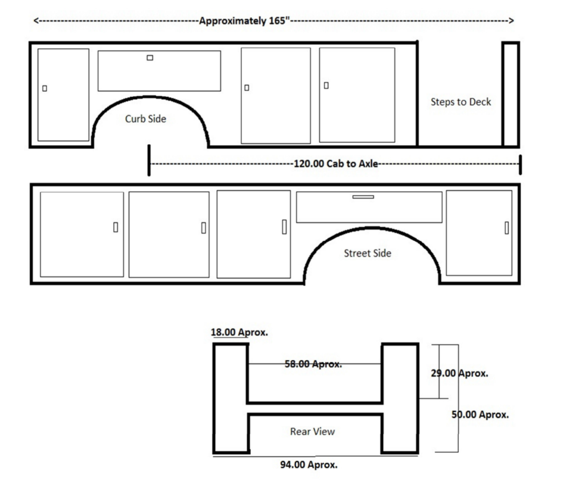

LINE BODY DRAWING (not including tail shelf)

EXAMPLE OF TAIL SHELF and REAR OUTRIGGERS (New pictures per Amendment 1)

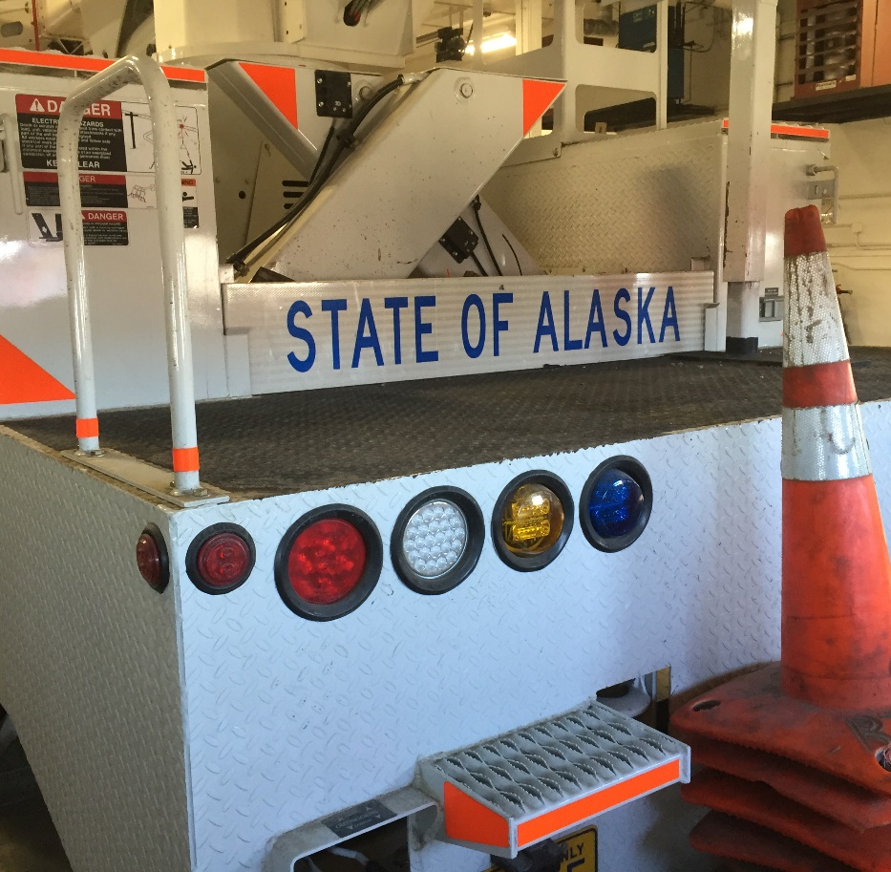
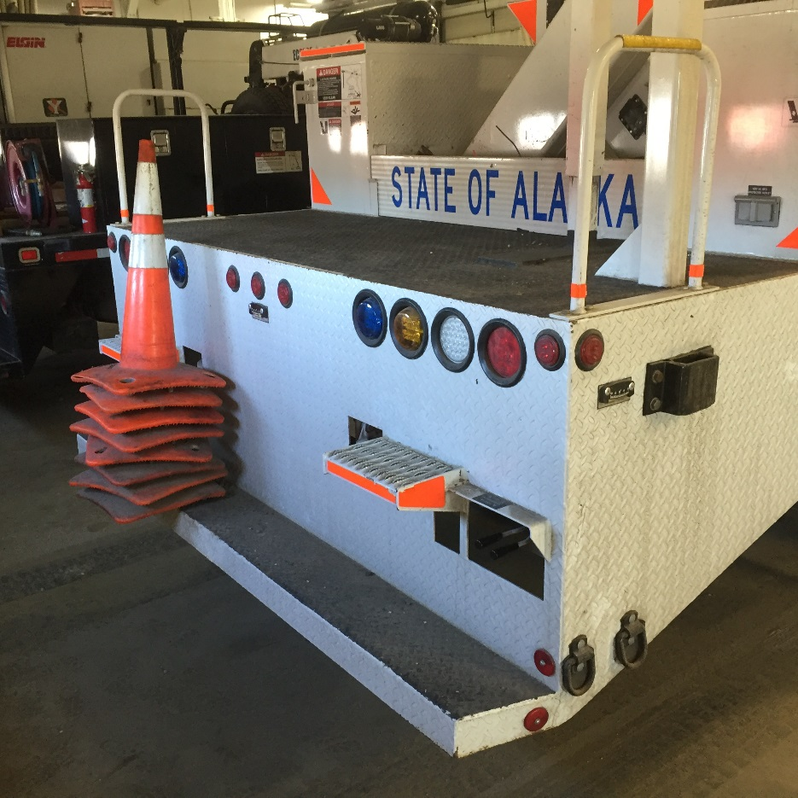

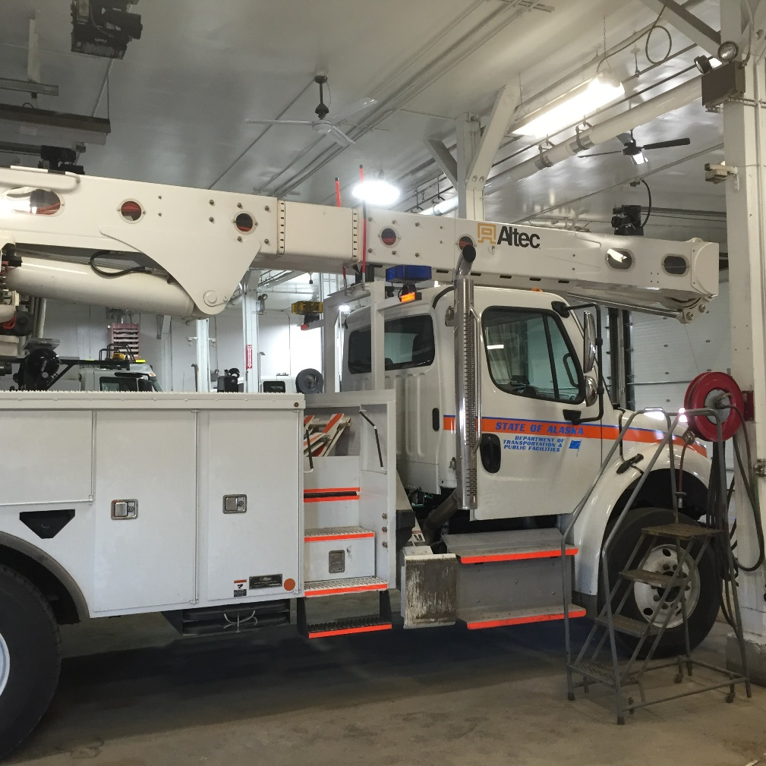
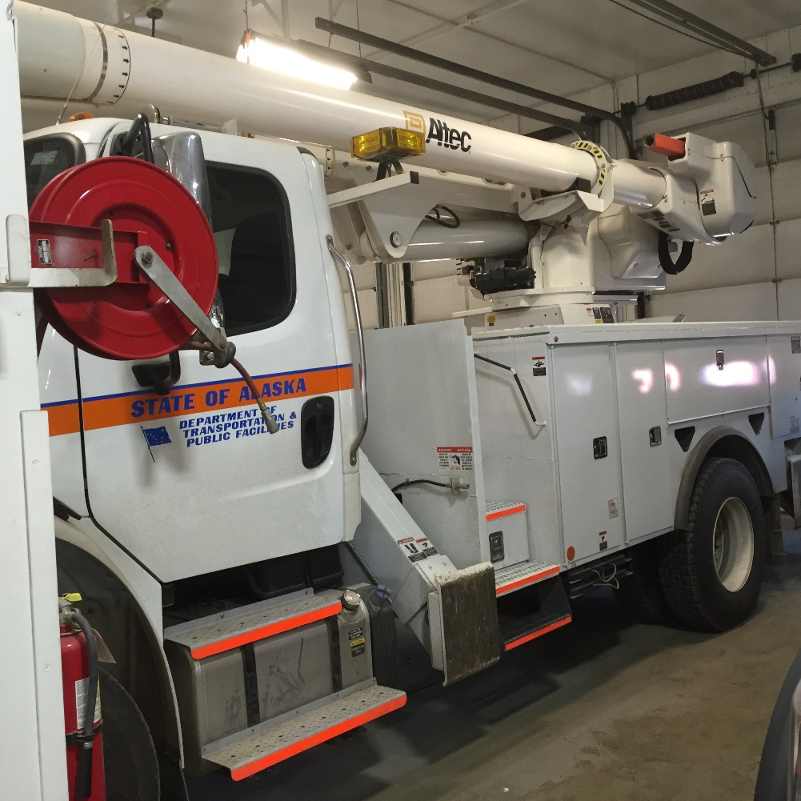
BID SCHEDULE INSTRUCTIONS:

All bids must include both unit pricing and extensions and be otherwise complete in the format requested.

DELIVERY: Indicate, in the space(s) provided, the time required to make delivery after the receipt of an order (ARO). Failure to make an entry in the space(s) provided will be construed as an offer to deliver within “Required Delivery” NUMBER of calendar days ARO. Bids which specify deliveries in excess of “Required Delivery” NUMBER of calendar days ARO will be considered non-responsive and the bid(s) will be rejected.

The materials, equipment or services bid will conform to and meet the requirements of the Contract Bid Documents and are hereby incorporated into this document:

Complete the attached bid price sheets and return with other bid documents as required in Section II – Standard Terms and Conditions, paragraph 13.

Item Total
# Unit Description Amount

1a ea. 38,000 GVWR 4x2 Truck $
With mounted Articulating Over center Aerial Lift
Per Specification #279-55 Fairbanks contained herein.

Truck Chassis - Year, Make & Model Offered:

(*)

Aerial Lift - Make & Model Offered:

(*)

Service Body – Make & Model Offered:

(*)

1b ea. Training in Fairbanks $

1c ea. Publications: $
2 sets of paper publications
1 set of electronic publications on CD, DVD or online access in lieu of CD or DVD.
Per Specification Section I Item 7.0

TOTAL BID PRICE FOR AWARD PURPOSE (1a through 1c) $

OPTIONAL ITEMS:

1d Optional Stationary mounted Lower Controls $
Per Specification 8.15.2.2
(Price required but will not be used in bid calculation)

1e Self-taught manuals, CD or DVD on boom operation and maintenance $
Per Specification 10.4.1
(Price required but will not be used in bid calculation)

1f Self-taught manuals, CD or DVD on truck operation and maintenance $
Per Specification 10.4.2
(Price required but will not be used in bid calculation)

8 1a Boom automatic locking system $
As per 8.13.1
(Price required but will not be used in bid calculation)

The actual F.O.B. point for all items purchased under this contract is the final destination anywhere within the State of Alaska. Ownership of and title to the ordered items remains with the contractor until the items have been delivered at their final destination and accepted as final and complete by the State.

For pricing purposes, the F.O.B. point is dockside Seattle/Tacoma.

The cost of shipping and delivery for orders beyond the limits of Seattle/Tacoma dock will be handled as follows. The contractor will prepay the shipping and delivery charges to any destination named by the State in its order. The contractor will charge-back those shipping and delivery charges to the State as a separate line item on the State’s invoice. All shipping charges over $100 must be documented by a copy of the actual shipping invoice and received with the invoice charge to the State.

Ship to location:

Fairbanks International Airport
5801 Airport Industrial Road
Fairbanks, Alaska 99709

Required Delivery: Maximum 360 days after receipt of order (ARO)

Offered Delivered Time: __________ Days ARO.

Weight Slip: To be delivered with Manufacturers Certificate of Origin as specified in Section I item 8.0 and 9.0

THIS IS NOT AN ORDER
SEALED BIDS MUST BE SUBMITTED TO THE STATE EQUIPMENT FLEET PRIOR TO BID OPENING AT WHICH THEY WILL BE PUBLICLY OPENED.
IMPORTANT NOTICE: If you received this solicitation from the State’s “Online Public Notice” web site, you must register with the Procurement Officer listed on this document to receive subsequent amendments. Failure to contact the Procurement Officer may result in the rejection of your offer.
BIDDER'S NOTICE: By signature on this form, the bidder certifies that:

(1) the bidder has a valid Alaska business license, or will obtain one prior to award of any contract resulting from this ITB. If the bidder possesses a valid Alaska business license, the license number must be written below or one of the following forms of evidence must be submitted with the bid:
- a canceled check for the business license fee;
- a copy of the business license application with a receipt date stamp from the State's business license office;
- a receipt from the State’s business license office for the license fee;
- a copy of the bidder’s valid business license;
- a sworn notarized affidavit that the bidder has applied and paid for a business license;

(2) the price(s) submitted was arrived at independently and without collusion and that the bidder is complying with:
- the laws of the State of Alaska;
- the applicable portion of the Federal Civil Rights Act of 1964;
- the Equal Employment Opportunity Act and the regulations issued thereunder by the State and Federal Government;
- all terms and conditions set out in this Invitation to Bid (ITB).
If a bidder fails to comply with (1) at the time designated in the ITB for opening the State will reject the bid. If a bidder fails to comply with (2) of this paragraph, the State may reject the bid, terminate the contract, or consider the contractor in default. Bids must be submitted under the name as appearing on the person’s current Alaska business license in order to be considered responsive.

If a contract award is made by the State of Alaska, the undersigned offers and agrees to furnish materials, equipment and services in compliance with all terms and conditions specified in ITB/Contract. Submittal of this document with authorized signature constitutes full understanding and a promise to comply with all specifications, terms and conditions of ITB/Contract.

TO BE COMPLETED BY BIDDER:  ____________________________  COMPANY SUBMITTING BID  ____________________________  AUTHORIZED SIGNATURE  ____________________________  PRINTED NAME  ___________________________DATE | _______________________________  ADDRESS  ________________________________ CITY, STATE, ZIP  ________________________________ PHONE/FAX  ________________________________E-MAIL ADDRESS | ___________________________  ALASKA BUSINESS LICENSE NO:  DOES YOUR BUSINESS QUALIFY FOR PREFERENCES?  [ ] YES [ ] NO  DOES YOUR BUSINESS QUALIFY FOR THE VETERANS PREFERENCES?  [ ] YES [ ] NO
Revised 03/14/2012

