STATE OF ALASKA
DEPARTMENT OF NATURAL RESOURCES
DIVISION OF MINING, LAND AND WATER
SOUTHCENTRAL REGIONAL OFFICE
550 W. 7TH AVE., SUITE 900 C
ANCHORAGE, AK 99501-3577

PUBLIC NOTICE

ADL 232218
Applicant: Jeffrey Bevans
Improvement of an Existing RS 2477 Trail

Proposed Project and Location:

In accordance with the provisions of 11 AAC 51.100, the Department of Natural Resources, Division of Mining, Land and Water, Southcentral Region Office is considering the authorization of trail surface improvements within an existing 100 foot wide easement for Pinochle Creek Trail (also known as Hicks Creek Trail; “RS 2477 Trail” # 426), near the Glenn Highway in Glacier View, Alaska. The applicant proposes to improve the route by (1) relocating the trail within the easement to avoid boggy terrain, (2) hardening the trail surface with logs (corduroy road), and (3) grading the trail surface. The improvements are proposed to take place within the first 8.5 miles of the easement, beginning near the Glenn Highway, within Section 20 of Township 20 North, Range 9 East, Seward Meridian. Nothing herein implies the authorization of a new easement; improvements described herein will be within an existing easement.

Members of the public and interested parties are invited to comment on this proposal. The Division of Mining, Land and Water must receive written comments addressed to the DNR DMLW Southcentral Region Office, 550 W. 7th Ave., Suite 900 C, Anchorage AK 99501-3577 no later than 5:00 pm on Tuesday, July 14th, 2015. Comments and questions may be submitted to the attention of Kenton Curtis: Kenton.Curtis@Alaska.gov, telephone 907-259-5035, or fax 907-269-8913. In order to be given full consideration, all comments should clearly explain the facts on which they are based and how they pertain to the proposed action. Following the comment deadline, all responses will be reviewed and the Department’s decision on this matter may be modified as a result of information received. 11 AAC 05.010 is available on-line by conducting a search of the webpage at http://www.legis.state.ak.us/basis/folio.asp. The State of Alaska, Department of Natural Resources complies with Title II of the Americans with Disabilities Act of 1990. Individuals with disabilities who may need auxiliary aids, services or special modifications to participate may contact the TDD number at (907) 269-8411.

The Division of Mining, Land and Water Southcentral Region Office reserves the right to waive technical defects in this notice.

/s/ Regional Manager, Southcentral Region Office
DNR Division of Mining, Land and Water

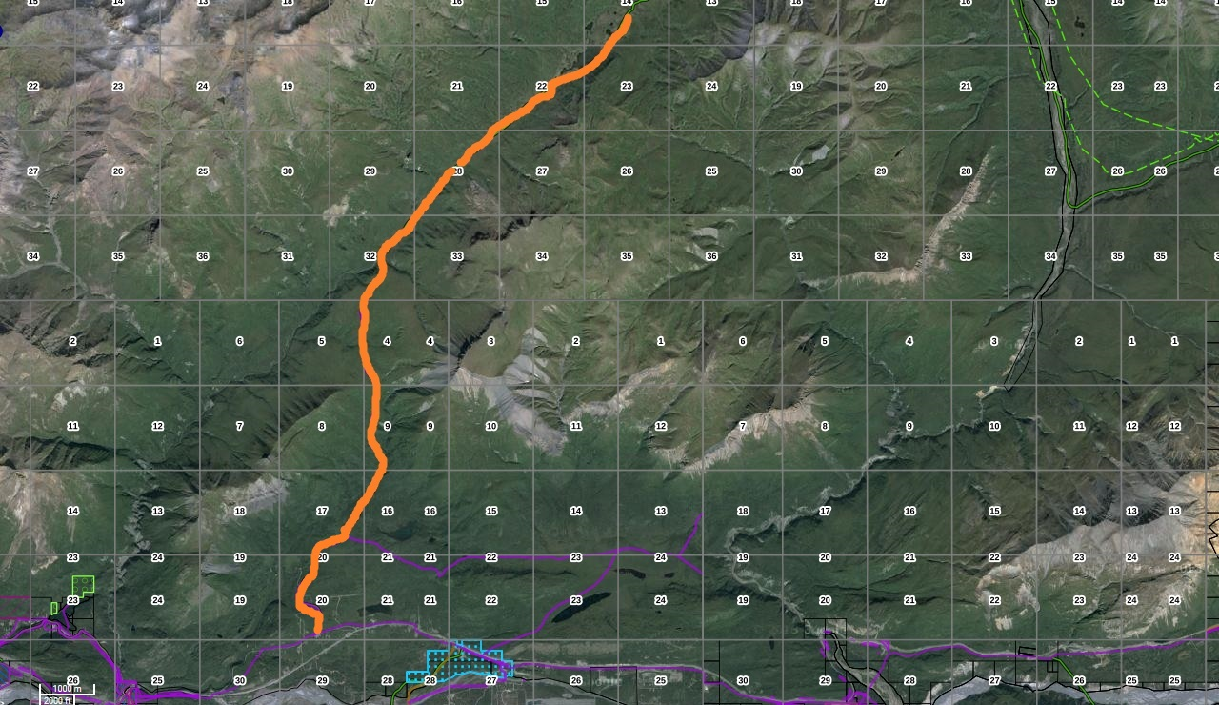
End of Authorization
Beginning of Authorization
Hundred Mile Lake
Hick’s Lake
Glenn Highway MP 99

