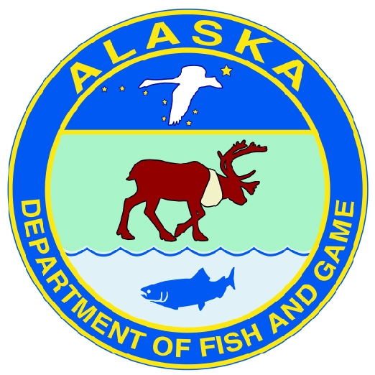
Alaska Department of Fish and Game

Minto Nenana Fish and Game Advisory Committee
Meeting Announcement

The Minto Nenana Fish and Game Advisory Committee will meet on Tuesday, December 17, 2013 at 11:00 AM
in the Nenana Tribal Hall in Nenana.
The purpose of this meeting is to discuss the 2013 fishing and hunting season as well as comment on Board of Game Proposals.

The Minto Nenana Fish and Game Advisory Committee is a collection of community members from all user groups that come together, discuss Fish and Game issues and recommend changes to current regulations. They also represent their community before the Board of Fisheries and Board of Game at board meetings.
This meeting is open to the public.
For more information contact:
Nissa Pilcher, Alaska Department of Fish and Game
Boards Support Section
(907) 459-7263/1-866-459-7263

